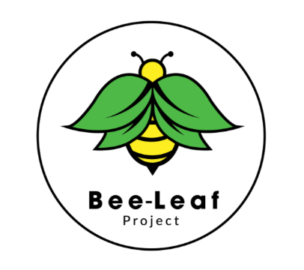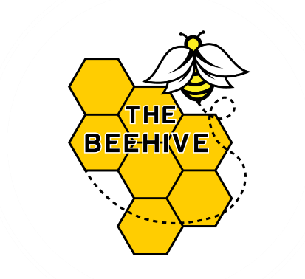

Information for Parents
The Beehive Independent School is committed to providing clear and accessible information to all parents and carers, in accordance with Part 6 of the Independent School Standards.

School Contact Information
School Name: The Beehive Independent School
School Address: 14 Gildridge Road, Eastbourne, BN21 4RL
School Telephone Number: 01323 573604
Proprietor Name: Taner Fikret

Available Policies and Information
- A copy of the Safeguarding and Child Protection Policy is available on request.
- A Curriculum Overview outlining the subjects and key areas of study is available on request.
- The school’s Complaints Policy is available on request, including details of how complaints are handled through to an independent panel if necessary.
- Information about provision for students with Special Educational Needs and Disabilities (SEND) is available on request.

Inspection Reports
Following inspections, copies of inspection reports will be made available to all parents and carers.

Requests for Information
Parents and carers may request a paper copy of any of the above information by contacting the school office.
For any further information or enquiries, please contact the school directly.

