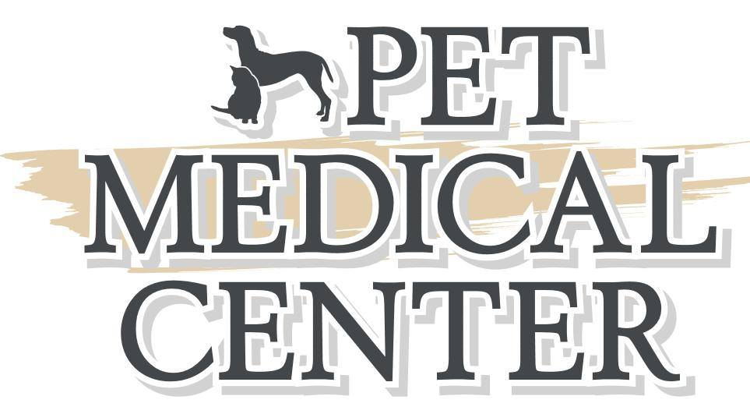

**Anesthesia Instruction Sheet**

**Your pet is scheduled to have a procedure done with anesthesia or sedation. Please follow these instructions to ensure that your pet has as safe an anesthetic procedure as possible.**

* **Please do not feed your pet after 10 pm the night before surgery. Water is fine.**
* **Please do not let your pet drink an excessive amount of water the morning of surgery.**
* **Please give all medications that you routinely do, unless instructed otherwise by the Veterinary Staff. Please bring all current medications for use during the hospital stay.**
* **Please have your pet to the hospital by 9:00 am the morning of the procedure. We open at 7:00 for early drop-off, or you can leave your pet the night before if needed.**
* **Please let your pet urinate/defecate before bringing them to the office.**
* **Please let us know if your pet is having any abnormal symptoms including vomiting, diarrhea, coughing, sneezing, etc.**

**Thank you for trusting us with the care of your pet. We will call or text as soon as your pet is awake!**

**Pet Medical Center of Urbandale Staff**

**4450 128th St**

**Urbandale, IA, 50323**

**515-331-9035**