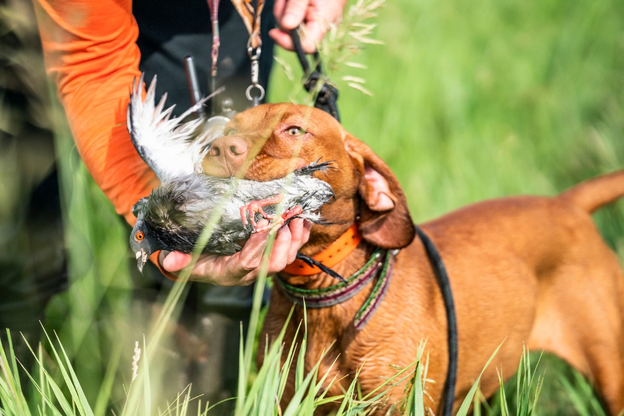
Puppy Questionnaire

- How did you hear about us?

- How often do you hunt?

- Do you hunt waterfowl?

- What is your favorite type of hunting?

- Have you heard of Navhda? If so what is your role in the club?

- What are the three most important attributes in your next vizsla?

- Do you have children? If so how many and what are their ages?

- Where will you keep your puppy for kenneling purposes? Will your dog be a house dog?

- Do you have any intentions of breeding your dog?

- Do you plan on training your dog yourself or sending it to a
trainer?

- What made you decide to own a Vizsla?

- What sex do you prefer? Are you open to both if preferred sex isn’t available?

- Do you have any intentions on testing your dog in advance hunt test or Navhda Test?

- What type of personality are you looking for in a vizsla?

- Do you own any other dogs? If so what breed?

