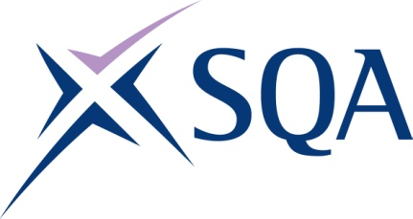
GM28 22 | SVQ in Team Leading at SCQF Level 6

To attain the qualification candidates must complete 6 Units in total. This comprises:

- 4 mandatory Units
- 2 optional Units

Please note the table below shows the SSC identification codes listed alongside the corresponding SQA Unit codes. It is important that the SQA Unit codes are used in all your recording documentation and when your results are communicated to SQA.

Mandatory Units: Candidates must complete all 4 Units from this group
SQA code | SSC code | Title | SCQF level | SCQF credits
HK25 04 | CFAM&LAA1 | Manage Yourself | 6 | 5
HK2L 04 | CFAM&LDD1 | Develop and Sustain Productive Working Relationships with Colleagues | 6 | 6
HC8V 04 | CFAM&LDB2 | Allocate Work to Team Members | 5 | 6
H8H2 04 | CFAM&LEB1 | Provide Healthy, Safe, Secure and Productive Working Environments and Practices | 7 | 7

Optional Units: Candidates must complete 2 Units from this group
SQA code | SSC code | Title | SCQF level | SCQF credits
H5XP 04 | CFAM&LBA3 | Lead your Team | 7 | 9
H69F 04 | CFAM&LDC5 | Help Individuals Address Problems Affecting their Performance | 6 | 5
H99J 04 | CFAM&LDD7 | Represent your Area of Responsibility in Meetings | 5 | 2
HK2G 04 | CFAM&LDA6 | Initiate and Follow Disciplinary Procedures | 6 | 6
HK2J 04 | CFAM&LDA7 | Initiate and Follow Grievance Procedures | 6 | 6
H41M 04 | CFAM&LDA3 | Induct Individuals Into Their Roles | 6 | 4
H41N 04 | CFAM&LDB5 | Manage Team Communications | 5 | 3
H41P 04 | CFAM&LDB9 | Promote Staff Wellbeing | 6 | 5
H41R 04 | CFAM&LDC1 | Identify Individuals’ Learning Needs and Styles | 6 | 4
H9YF 04 | CFACSC5 | Monitor and Solve Customer Service Problems | 6 | 6
HK20 04 | CFACSD8 | Work with Others to Improve Customer Service | 6 | 8
H9YD 04 | CFACSC3 | Resolve Customer Service Problems | 5 | 6
HK21 04 | CFACSD2 | Support Customer Service Improvements | 5 | 5
H988 04 | CFAM&LDB3 | Quality Assure Work in Your Team | 5 | 6

