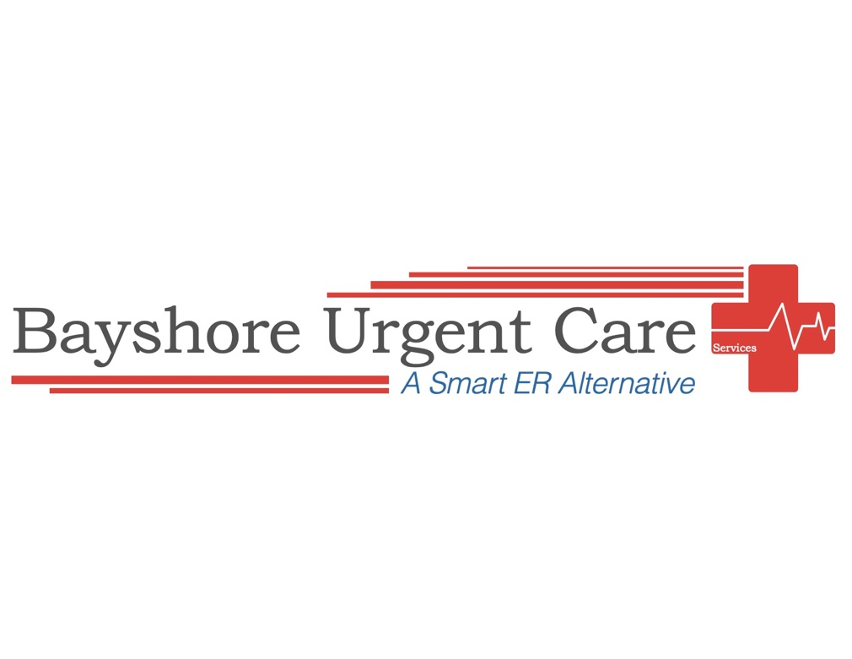

Practice Forms

Please Review and Keep for Your Records.

Thank You

ATTENTION

IF YOU THINK YOU ARE HAVING A LIFE-THREATENING CONDITION SUCH AS, A HEART ATTACK OR STROKE. PLEASE NOTIFY THE FRONT DESK STAFF.
IMMEDIATELY

PRACTICE NOTICES
Assignment of Benefits
If I am entitled to applicable insurance benefits of any, and all types, I assign such benefits to Venture Medical of Florida LLC. (dba Ellenton Urgent Care) for services rendered to me. I authorize payment directly to Venture Medical of Florida LLC of all such insurance benefits payable to me. Such insurance includes, but is not limited to, private commercial insurance, auto/liability insurance, or any governmental programs such as Medicare, Medicaid, or Worker’s Compensation and authorizes Venture Medical of Florida LLC to release medical information to such insurance providers as necessary to satisfy conditions for payment of the assigned benefits. I certify that the information given regarding my insurance is accurate and current.

Financial Policy
The undersigned individually obligates him/her and guarantees prompt payment of all charges for services rendered to the patient when not covered by insurance carriers or others. In network insurance co-payment must be paid prior to being seen. Cash pay and out of network patients must pay the office visit prior to being seen and may be subject to further charges (medications, testing, etc) that must be paid at the end of your visit. Payment of any unpaid balance is due within 30 days of final billing. If payment is not received within 30 days of the date of final billing, finance charges may begin to accrue at the maximum rate allowable by law. In addition, such balance may be turned over for collection activity, at which time the undersigned shall be liable for attorney’s fees and/or collection agency’s fees and expenses. The undersigned understands that Venture Medical of Florida LLC has the right to examine credit bureau files for financial information regarding collection of unpaid debt.

HIPPA Disclosure
By signing below, I understand that Ellenton Urgent Care shall not publish or otherwise make generally available any protected individually identifiable health information or data that identifies a patient for purposes other than treatment, payment or other health care operations without his/her express written consent. I understand that this does not restrict the internal use of such information or date that is required in the performance of the scope of work that this office has been engaged to perform for patients. I understand that this office maintains physical electronic and procedural safeguards to protect individually identifiable health information. As a patient of Ellenton Urgent Care, I understand that I have the right to request special privacy protections. I have the right to request restrictions on certain uses and disclosures of my health information, by writte request specifying what information I wish to have imposed. I hereby acknowledge that this medical practice Notice of Privacy Practices has been made available to me. I further acknowledge that a copy of the current notice will be posted in the reception area, and that I will be offered a copy of this notice.

ATTENTION:

Motor Vehicle Accident
Or
Workers Compensation

If you are here to be seen for any of the reasons above,
Please inform the Front desk staff, so we can provide you with the necessary documentation.

Follow Up Policy

Any questions regarding medications, symptoms, at home instructions or if symptoms do not improve within 3-4 days please call the office at 941-909-7900.

Our Business hours are 8am-8pm Monday-Friday
9am-6pm Saturday & Sunday

If approved by your insurance, there will be no charge for the follow up visit if you return within FIVE days of your initial visit. Follow up is only good for one visit in those FIVE days. Any other visits will be charged either your co-payment or the office visit. This also applies to cash pay patients, with no charge, if it is within the five days of your initial visit.

Any new health concerns non-related to previous illness/injury will result in a new office visit co-pay.

If additional testing or procedures are needed patients will be responsible for payment at the end of the visit.

Pursuant to new state law, any patient that has been prescribed a narcotic medication will need to return to the office for any refill and will be obligated to pay the office fee.

Medical Information Release and Message/Email Authorization

I give permission to Ellenton Urgent Care to release my medical information to the following people named below (this does not apply to other physicians) it does apply to family members, friends and others with whom you would allow such information to be shared.

I authorize the providers and representatives of Ellenton Urgent Care to leave messages regarding my test results/appointments/financial information on my voicemail at numbers below if they do not reach me.

I give permission to Ellenton Urgent Care to EMAIL a follow up policy and Education

TO THE PATIENT: You have the right, as a patient to be informed about your condition and recommended surgical, medical or diagnostic procedure to be used so that you may make the decision whether or not to undergo any suggested treatment or procedure after knowing the risks and hazards involved. At this point in your care, no specific treatment plan has been recommended. This consent form is simply an effort to obtain your permission to perform the evaluation necessary to identify the appropriate treatment and/or procedure for any identified condition(s).

All results and education related to your office visit will be published online to your patient portal account. Please access your portal account for this information.

This consent provides us with your permission to perform reasonable and necessary medical examinations, testing and treatment. By signing below, you are indication that (I) you intend that this consent is continuing in nature even after a specific diagnosis has been made and treatment recommended; and (2) you consent to treatment at this office or any other satellite office under common ownership. The consent will remain fully effective until it is revoked in writing. You have the right at any time to discontinue services.

You have the right to discuss the treatment plan with your provider about the purpose, potential risks and benefits of any test ordered for you. If you have any concerns regarding any test or treatment recommended by your health care provider, we encourage you to ask questions.

I voluntarily request a physician, and/or mid-level provider (Nurse Practitioner, Physician Assistant, or Clinical Nurse Specialist), and other health care providers or the designees as deemed necessary, to perform reasonable and necessary medical examination, testing and treatment for the condition which has brought me to seek care at this practice. I understand that if additional testing, invasive or interventional procedures are recommended, I will ask to read and sign additional consent from prior to the test(s) or procedure(s).

