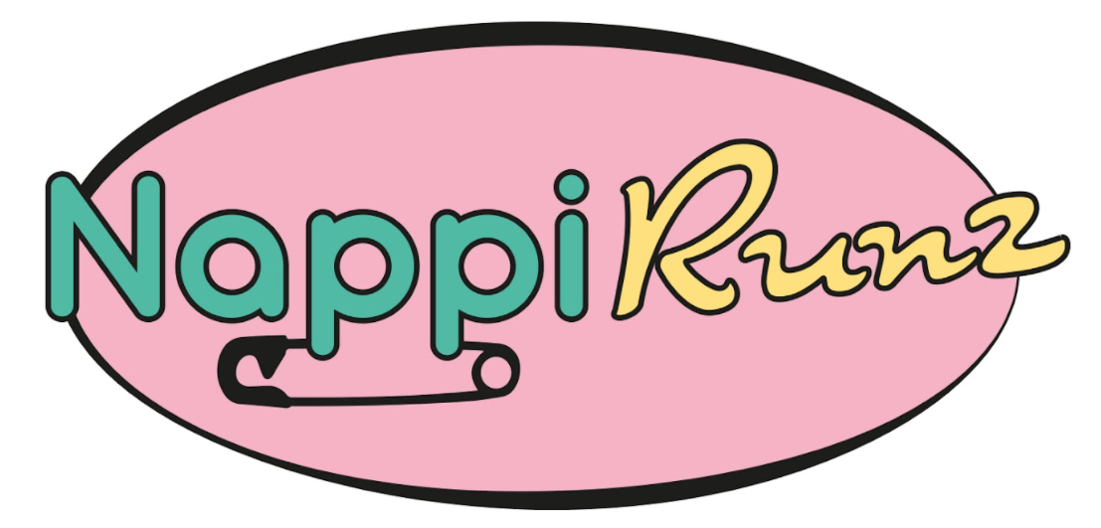
Nappy Referral Form

A referral can be made by a professional who works with families, such as:
Health Visitor, Midwife, Teacher, GP, Community Support/Charity Worker, Social Worker, Minister.

Details of person making referral:
Name
Organisation
Phone number
Is the family a new referral or one we have previously supported*

Please note that currently we hold stock in all sizes but have set a maximum individual request limit of six packs for size 1 and 2 and three packs for sizes 3 - 8 **
As some brands of pull up are gendered we ask that you specify boy or girl also.
Size | Number Required | Size | Number Required
0 |  | 7
1 |  | 8
2 |  | 4 pull ups
3 |  | 5 pull ups
4 |  | 6 pull ups
4+ |  | 5 night pull ups
5 |  | 6 night pull ups
5+ |  | 7 night pull ups
6 |  | 8 night pull ups
6+
BOY |  | GIRL
Additional Requests:

*To understand more about the impact NappiRunz is having in the community we are looking to expand the data we collect on where the nappies go. This helps us collate more information on our reach across Edinburgh the Lothians and Fife.
** In some cases, we will not be able to fulfil all requests, but our team will endeavour to get back in touch once stocks have increased.

