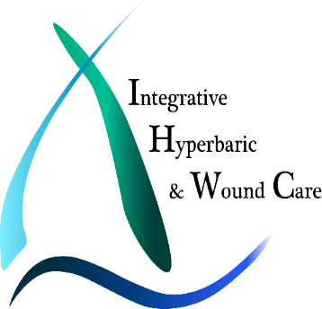
Hyperbaric Oxygen Therapy or “Mild” Hyperbaric Therapy

“Can’t I just buy a chamber and put it into my home?”
IS MILD HYPEBARIC THERAPY SAFE AND EFFECTIVE?
First of all, you cannot legally put a medical grade hyperbaric oxygen therapy chamber into your home. In addition to the National Fire Protection Association (NFPA-99) regulations and the illegality of medical-grade oxygen purchase, it just would not be safe. So what can you legally put into your home? A mild or soft hyperbaric chamber that can go to 1.0 atmospheres and can only use ambient air, which is 21% oxygen. (A medical hyperbaric can typically go to 3.0 atmospheres and provides 100% medical-grade oxygen).
WHAT IS THE DIFFERENCE BETWEEN MILD HYEPRBARIC THERAPY AND MEDICAL HYPERBARIC OXYGEN THERAPY?
Hyperbaric Oxygen Therapy (HBOT) and Mild Hyperbaric Oxygen Therapy (MHT) are not the same.
To compare the differences, let’s look at the oxygen in the blood. We measure the changes from arterial blood gases. This refers to how much oxygen is actually getting into the body and to the tissues – this is what is actually making the changes. The following chart shows the differences between the different types of chambers and oxygen supplied to the tissues:
Pressure | Oxygen | Arterial Oxygen Pressure | Oxygen  Increase | Unit Type
Normal Air | Ambient – 21% Oxygen | 50 mmHg pO2 | none | Normal Living
- Atmosphere  Hyperbaric | Ambient Air – 21% Oxygen | 159 mmHg p02 | 3-Fold | Home Mild Hyperbaric
1.3 Atmosphere  Hyperbaric | 100% Oxygen | 988 mmHg p02 | 20-Fold | Medical Soft Hyperbaric
1.5 Atmosphere  Hyperbaric | 100% Oxygen | 1140 mmHg p02 | 23-Fold | Medical Hyperbaric
- Atmosphere  Hyperbaric | 100% Oxygen | 1520 mmHg p02 | 30-Fold | Medical Hyperbaric
2.5 Atmosphere  Hyperbaric | 100% Oxygen | 1900 mmHg p02 | 38-Fold | Medical Hyperbaric
- Atmosphere  Hyperbaric | 100% Oxygen | 2280 mmHg p02 | 47-Fold | Medical Hyperbaric
The Bottom Line:
- A Home Mild Hyperbaric soft chamber can provide maximally 3 times more oxygen to your tissues than normal air.
- A Medical Soft Hyperbaric Chamber at many clinics can provide maximally 20 times more oxygen to your tissues than normal air.
- A Medical Hyperbaric Oxygen Therapy chamber can provide 23 to 47 times more oxygen to your tissues than normal air.
Let’s look at the reasons why we do NOT use Mild Hyperbaric Therapy soft chambers. For a quick comparison:
HBOT Chamber | MHT Soft Home Chamber
100% medical grade oxygen | Ambient air (approximately 21% oxygen—mostly nitrogen)
Pressurized typically to a max of 3.0 atmospheres | Pressurized to a max of 1.0 atmospheres
Regrow bone and tissue in severely damaged areas of the body | Cannot regrow bone and tissue
Supported by thousands of clinical studies which validate successful healing | No such correlation has been made with soft chambers and healing
Many treatments are recognized for reimbursement by insurance companies and federal government | No conditions are reimbursed by insurance companies using these chambers
Designed to go to therapeutic pressures to achieve healing | Designed to temporarily treat divers and mountain climbers in route to a hard chamber
Kills harmful bacteria | Can promote the undesirable growth of aerobic bacteria
Meets the American Society of Mechanical Engineers, Pressure Vessels for Human Occupancy (“ASME PVHO-1”) standard | Does not always meet the “ASME PVHO-1” standard
Loss of electrical power has no effect on pressure and oxygen flow | Loss of electrical power and chamber rapidly deflates causing possible barotrauma to patient’s ears and pneumothorax to patient’s lungs
No risk of contaminated or polluted air. A closed system of oxygen is piped in directly. | Risk of breathing contaminated or polluted air which can be counterproductive
Designed to heal ischemic tissue or tissue that is restricted from receiving enough oxygen by hyper-oxygenating the body, blood and plasma. | No research shows healing of ischemic tissue
Research shows a total of 30-40 treatments are generally required for most indications | Some results may be obtained in the lower pressure air filled chambers, however it will take many, many more sessions and the results often do not hold, or create issues with yeast or bacteria growth
Designed to use enriched gases like 100% oxygen | Never designed to be used with enriched gases like 100% oxygen
At Integrative Hyperbaric & Wound Care we find it very important to treat at a research validated protocol. All valid scientific studies demonstrating the benefit of hyperbaric therapy were performed at pressures higher than those able to be achieved in an MHT soft chamber. You cannot apply those benefits at the much lower pressures from MHT soft chambers.
The FDA does not recognize MHT soft chambers as a medical device for hyperbaric oxygen treatment. The FDA only recognizes MHT soft chambers as inflatable bags as a device used to treat altitude sickness during transport to a definitive medical facility. Scientific literature shows that oxygen becomes bacteriostatic (biological or chemical agent that prevents bacteria from reproducing) at 1.5 atmospheres. Since MHT soft chambers produce less than 1.5 atmospheres they not only cannot prevent bacteria from growing, they can actually enhance the growth of some molds, fungus, and aerobic bacteria!
Parents and patients are also being informed that they can attach an Oxygen concentrator to the MHT soft chambers to increase oxygen delivery to the MHT soft chamber’s occupants. This is an immediate concern as the risk of fire is significantly elevated when people indicate that they are also using computer games and DVDs inside the ‘chamber’ to keep the occupants entertained. This can create a dangerous and potentially life threatening scenario!
Many of the MHT soft chambers manufacturer’s websites make a deliberate attempt to embrace a range of medical conditions and disorders under the banner of ‘hyperbaric oxygen therapy’. The public are ‘none the wiser’. However the evidence supporting the use of Hyperbaric Oxygen Therapy in these conditions and disorders are on the basis of applications using 100% Oxygen at pressures typically 1.5-2.5 ATA or greater. Hyperbaric oxygen therapy is about saturating the body with oxygen. This is most effectively done by delivering 100 percent oxygen by inhalation through your airways under the pressure created in a medical HBOT.
The bottom line, not all “hyperbarics” are created equal. Do your research, look at the Peer Reviewed research that is out there, think about what makes sense, and think safety first.
When looking for a provider of hyperbaric oxygen therapy inquire about the chambers they use, age of chambers, service records, oxygen provider, do they require a mask or hood, and are their certified physicians and technicians on staff and someone who has gone through the Hyperbaric Safety Director course.
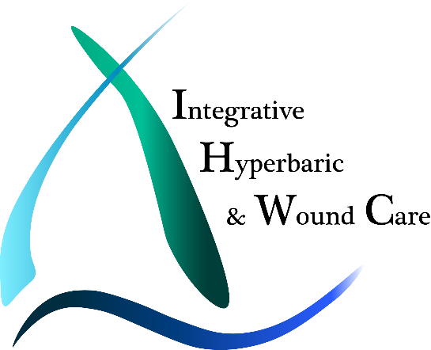
410 Pine St SE, Suite 330
Vienna, VA 22180
703-938-1421

