
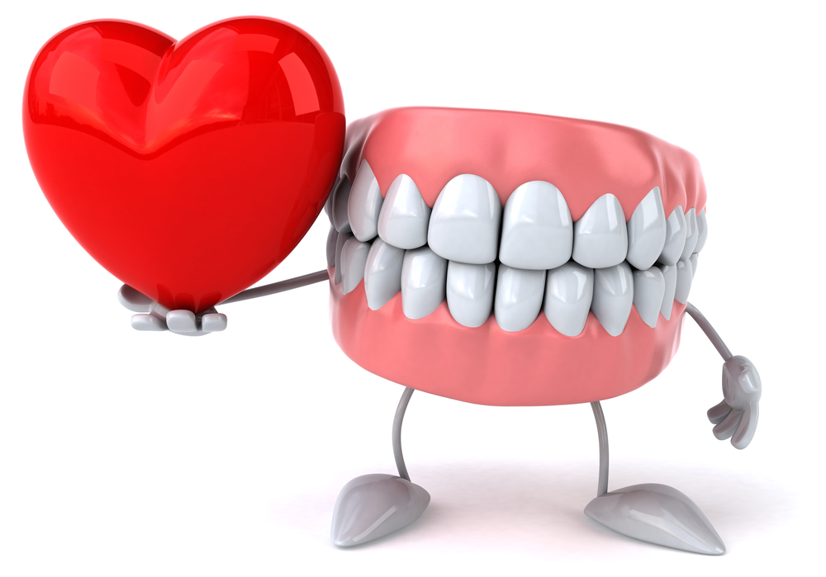
Supporting Complex Dental Care with HBOT
By Shannon Ginnan, MD
Virginia Integrative Health & Hyperbaric

Hyperbaric Oxygen Therapy (HBOT) is a revolutionary treatment used in number of indicated conditions to help promote formation of new blood vessels, heal nerve endings, reduce pain and shorten pain cycles, and enhance immune system regulation. It involves placing the patient in a Hyperbaric chamber, pressurized to the indicated atmospheric pressure depending on the type of condition, while breathing 100% medical-grade oxygen.
It allows blood and tissues to become super-saturated with oxygen, with many benefits including enhancing the body’s immune system and ability to kill viruses and bacteria. One of the most exciting areas of growth for this is dentistry.
Need dental implants post-radiation?
In the dental field, Osteoradionecrosis is a complication from head/neck radiation where portion(s) of jaw bone die due to lack of blood supply. In these cases, dental intervention alone can often fail, as the jaw often cannot heal adequately. However, a series of HBOT treatments before and after dental procedures can stimulate new blood vessel growth, vastly improving chances of repairing jaw compromised by radiation.
Jaw/bone infection that won’t heal?
Osteomyelitis of the jaw is a chronic bone infection that’s often difficult to heal with antibiotics alone because of its deep-seated nature and poor blood flow. HBOT increases blood flow to the area by stimulating the development of new small blood vessels called capillaries, increasing antibacterial capability of white blood cells and “natural killer” cells by providing high levels of oxygen needed to heal.
Difficulty producing saliva post radiation?
Xerostomia can be caused by radiation for head/neck cancer, which causes patients to no longer be able to produce adequate or any saliva. It can cause significant disability, beyond discomfort, leading to compromises in digestive/immune system function. HBOT has been shown to increase saliva production, improve the quality and bacterial fighting capability, reducing infections and cavity formation.
What other conditions can Hyperbaric Oxygen Therapy help with?
The 13 FDA approved indications for HBOT include Delayed Radiation Injury post-cancer, non-healing wounds/ulcers and compromised grafts/flaps (particularly diabetic and post-surgical patients), Osteomyelitis bone infections (particularly certain dental and lower limb infections), necrotizing soft tissue infections, severe anemia and more.
It amplifies white blood cell action, antibacterial-enables them to eliminate bacteria more efficiently, enhancing wound healing and helping to resolve bruising and scarring with new collagen formation. The low-risk treatment involves medical-grade oxygen becoming a liquid, allowing access to areas to increase healing.
HBOT therapy can go hand-in-hand with dental care in situations that would otherwise make necessary dental procedures almost impossible to perform with a chance of a successful outcome. If you are having difficulty with any of these dental issues, or other conditions HBOT is indicated to treat, consider Hyperbaric to help alleviate inhibiting symptoms and optimize recovery.

