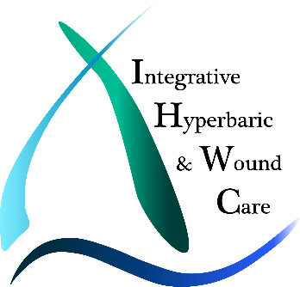
Post-Cancer Recovery with HBOT
By Christina Avapato
Edited by Calista Petrie, MA
As Published in “The Washington Post”
Integrative Hyperbaric & Wound Care
Dr. Shannon Ginnan, MD

The Basis of Hyperbaric Oxygen Therapy
Simply stated, Hyperbaric Oxygen Therapy (HBOT) is the inhalation of 100% medical grade oxygen in a pressurized and highly controlled chamber. As the patient breathes in 100% oxygen opposed to the 21% oxygen available in common air, HBOT augments the body’s natural healing processes to speed up and improve recovery from a variety of illnesses, including delayed radiation injury post-cancer.
Utilizing HBOT In An Integrative Cancer Recovery Plan
One of the most promising FDA approved indications for HBOT is its ability to help heal a patient after radiation treatment for cancer. Radiation therapy is remarkably effective at treating many forms of cancer but takes a tremendous toll on the body’s systems and cells. The very premise of radiation is that it destroys the blood supply to the area of cancer to kill those cancer cells. Unfortunately, radiation can also damage healthy tissues around the cancer site that then must be healed once radiation therapy is complete.
Because HBOT can boost the body’s natural healing process (over time it actually causes new blood vessel growth), it can speed up the recovery of these once healthy tissues, improve the outcome of the healing process, and help restore balance internally. The outcome of patient’s cases treated with HBOT can also be improved by combining an integrative approach, looking for underlying causes with comprehensive diagnostics and functional medicine care. HBOT, in combination with integrative care or even just on its own, has helped many post-cancer patients experience an increase in energy and mobility, and a reduction in inflammation, among many other symptom improvements.
The post-cancer healing process is different for each patient and type of cancer. Patients who have seen the most improvement with it have had the following types of cancer: prostate, breast, and brain cancers, cancer in the neck area - particularly lymphoma, bone radiation damage (osteoradionecrosis), including the jaw, lung and bladder cancers, and other cancers treated with radiation.
Symptoms HBOT Can Treat
HBOT is highly effective at treating the following symptoms and side effects incurred due to radiation treatment for cancer: pain, scar tissue, cognitive dysfunction, difficulty swallowing, speaking, and producing saliva, blood in the elimination system, malabsorption, open wounds, digestive issues, and low energy.
Fighting cancer is a difficult battle, but the healing process from cancer treatment is a whole separate battle that many patients don’t anticipate. Hyperbaric Oxygen Therapy has the potential to put them back in the driver’s seat of their health, helping in recovery towards a healthier and happier tomorrow.

