

Date of Enrollment:

_________________________

111 N. Main St. Highlands, Texas 77562 **|** 281-426-2221**|** Fax: 281-936-0222

**WWW.HIGHLANDSBUILDINGBLOCKS.COM**

**Enrollment Form**

**Child’s Information**

CHILDS NAME: ___________________________________________ AGE: ___________ DOB: ________________

FULL ADDRESS: ____________________________________________________ ZIP CODE___________________

DOES YOUR CHILD HAVE ANY MEDICALLY DIAGNOSED ALLERGIES?________ TO WHAT? ____________________

*Children with Food Allergies must have a Food Allergy Emergency Care Plan form completed by the physician before the child can start care.

IS YOUR CHILD TAKING ANY DAILY MEDICATIONS?_________WHAT?___________________________________

DOES YOUR CHILD HAVE ANY MEDICAL CONDITIONS, ILLNESSES, ETC? __________________________________

____________________________________________________________________________________________

HAS YOUR CHILD EVER BEEN IN DAYCARE BEFORE? __________ WHERE? ________________________________

HOW DID YOU HEAR ABOUT US? 🞏 INTERNET 🞏 DRIVE-BY 🞏 FRIEND/FAMILY: ______________________

🞏 OTHER: __________________________________

**Parent/Legal Guardian’s Information**

**Account Holder #1 Account Holder #2**

**NAME: ________________________________________ NAME: ___________________________________________**

**RELATION TO CHILD: ___________________________ RELATION TO CHILD: ________________________________**

**Address: ______________________________________ Address: _________________________________________**

**Primary Phone: ________________________________ Primary Phone: _____________________________________**

**Email: _______________________________________ Email: _____________________________________________**

**TDL#________________________________________ TDL#______________________________________________**

**Employed By: _________________________________ Employed By: ______________________________________**

**Work Address: ________________________________ Work Address: ______________________________________**

**Work Ph: _________________________________________ Work Ph: ______________________________________**

**Parents Are:** Together Divorced Separated Widowed

**Please list the names & Ages of all siblings of your child: ______________________________________________________**

**_____________________________________________________________________________________________________**

**_**

A working email address is required for at least one parent/guardian

**Child’s Name ____________________ is Enrolled as:**

**⬜ Full Time**

**⬜ Drop-In**

**Full Time:**

* Full Tuition is due each week regardless of tuition. Unfortunately, our expenses are fixed according to enrollment, not attendance.
* Parents have access to web cams for a weekly fee of $5/ family.
* After one year of enrollment, you get one free vacation week.

**Drop-In:**

* Parents pay the drop in rate for each day the child is in care
* Payment is due at the time the child is dropped off
* Parents DO NOT have access to the web cams

**My child will most likely be in attendance the following days:**

🞎 Monday 🞎 Tuesday 🞎 Wednesday 🞎 Thursday 🞎 Friday

**He/She will most likely eat the following meals at the center:**

🞎 Breakfast

🞎 Lunch

🞎 PM Snack

*DINNER (DURING SCHOOL YEAR)

**DROP OFF DEADLINE FOR MORNINGS IS 9:00AM.**

**Children must be picked up by 6 pm to avoid late pickup fees.**

**Parent Signature: ___________________________________**

**Date: ____________**

**Authorization for Emergency Medical Attention - These Blanks must be completed fully.**

In the event that I cannot be reached to make arrangements for emergency medical attention, I authorize the facilities director or person in charge to take my child to:

Physician: _______________________________ Address: __________________________Ph: __________________

**Hospital:** **San Jacinto Methodist - 4401 Garth Road – Baytown, TX 77520 (281) 420-8879**

Insurance: ____________________________ Group#___________________ Policy #________________________

I give my consent for necessary emergency treatment when my child is in care at the name physician and hospital/clinic or which hospital/clinic responds to.

Signature Parent/Guardian:______________________________________________ Date: ____________________

**If an Emergency situation occurs, the facility will call 911 first.**

Transportation: I hearby 🞎 GIVE - 🞎 DO NOT GIVE permission for my child to be transported and supervised by Building Blocks Staff on field trips and to and from school.

Water Activities: I hearby 🞎 GIVE - 🞎 DO NOT GIVE permission for my child to participate in the following activities: Splash Pools, Swimming Pools, Wading Pools or other bodies of water provided by the center.

*\*\*Building Blocks does not assume any responsibility for the loss, damage or theft of any property belonging to the child and the parent agrees that Building Blocks and it’s personnel are not responsible for any such property even if it’s loss, damage or theft occurs on the centers property.* INITIAL: _____________

**Please advise us of any custody restrictions, or of anybody that is not allowed to pick up your child from our facility. Copies of court documents may be required.**

_______________________________________________________________________________________

_______________________________________________________________________________________

_______________________________________________________________________________________

Physicians Statement

For children NOT enrolled in public school

Child’s Name: _____________________________________________ DOB: ___________________

Physicians Name: ________________________________________ Ph: _______________________ Address: __________________________________________________________________________

I have examined ____________________________________________ within the past year and find that he/she is free of any communicable diseases and is able to participate in the childcare program.

Physicians Signature: ______________________________________ Date: ____________________

Do we have permission to obtain your child’s immunization records from Texas Immtrac if the need arises? 🞎 YES 🞎 NO

Do we have permission to give your child a vision & hearing screening? (for children that are over 4 but not yet in public school)

🞎 YES 🞎 NO

---------------------------------------------------------------------------------------------------------------

My School Age Child Attends

|  |  |  |
| --- | --- | --- |
| 🞏 B.P Hopper Primary | 405 E. Houston Highlands, TX 77562 | 281-420-4685 |
| 🞏 Highlands Elementary | 200 E. Wallisville Highlands, TX 77562 | 281-420-4900 |
| 🞏 Other |  |  |

🞏Before School Only 🞏 After School Only 🞏 Both Before and After School 🞏 Half-Day Pre-K

My Child’s Immunization record and vision/hearing screening records are on file at the school All these records and tuberculosis test results are current. Signature: _________________________

Childcare Account Agreement

**(Primary Account Holder)**

Last Name: _________________________ First Name: __________________________

Social Security # ____________________________ TXDL# ______________________

Cell Phone: _________________________ Home Phone: ________________________

Present Address: ____________________________________________

City __________________________State: ______________ Zip: _________________

**Manditory Card on File**

Please place a debit/credit card on file with the center. This card can be charged automatically each week/biweekly/monthly if you wish or can be charged with your permission whenever you wish. This information will be entered into our system and destroyed afterwards.

Name on Card: _____________________________________________

Card Number: ___________-____________-____________-_____________

Exp. Date: ____/_______ CVC: _________ Billing Zip: ______________

Auto Pay? YES NO

The undersigned agrees and understands that the services rendered for child care are subject to the following conditions:

1. All tuitions are due and payable in full by Monday of each week.
2. Tuitions not paid by Wednesday evening could result in a $10.00 late fee.
3. The customer (parent or guardian), agrees to pay, in the event the account is turned over to an agency or attorney for collection, reasonable attorney fees, plus all attendant collection costs, or court costs.
4. Any fees due that are not paid if my child leaves the program will be due immediately.
5. Any fee’s that are not paid within 30 days will be subject to a collection fee of 10% of the account balance and will be sent to a collection agency.
6. Any family behind on tuition will not be allowed to view the camera’s until their account is brought current.
7. Any remaining balance when the family de-enrolls from the center will be charged to the card on file.

Agreed and understood:

Primary Account Holder Signature: _______________________________ Date: _______________

Secondary Account Holder Signature: _____________________________ Date: ________________

Emergency Contact Information

Child’s Name:____________________________________

Please complete **all** information for each contact. We must have at least one alternative contact, other than the parents.

**DO NOT INCLUDE THE PARENTS ON THIS PAGE.**

|  |  |  |  |
| --- | --- | --- | --- |
| **CONTACT NAME & RELATION TO CHILD** | **FULL ADDRESS** | **CELL PHONE NUMBER** | **PERMISSION TO PICK UP CHILD?**  **YES OR NO** |
| Relation to child: |  |  |  |
| Relation to child: |  |  |  |
| Relation to child: |  |  |  |
| Relation to child: |  |  |  |
| Relation to child: |  |  |  |

**ATTENDENCE PROCEDURES:**

Attendance for your child/children will be taken electronically using an 8-digit pin number or via the Q-code on the Smartcare App. Please be sure that they are aware of the procedure when picking up and dropping off your child. Should you need to add anybody to the list in the future, please give management written notice.



**Release of Photograph and/or Name**

*Consent for publication of my name, likeness, image, photograph, videotape, film and statement.*

I give consent to Building Blocks Childcare, the director, assistant director or any staff of the facility to photograph, film, or videotape me or my child, and to use photos, digital reproductions, films, or videotapes with or without my or my child’s name, and to quote or record statements from me or my child for promotions, advertisements, publicity, and other purpose including flyers, newspapers, and websites.

I grant Building Blocks Childcare, the director, assistant director or any staff of the facility all rights to reproduce, edit, mix, distribute, and display publicly, including on the internet, photographs, film, videotape and statements, and to prepare derivative works. Building Blocks Childcare is not responsible for unauthorized duplication or use by third parties including on the internet. Building Blocks Childcare has no financial commitment to me as a result of this consent and release. I expressly waive, release and discharge Building Blocks Childcare, the director, assistant director and any staff of the facility from all claims, causes of actions, and demands that I or my child may have against them arising from publication of my or my child’s name, likeness, or statement. This release is valid until revoked and applies to multiple times and uses. Building Blocks Childcare has no liability for any use made before the facility director or owner receives my written revocation.

Child’s Name: _____________________________________________________

Parent/legal Guardian: ____________________________________________

*I hereby certify that I am the parent or legal guardian of the child named above and I give my consent on behalf of him or her.*

Signature: _____________________________________________________

Date: ______________________________

**SHOULD A CHILD’S PHOTO BE USED ON OUR WEBSITE OR FACEBOOK PAGE, THEIR NAME WILL NOT BE RELEASED OR CONNECTED TO THE PHOTO.**Parent Handbook Acknowledgement**

I/We acknowledge that we have received, read and understand the policies and procedures stated in the Parent Handbook. We are aware of the mission statement, medical policies and financial arrangements of Building Blocks Childcare. We agree to these conditions and will abide by them.

Parent/Legal Guardian Signature/Date:________________________________________________________________

This acknowledgement must be placed in our files. Please sign the form and return it to our office. Parent Handbooks are available to view on our website: [www.highlandsbuildingblocks.com](http://www.highlandsbuildingblocks.com), or a copy may be obtained from the office.

------------------------------------------------------------------------------------------------------

**Discipline/Dismissal Policy**

Building Blocks implements a “3 strikes” rule. If a child is sent home due to behavior issues, the 3rd time will result in immediate dismissal from the center. Please read our discipline and severe behavior section of the Parent Handbook. No exceptions will be made.

I have read the discipline/severe behavior policy and are aware that certain behaviors will not be permitted. I agree to withdraw my child immediately on the 3rd strike if that time comes.

Parent/Guarding Signature/Date: ____________________________________________

**Account Changes**

**Written notice must be given in advance of any changes that must be made to your account**. This includes payment changes or if the child leaves the center. Your account will be charged for 2 weeks if no notice is given and you will be held responsible for the balance.

Parent/Guarding Signature/Date: ___________________________________________

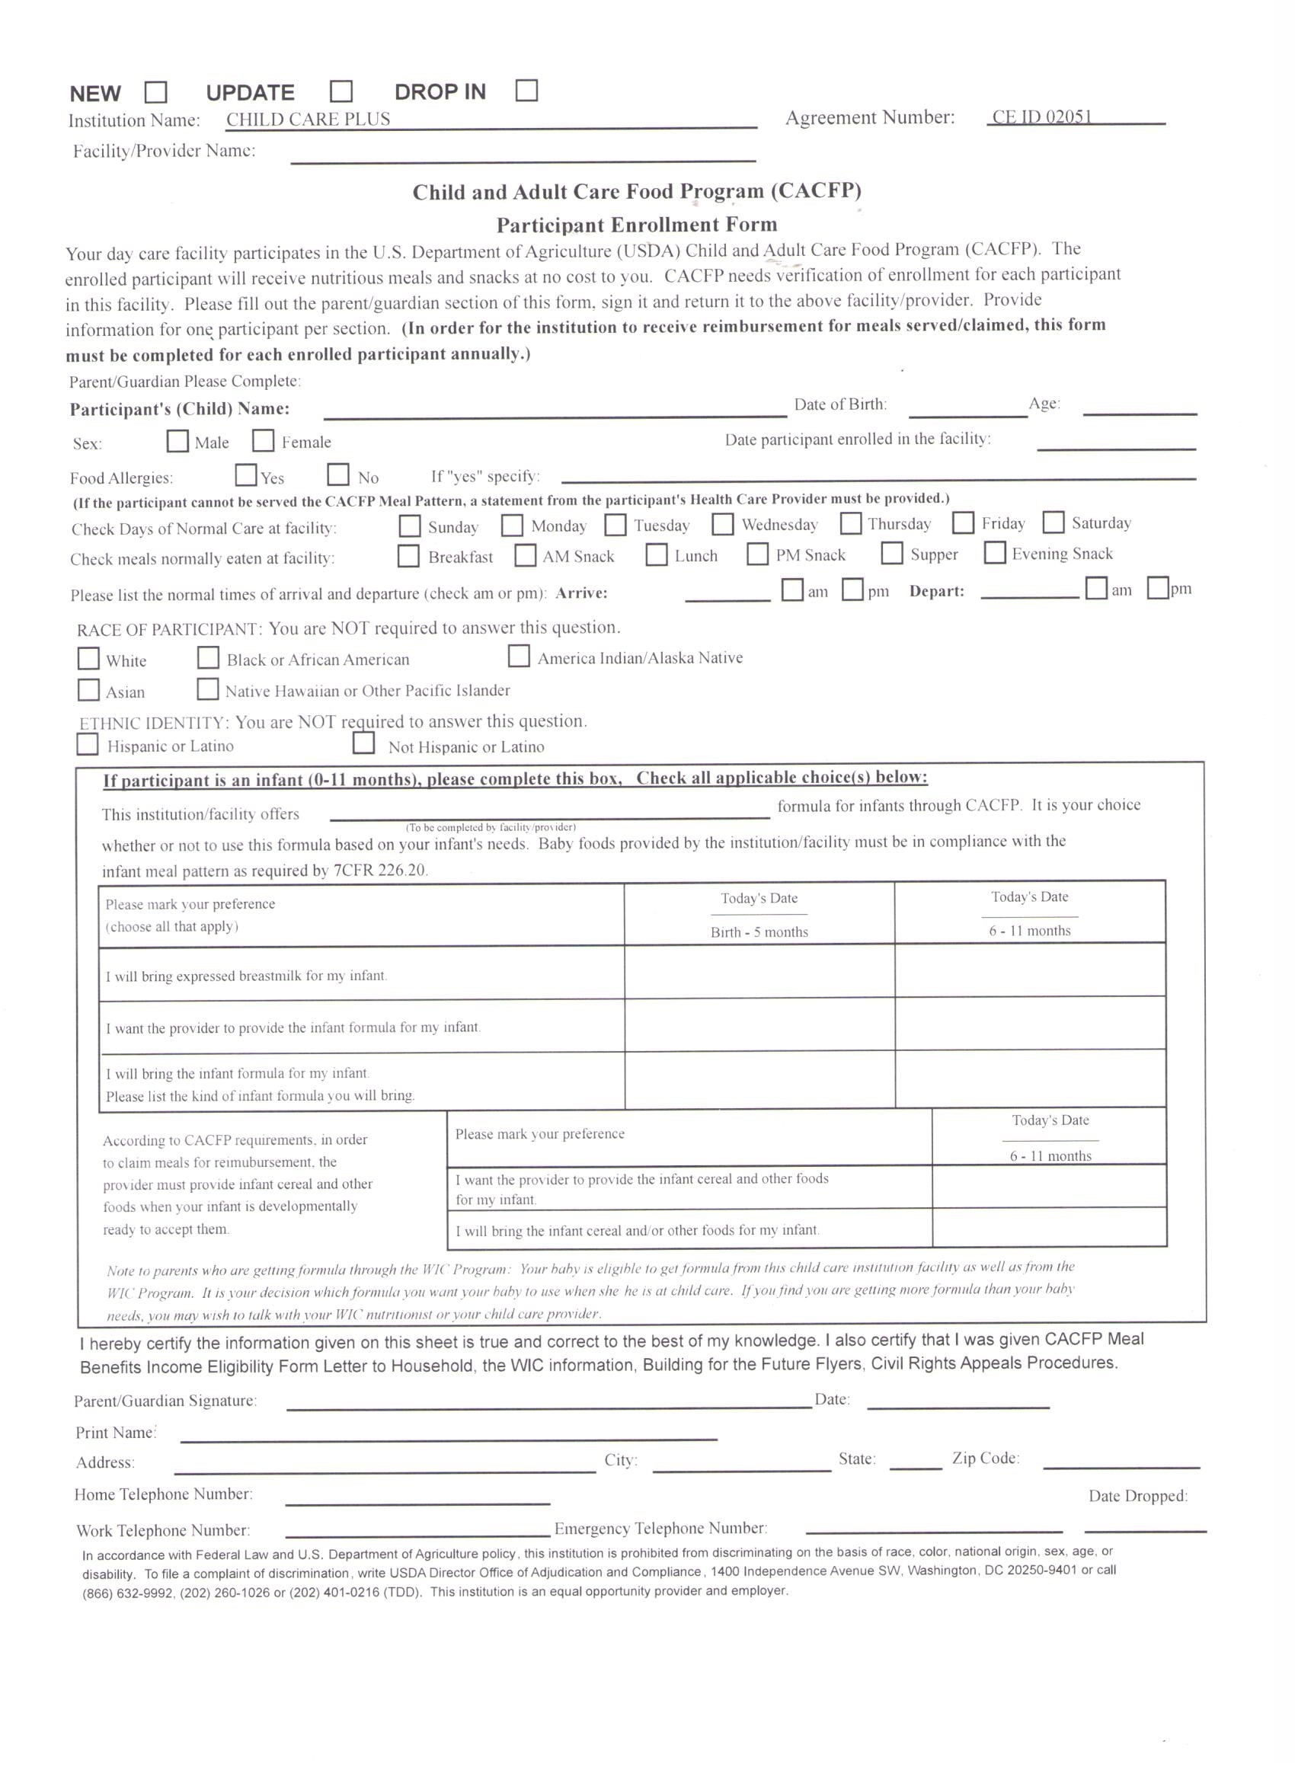

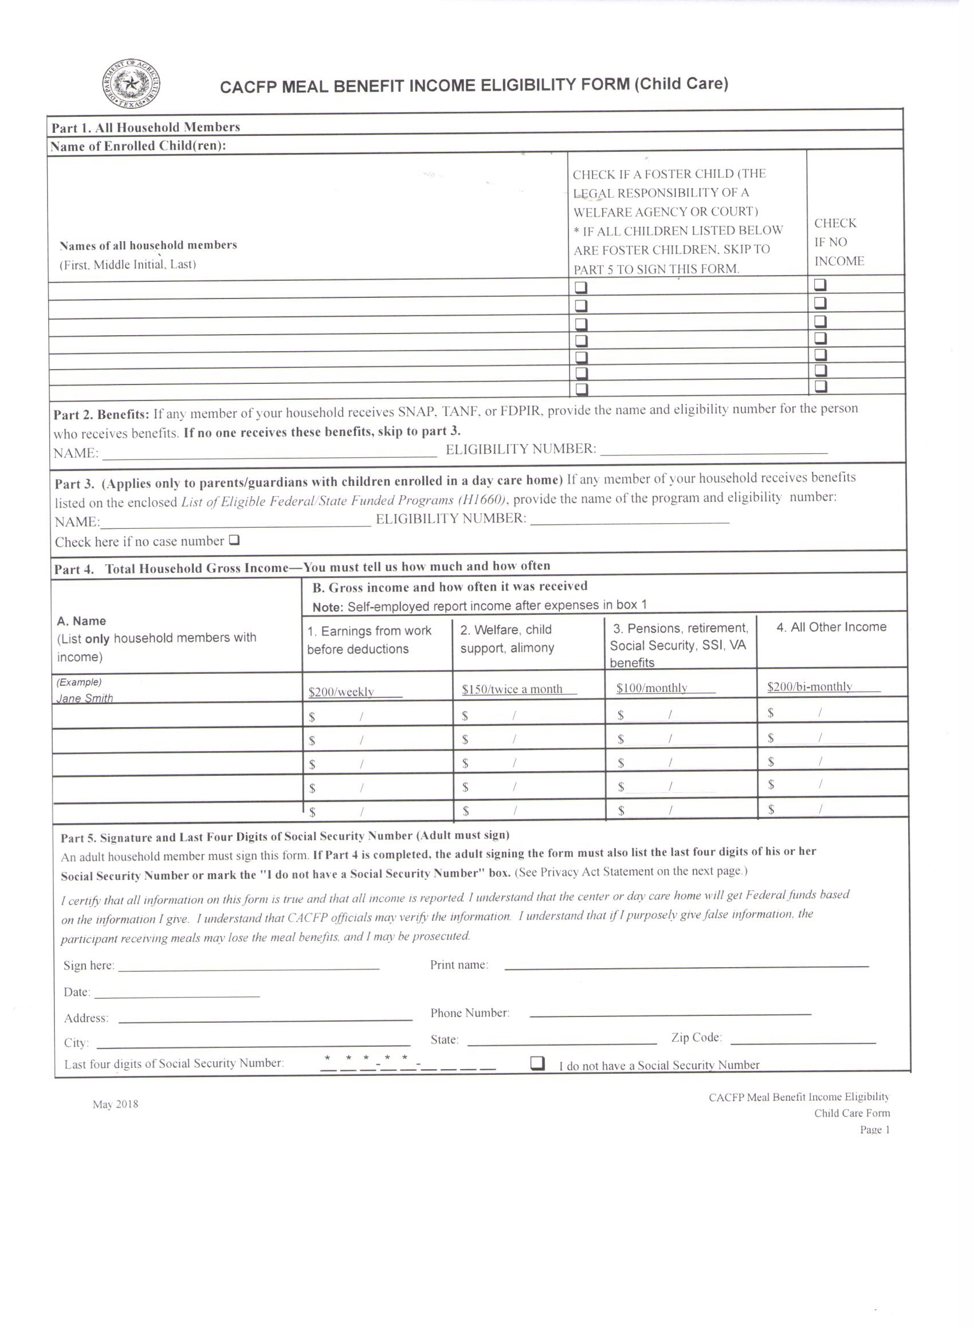

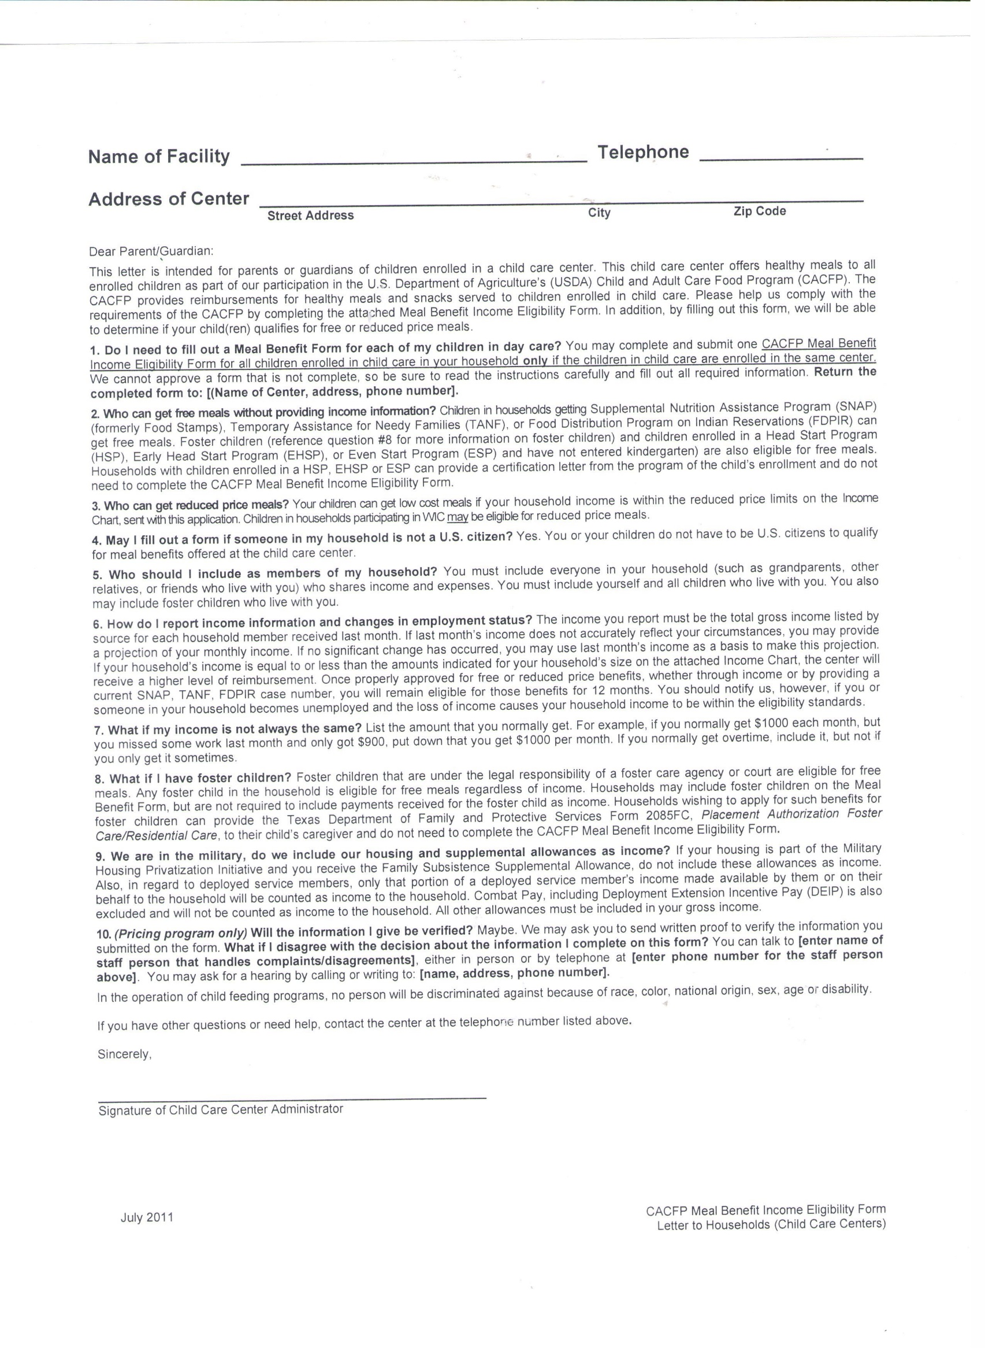

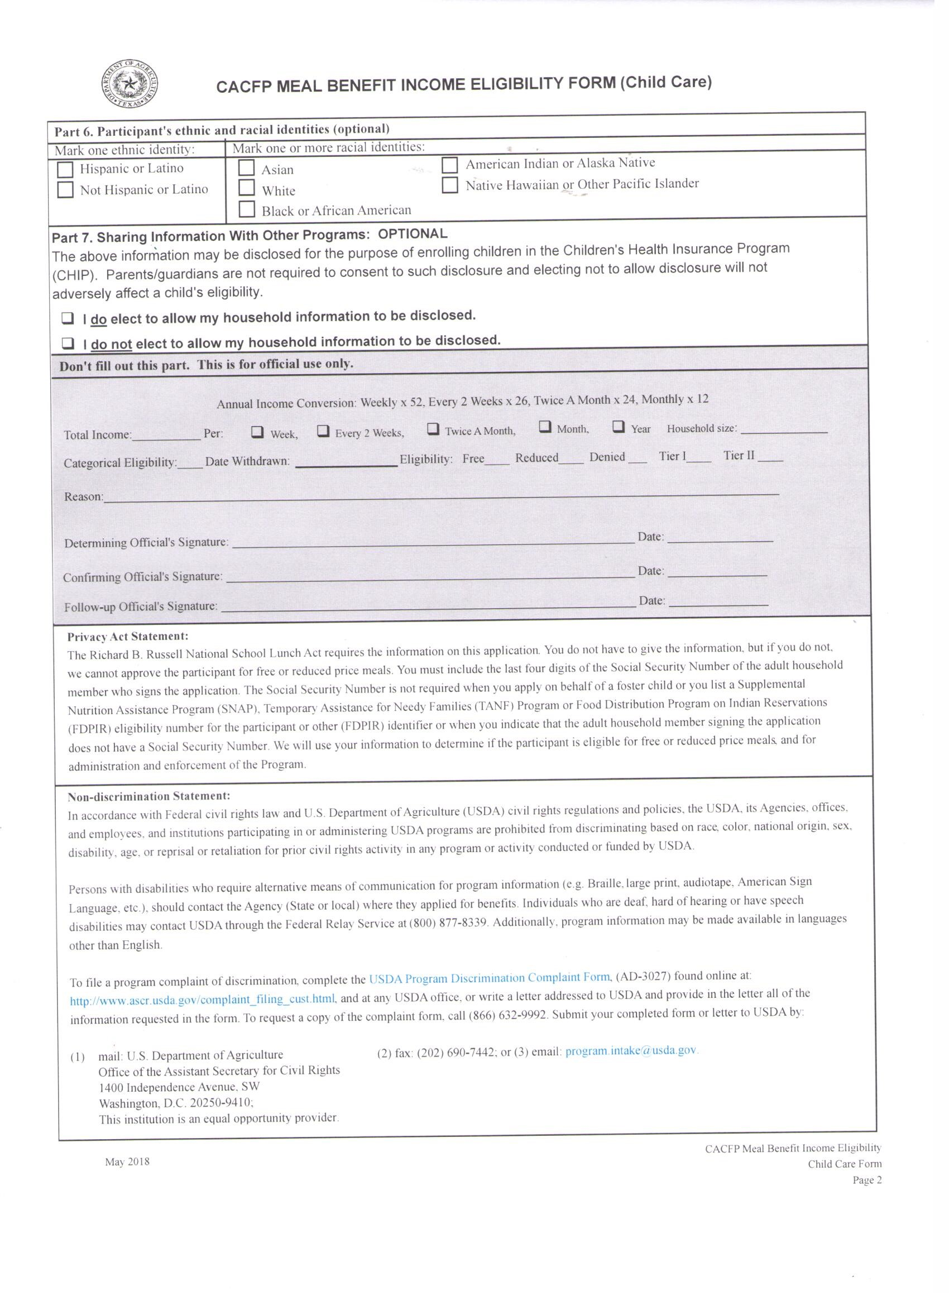

CHILDREN’S BIOGRAPHY (For children 4 and under)

These answers will help your child’s teacher better care for your child while they are here. Please answer as honestly as possible. No judgements are made.

Child’s Name: __________________________________________________ Birthdate:_______________________________

Does your child have any siblings? What are their names and ages? **________________________________________________**

**______________________________________________________________________________________________________**

**DISPOSITION**

How does your child react when you leave them?______________________________________________________________

What is your child’s normal disposition?_____________________________________________________________________

Does your child have any bad habits? _____________________________________________________________________

Are there any restrictions to play or activities?________________________________________________________________

Any speech / hearing /vision problems?_____________________________________________________________________

Has you child had any communicable diseases? If so, when?____________________________________________________

_____________________________________________________________________________________________________

Is your child prone to any illness (such as headaches, tummy aches, etc.)? **__________________________________________**

**EATING**

What are your child’s favorite foods? ______________________________________________________________________

What are your child’s least favorite foods?____________________________________________________________________

Does your child eat with utensils? Which one(s)?_______________________________________________________________

**SLEEPING**

What time does your child usually wake up?____________________________________________________________________

What is their mood when they wake up?________________________________________________________________________

What time does your child usually go to sleep at night?____________________________________________________________

What is their mood when they are put to bed?____________________________________________________________________

Does your child sleep through the night? _______________________________________________________________________

Where (on what) does your child sleep? _______________________________________________________________________

Does your child take a nap? If yes, when?______________________________________________________________________

**PERSONALITY TRAITS**

How is your child most easily settled?________________________________________________________________________

## What are your child’s favorite activities?______________________________________________________________

Has your child had experience playing with other children?_______________________________________________________

How does your child show when he/she is:

Afraid?_________________________________________________________________________________________________

Happy? ________________________________________________________________________________________________

Angry?_________________________________________________________________________________________________

Tired? _________________________________________________________________________________________________

Sick?___________________________________________________________________________________________________

What forms of discipline are most often used in your home?_______________________________________________________

How does your child feel about daycare?______________________________________________________________________

Are there any recent traumatic events that have occurred within your life that could affect your child? If yes, what?__________________________________________________________________________________________________

Does your child have any special toys, blanket, etc.? _________________________________________________________

**POTTY TRAINING (If applicable)**

If your child is potty trained, can he/she be relied upon to indicate bathroom needs?_____________________________________

Does your child have any fears relating to potty training? ________________________________________________________________________________________________________________________________________________________________________________________________________________

Does your child have any accidents? When? ___________________________________________________________________

What word does your child use for:

Bowel movements?_______________________________________________________

Urination?______________________________________________________________

Soiled Diaper?___________________________________________________________

**GENERAL**

What do you expect from childcare? _______________________________________________________________________

________________________________________________________________________________________________________

Any other comments/suggestions?_________________________________­­­­____________________________________________

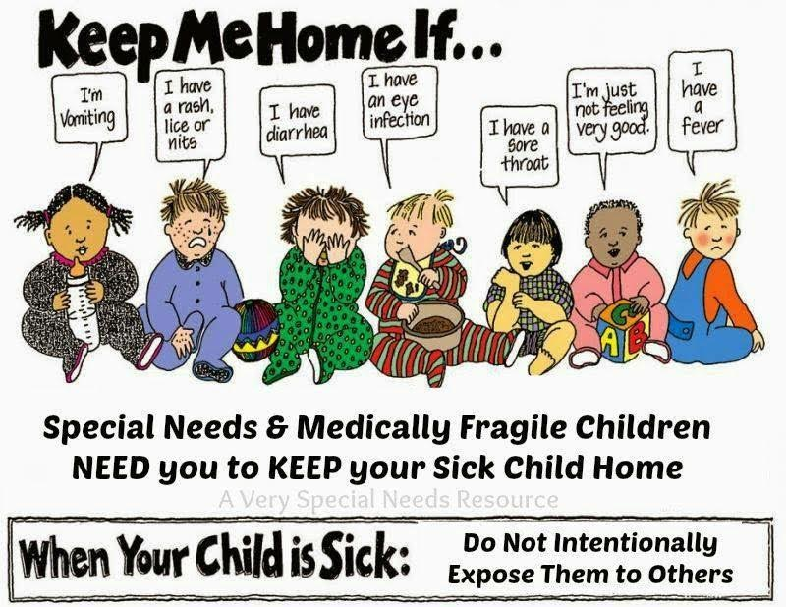



**Items your child will need upon enrollment here:**

* Completed Enrollment Packet
* Current Immunization Record
* Communicable Disease form signed by child’s physician (in enrollment packet)
* **Copy of current driver’s license for both parents/guardians**
* Nap Mat or Nap Mat Rental Fee ($10.00, this is a state mandated necessity)
* Beach Towel or Small Blanket. (No Pillows Please)
* Diapers, Wipes, Diaper Cream, Powder, etc., for toddler children.
* A bottle of spray-on sunscreen (optional) and 1 can of mosquito spray (not optional) **ONLY DURING SPRING/SUMMER MONTHS**
* 2 season appropriate changes of clothes in a gallon zip lock baggie.
* A backpack, tote bag or diaper bag. (Can stay here or be taken home each day)
* Jr. Preschool and Preschool aged children (2-5) will be required to have school supplies in September for the Pre-K class. A list will be handed out for that class when the time comes.

**Please be sure all items are labeled with your child’s name.**

Thank you for your cooperation!



Hi, my name is Monika Land, and I am the Acting Director for Building Blocks Childcare. I’d like to personally thank you for your inquiry in our childcare facility. I have been working with children since 2000 and have worked at this childcare center since 2003. I have 2 children of my own, a son who is active duty in the Army and a daughter in Highschool. I grew up in Kaposvar, Hungary and moved here in 1997 with my husband at the time. I have completed my Child Development Associate as well as countless hours of trainings so I am confident you and your child will have the best experience while they attend here.

Your child’s safety, education and development are priorities in my life, as they are in yours, and here at Building Blocks our teachers are trained to treat and encourage your child in each of these areas every day, from 12 months old to 12 years old.

Below is a small list of features that makes our center stand out from others in this area and reminders about some key policies. If you have any questions, please do not hesitate to ask. Thank you!

* **Center Hours 6:00am – 6:00pm Monday – Friday. Drop off by 9:00am each morning.**
* **Accredited by Collaborative for Children in the Texas Rising Star Program**
* **Smartcare software keeps you connected with the center and classroom.**
* **Excellent record with the State of Texas Childcare Licensing Division**
* **Webcams you and family members can access from your computer, tablet or smartphone to watch your child during the day.**
* **Large playground and proper teacher to child ratios.**
* **Well trained staff in each classroom.**
* **2 hot meals per day and a healthy afternoon snack. (Dinner served to school-age children after school) Outside food is not permitted.**
* **We follow the Creative Curriculum practices and use Mother Goose Time curriculum for classroom learning activities in order to prepare children for Pre-K & Kindergarten.**
* **School Transport to and from BP Hopper Primary and Highlands Elementary.**

**Keep in Touch!**

Please be sure all contact information is up to date at all times. If changes are made, please notify office personnel immediately.

---------------------------------------------------------------------------------

Please enter the following into your phone so you have it at all times:

**Phone:** 281-426-2221

**Email:** [highlands.bbchildcare@gmail.com](mailto:highlands.bbchildcare@gmail.com)

**Emergency Number:** 832-661-1845 (Monika’s Cell)

---------------------------------------------------------------------------------

**SmartCare! Parent App**

Please download the Smartcare Parent App. You will use your cell phone to clock your child in and out each day. You can also use the app to pay your bill, check your balance and account activity and keep up with activities in the classroom! **To download the parent app:**

1. You will receive an email from Smartcare Services
2. Click the link to setup your password and PIN. Your email will be your username.
3. Download the app from Google Play or the iOP Apple Store!

---------------------------------------------------------------------------------

