**ME Squared Enterprises, LLC**

**BUSINESS PLAN**

For

**Continuous Onboard Re-Charge Environment (CORE)**

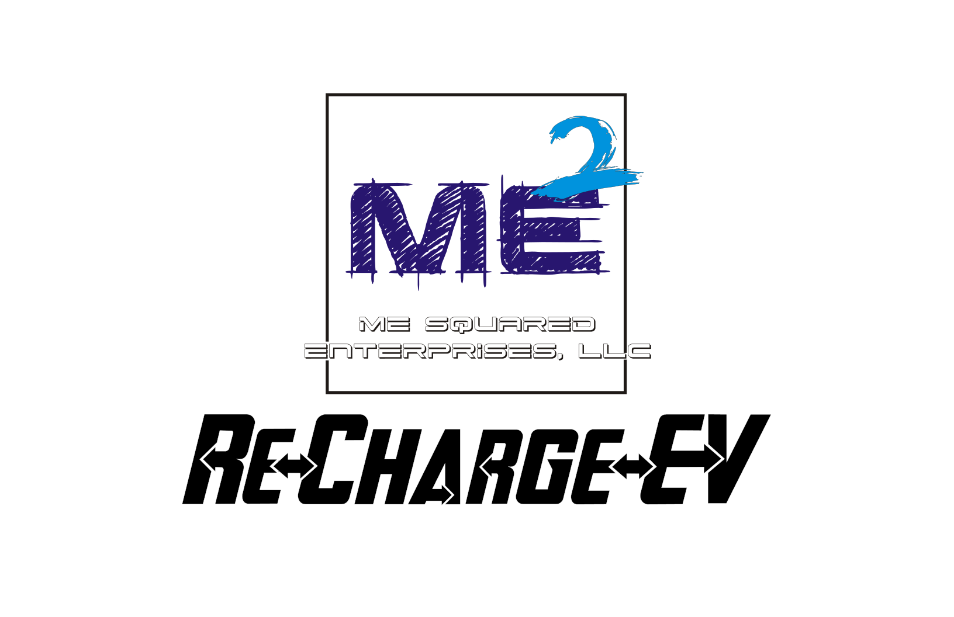

Raymond M. Folk

**President/CEO**

504 23rd St

Niceville, Florida 32578

8504965353

ray@mesqent.com.com

**I. EXECUTIVE SUMMARY**

Me Squared Enterprises LLC (referred to from hereon in as the "Company") was established as a S-corporation at 504 23rd St, Niceville, Florida 32578 with the expectation of rapid expansion in the renewable energy industry. The Company solicits financial backing to be able to introduce its new product (described below).

**Business Description**

The Company was formed on 02/28/2022 as S-corporation under Florida state laws and headed by Raymond M. Folk, Amy E. Folk.

The Company currently employs 2 full-time employee(s) and 0 part-time employee(s).

* Raymond M. Folk – President/CEO
* Amy E. Folk – CFO

**Management Team**

The Company has assembled an experienced management team:

**President/CEO** - Raymond M Folk

RF/Microwave, and Computer Engineer, with more than 38 years of proven experience and serves as the Primary Engineer/Designer on the project, handling all design, testing, prototyping. Mr. Folk currently serves as a Scientist & Engineer 4, for a Major Defense Contractor, serving the US Air Force, designing, and building a next-generation communications platform and previously as the Primary Weather Radar, Systems Upgrade Engineer. He has more than 38 years practical experience in radar and communications systems design and troubleshooting, as well as more than 30 years of experience in computer network design and management. Mr. Folk has been designing and working with low and high-voltage, AC and DC systems, for almost 4 decades with a proven track record of expertise. He has worked and consulted with engineers from many sectors, including MIT-Lincoln Laboratory (MIT-LL), US Navy, US Air Force, and the Federal Government.

**VP/CFO** – Amy E. Folk

Paralegal and Bookkeeper, with over 25 years’ experience and oversees the financial and legal aspects of the business. Mrs. Folk has more than 30 years of experience in accounting and bookkeeping as well as more than 20 years of paralegal experience. Her track record is well proven in both areas, and she is extremely capable of handling the financial side of the business.

**Business Mission**

Continuous Onboard Re-Charge Environment (CORE) – ***Patent No***.: **US 11,635,477 B2**, also dubbed Re-ChargeEV, is a

portable, mechanical-to-electrical voltage producing, onboard continuous charging technology, applicable to, but not limited to, fully-electric and hybrid-electric vehicles, electric aircraft/aerospace motor technology, marine electric propulsion systems as well as small and large-scale fully-electric portable/commercial generators.

***Notice: For purposes of this document, the terms EV and vehicle will be used to encompass all manner of auto, marine craft, and aircraft/aerospace vehicles, not just automotive.***

**New Product**

After a period of thorough trial and error, the Company is prepared to introduce the following product to the market:

***Continuous Onboard Re-Charge Environment (CORE)*** also dubbed Re-ChargeEV.

CORE has been developed to efficiently and inexpensively extend the range of current electric vehicles/crafts on the market, such as personal and commercial transportation, personal and commercial marine craft, and short and long-range electric aviation and aerospace vehicles.

CORE is designed to be extremely versatile and easily adaptable to any vehicle/craft utilizing electric drive motor ad shaft technologies. This includes small portable and commercial generators to Home Stand-By generators.

While primarily targeting vehicles used for medium and long-range driving or transportation, CORE can be applied to any electrical motor with a rotating shaft, battery array, and subsequent charging systems. The CORE system is equally adaptable to combustion-type vehicles being converted to either full-electric or hybrid-electric, as an after-market modification.

CORE works on the same principle of simultaneously charging a battery while in use, the same way laptops and other battery-powered equipment can operate while they are charging.

The Proof-of-Concept/Prototype is currently in the construction/build stage and requires further funding to fully complete and test. CORE works by providing equivalent voltages for the OEM charging systems, such as would be present with a commercial/home charging station, while the craft is in motion.

With further funding and R&D testing along with system tuning, the advantages that CORE can provide are virtually unlimited.

The CORE system is a technology designed to be integrated into current existing electric vehicle technology or future design to provide vehicle operational time and distance extension, depending on usage environment, with minimal to no

modifications to the OEM*'*s original vehicle design. It is intended to provide a constant and steady charging voltage to allow recharging of the existing Main Battery Array (MBA), while the vehicle is in motion, without the inefficiency and drawbacks of expending or using any of the vehicle*'*s battery voltage to produce the recharging voltages. It is designed to replicate the input charging energy as if the vehicle were parked and connected to an external charging station.

Currently battery drainage, limits todays EV drive life to a finite amount or time or distance, which is heavily dependent on many different variables, and while the systems can be “recharged” they must remain stationary to do so. CORE allows for the same “recharging” of the battery array while the vehicle is in motion. The amount of drive life enhancement can be between 5X to 10X or more, than the current limits and provide for much more economical and practical overall cost-of-ownership at the same time, dramatically reducing, carbon emissions and dependency on fossil fuels.

The key values would be, the environmental impact and the ability to deliver substantial increases in utilization and effectiveness of EVs and Hybrid EVs, as well as the ability to deliver such value while substantially decreasing cost, which should be able to translate into lower cost of goods/transportation costs, which would greatly help the economy.

The Company holds the following patents for this product:

**Continuous Onboard Re-Charge Environment (CORE) – Patent No.: US 11,635,477 B2**.

**Funding Request**

The Company requests an initial minimum investment/loan of $1,000,000.00 in exchange for 10-20% equity ownership in the Company. The funding proceeds will be used for the following, but not limited to, purposes: (See section IV. FINANCIAL PLAN)

* To hire additional "Key Personnel".
* Purchasing necessary supplies and products.
* Purchasing Production Equipment, to facilitate product manufacturing.
* Financing of adequate facilities to perform necessary work.
* Purchasing of "donor" equipment, for modification, for Proof-of-Concept and Production.

We expect to break-even within a 2-3 years’ time, following the introduction of our product.

**II. BUSINESS SUMMARY**

**Industry Overview**

In the United States, the renewable energy industry presently creates approximately 38% of the total Energy sales.

Sources: <https://www.eia.gov/totalenergy/data/monthly/>

<https://www.eia.gov/pressroom/releases/press481.php>

<https://www.eia.gov/renewable/annual/preliminary/>

<https://www.eia.gov/energyexplained/us-energy-facts/data-and-statistics.php>

<https://www.frontiersin.org/articles/10.3389/fsuep.2023.1174427/full#:~:text=Every%20year%20millions%20of%20retail%20electricity%20customers%20voluntarily,all%20retail%20electricity%20sales%20%28O%27Shaughnessy%20and%20Heeter%2C%202022%29>.

**EV/Hybrid Vehicle Market 2022-2030:**

The global electric vehicle market was valued at $163.01 billion in 2020, and is projected to reach $823.75 billion by 2030,

registering a CAGR of 18.2% from 2021 to 2030.

Source: <https://www.alliedmarketresearch.com/electric-vehicle-market>

**Global Aircraft Electric Motor Market 2026:**

The global aircraft electric motors market size is projected to grow from USD 8.4 billion in 2021 to USD 12.1 billion by 2026, at a CAGR of 7.4% from 2021 to 2026. The market is driven by various factors, such as increase in aircraft renewals and rise in development of UAVs and hybrid VTOLs.

Source: <https://www.marketsandmarkets.com/Market-Reports/aircraft-electric-motors-market-3248447.html>

**Marine Propulsion Market:**

The marine propulsion engine market was valued at USD 35.13 billion in 2021, and it is anticipated to reach USD 40.91 billion in 2027, while registering a CAGR of 2.63% during the forecast period (2022-2027).

The marine propulsion engine market is driven by the need for faster, cleaner, and fuel-efficient engines. The International

Maritime Organization (IMO) has drafted a new rule where the sulfur content in marine fuel will be reduced to 0.5% from 3.5%. This new regulation is expected to cut off emissions from ships by 77%. This has caused the ship operators to lower sulfur content fuels, such as marine gas oil, and it has also driven the demand for the electrification of marine vessels.

Source: <https://www.mordorintelligence.com/industry-reports/marine-propulsion-engine-market>

**Global Generator Market:**

According to Beyond Market Insights, The Global Portable Generator Market size was worth USD 4.69 Billion in 2022 and is estimated to grow to USD 7.3 Billion by 2030, with a CAGR of around 5.7 % over the forecast period from 2023 to 2030.

Source: <https://www.globenewswire.com/news-release/2023/04/05/2642050/0/en/Portable-Generator-Market-Set-to-Reach-New-Heights-in-Response-to-Increasing-Energy-Needs.html#:~:text=Opportunities%3A%201%20The%20growing%20demand%20for%20renewable%20energy,to%20develop%20new%20products%20that%20meet%20these%20requirements>

The U.S. generator sales market is projected to grow from $4.89 billion in 2021 to $6.94 billion in 2028 at a CAGR of 5.13% in forecast period, 2021-2028.

Source: <https://www.fortunebusinessinsights.com/u-s-generator-sales-market-106160>

**Market Research**

My research seems to show this is not being done on any scale at this time/date, as well as my being awarded the patent for this technology would seem to indicate.

The bulk of research seems to be going into battery improvements and regenerative-braking voltage recouping, which are great, but battery increases usually require larger cells, which equate to increases in battery array weight and the overall weight of the vehicle, which in turn negatively impacts performance, and in the case of regenerative-braking, doesn't recoup sufficient energy to recharge the battery system, just supplements it slightly, because this voltage is only produced when the brakes are being applied and when the electric motor is not being activated, which isn't all that often, in terms of long-distance driving.

Research shows that consumers in this industry primarily focus on the following factors when making purchasing decisions: (These are the Top Focuses, there may be more than is listed)

**In the Fully-EV/Hybrid-EV Market:**

[**Factors that influence EV buying behavior include**](https://www.sciencedirect.com/science/article/pii/S095965261934781X):

* Initial Pricing
* Total cost of ownership
* Driving experience
* Charging infrastructure availability
* Social influence
* Environmental awareness
* Affordability
* Availability
* Familiarity
* Vehicle range
* Refilling time

Sources:

<https://www.sciencedirect.com/science/article/abs/pii/S095965261934781X>

<https://www.greenbook.org/mr/insights/what-are-consumer-reactions-to-electric-vehicles/>

<https://www.sciencedirect.com/science/article/pii/S136192092200356X>

**In the Global Aircraft Electric Motor Market:**

[**Factors that influence Electric Aerospace buying include**](https://www.sciencedirect.com/science/article/pii/S095965261934781X):

* Total cost of ownership
* Operational Safety
* Charging infrastructure availability
* Social influence
* Environmental impact
* Affordability
* Availability
* Vehicle flying range
* Recharging time

Sources:

<https://www.weforum.org/agenda/2020/11/electric-planes-aviation-future-innovation/>

<https://www.weforum.org/agenda/aviation-and-travel>

<https://www.aviationtoday.com/2021/07/22/challenges-still-exist-certifying-electric-aircraft/>

<https://www.nrel.gov/docs/fy22osti/80220.pdf>

**In the Marine Propulsion Market:**

[**Factors that influence Electric Marine Propulsion buying behavior include**](https://www.sciencedirect.com/science/article/pii/S095965261934781X):

* Total cost of ownership
* Initial Pricing
* Operating experience
* Operational Safety
* Charging infrastructure availability
* Social influence
* Environmental awareness
* Affordability
* Availability
* Familiarity
* Vehicle range
* Refilling time

Sources:

<https://boatingindustry.com/blogs/2022/08/18/electric-boats-consumer-trends-and-5-tips-for-selling/#:~:text=When%20you%E2%80%99re%20highlighting%20benefits%20of%20electric%20boats%2C%20address,lack%20of%20electric%20boat%20infrastructure%2C%20and%20higher%20prices>.

<https://www.godownsize.com/electric-boat-problems/>

<https://www.tradeonlytoday.com/columns-blogs/e-pwc-are-almost-here>

**In the Global Generator Market:**

[**Factors that influence Electric Portable and Home Stand-By Generator buying include**](https://www.sciencedirect.com/science/article/pii/S095965261934781X):

* Total cost of ownership
* Driving experience
* Charging/Recharging Capabilities
* Operational Safety
* Social influence
* Environmental awareness
* Affordability
* Availability
* Familiarity

Sources - Portable:

<https://www.consumerreports.org/portable-generators/best-portable-generators-of-the-year-a6834235201/>

<https://www.consumerreports.org/home-garden/generators/buying-guide/>

<https://www.consumerreports.org/portable-power-stations/portable-power-stations-things-to-know-battery-inverter-generators/#:~:text=These%20pricey%20battery-powered%20devices%20are%20the%20only%20type,Portable%20...%205%205.%20They%20Don%27t%20Come%20Cheap>

<https://www.thisoldhouse.com/electrical/23493931/generator-buying-guide>

Sources – Home Stand-By:

<https://www.consumerreports.org/home-garden/generators/buying-guide/>

<https://www.tomsguide.com/news/should-you-get-a-home-generator-heres-the-pros-and-cons>

<https://generxgenerators.com/2019/02/26/whole-house-generators-6-things-you-need-to-know/>

<https://www.thisoldhouse.com/electrical/23493931/generator-buying-guide>

**Business Goals and Objectives**

**Short Term:**

To perfect and produce a quality product that delivers on economic performance, safety, reliability, and effectiveness.

**Long Term:**

To make this technology the "Gold-Standard" in future electric transportation and device manufacturing.

**Legal Issues**

The Company affirms that its promoters have acquired all legally required patents, but further Patent Trademark coverages may be sought.

**III. MARKETING SUMMARY**

**Target Markets**

*The Company's major target markets are as follows:*

* Fully-Electric/Hybrid-Electric Vehicle Market
* Global Aircraft Electric Motor Market
* Marine Propulsion Market
* Portable / Home Electric Generator Market

The estimated number of potential clients within the Company's geographic scope is: 10s of Millions.

**Distribution Strategy**

This technology and associated products are intended to be included with and/or distributed as both, part of the OEM manufacturing process and as After-Market Add-On products/features.

**Promotional Strategy**

The Company will promote sales using the following methods:

Online Advertising, TV/Radio Advertising, Print Ads, available media outlets.

**SWOT Analysis**

***Strengths***

CORE was developed in response to the need to efficiently extend the range of current electric vehicle types, such as personal and commercial, long-distance transportation, personal and commercial marine, and short and long-range electric aerospace vehicles.

CORE is designed and intended to be versatile and easily adaptable to include power generators, from small portables to commercial building suppliers.

While primarily targeting medium and long-range transportation, it is adaptable to any electrical motor with a rotating shaft, battery array, and subsequent charging systems. CORE works by providing equivalent voltages for the OEM charging systems that would be present with a commercial/home charging station. The CORE system is equally adaptable to combustion-type vehicles being converted to electric, as an after-market modification, as well.

The CORE system is a technology designed to be integrated into current existing electric vehicle technology or future design to provide vehicle operational time and distance extension, depending on usage environment, with minimal to no

modifications to the OEM*'*s original vehicle design. It is intended to provide a constant and steady charging voltage to allow recharging of the existing Main Battery Array (MBA), while the vehicle is in motion, without the inefficiency and drawbacks of expending or using any of the vehicle*'*s battery voltage to produce the recharging voltages. It is designed to replicate the input charging energy as if the vehicle were parked and connected to an external charging system.

With the continuing high prices for fossil fuels and our increased dependency on foreign fuel commodities, it has become

extremely important to improve the overall performance of today*'*s renewable energy platforms. To reduce our dependency, lower the cost of transporting goods, thereby lowering the price of goods to consumers, while still providing a substantial profit for business owners and distributors.

***Weaknesses***

There is not an apparent downside to the CORE System, as the technology was designed, that if any part fails, it would not interfere with the ***Normal*** operations of the vehicle. The system would revert back to its ***Standard Mode of Operation***, meaning the vehicle or device would operate just as originally intended, by the Original Equipment Manufacturer (OEM).

This technology is not intended to replace the necessity of a home or external charging system environment, but to

supplement and extend the overall range of these vehicles and reduce the dependency on both home and commercial

charging station infrastructures, as well as reducing the need for periodic stopping and charging of the vehicle. It is targeted at reducing the dependency and use of fossil fuels and greenhouse gasses, while improving one*'*s carbon footprint and the environment.

This technology is not intended or expected to perform well in stationary or "Stopped-Traffic" type conditions but does include means to overcome such conditions, such as the addition of Solar Panel and Auxiliary Battery Arrays, and future developments.

***Opportunities***

* EV/Hybrid Vehicle Market
* Global Aircraft Electric Motor Market
* Marine Propulsion Market
* Global Generator Market, both Portable and Home/Business/Industrial Standby
* Most electrical motor-driven devices
* Rural Farming Equipment
* Advancements in Clean Energy Initiatives and Businesses

***Threats***

The current looming threat to this technology would be from the Oil industry and the reduction of Fossil Fuels dependency, such as Crude Oil, Gasoline, Diesel, and Natural Gas.

**Services**

First-rate production, service, and reliability is to be the focus of the Company and a cornerstone of the brand's success, which is expected to create a loyal brand following and return business. All clients will receive conscientious, one-on-one, timely service in all capacities, be they transactions, conflicts, or complaints.

**IV. FINANCIAL PLAN**

**Purpose Amount**

|  |  |  |  |  |  |  |
| --- | --- | --- | --- | --- | --- | --- |
| **Item** | **Condition** |  | **One-Time Exp** | **No.** | **Monthly Exp** | **Annual Exp** |
| Electric Vehicle | New/Used |  | $80,000.00 |  |  |  |
| Electric Motor (Boat) | New/Used |  | $75,000.00 |  |  |  |
| W/ Batteries |  |  | $45,000.00 |  |  |  |
| Electric Aircraft Engine | New/Used |  | $80,000.00 |  |  |  |
| Electric Generator | Modified |  | $10,000.00 |  |  |  |
| Tools |  |  | $10,000.00 |  | $500.00 | $6,000.00 |
| Labor / Salaries (Monthly x 4) |  |  | $320,000.00 | 4 | $26,666.00 | $319,992.00 |
| Facilities Rental / Property Rental |  |  | $20,000.00 |  | $3,500.00 | $42,000.00 |
| Utilities |  |  | $3,000.00 |  | $1,500.00 | $18,000.00 |
| Computers/Software - R&D |  |  | $80,000.00 |  | $1,200.00 | $14,400.00 |
| Internet/Phone |  |  | $5,000.00 |  | $1,000.00 | $12,000.00 |
| Security (Property) |  |  | $16,000.00 |  | $300.00 | $3,600.00 |
| EV Charging Station x3 | New/Used |  | $3,500.00 | 3 | $10,500.00 | $126,000.00 |
| Marketing |  |  | $30,000.00 |  | $1,500.00 | $18,000.00 |
| CAD/3D Printing - R&D |  |  | $50,000.00 |  | $2,000.00 | $24,000.00 |
| Patent/Trademark Protections |  |  | $30,000.00 |  | $1,800.00 | $21,600.00 |
| Website Development |  |  | $10,000.00 |  | $2,000.00 | $24,000.00 |
| Office Expenditures |  |  | $3,000.00 |  | $500.00 | $6,000.00 |
| Test Equipment | New/Used |  | $140,000.00 |  | $2,000.00 | $24,000.00 |
| Research/Development (R&D) |  |  | $100,000.00 |  | $16,000.00 | $192,000.00 |
| Insurance / Health Insurance |  |  | $200,000.00 |  | $5,000.00 | $60,000.00 |
|  |  |  |  |  |  |  |
| **Totals:** |  |  | $1,310,500.00 |  | $75,966.00 | $911,592.00 |
| **Startup Totals:** |  |  | $1,310,500.00 |  | $1,386,466.00 | $1,386,466.00 |
| **Recurring Totals:** |  |  |  |  | $75,966.00 | $911,592.00 |
|  |  |  |  |  |  |  |
| Requested Loan/Grant Amount |  |  |  |  |  | $1,500,000.00 |
| Misc Available |  |  |  |  |  | $588,408.00 |

**V. APPENDIX-1 - DIAGRAMS**

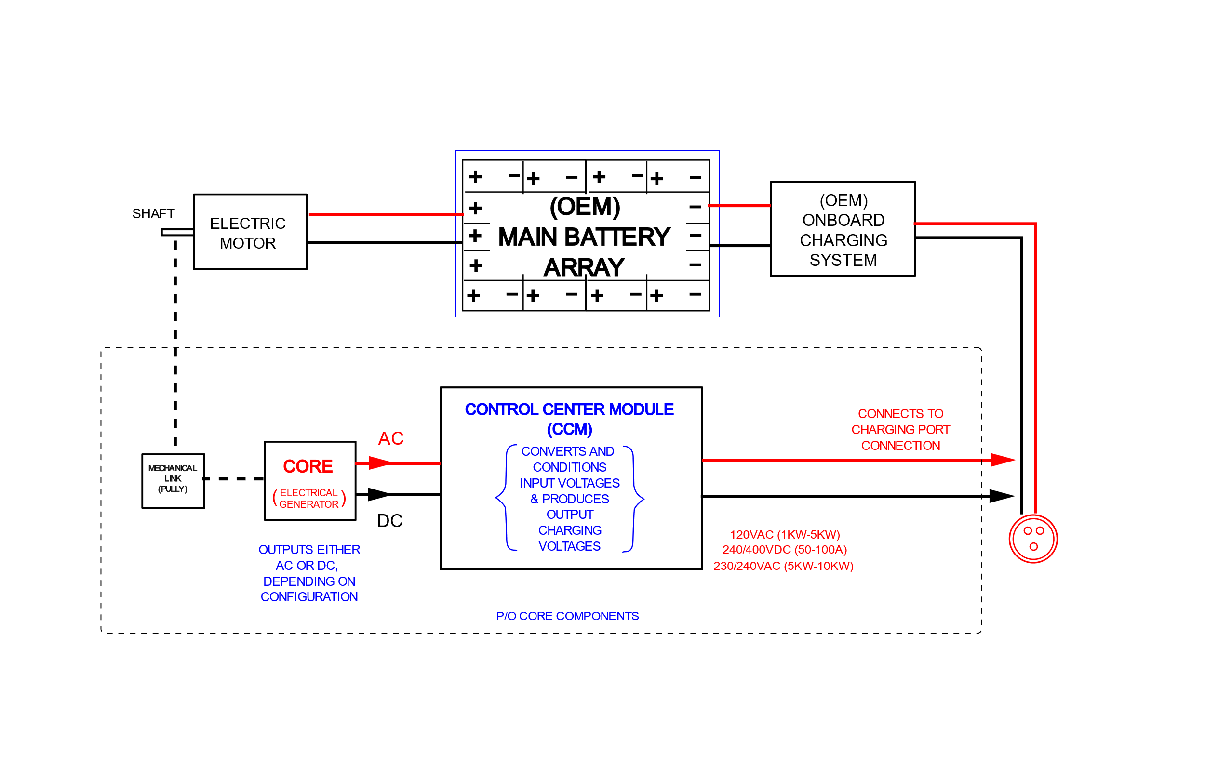

**Basic Block Diagram**

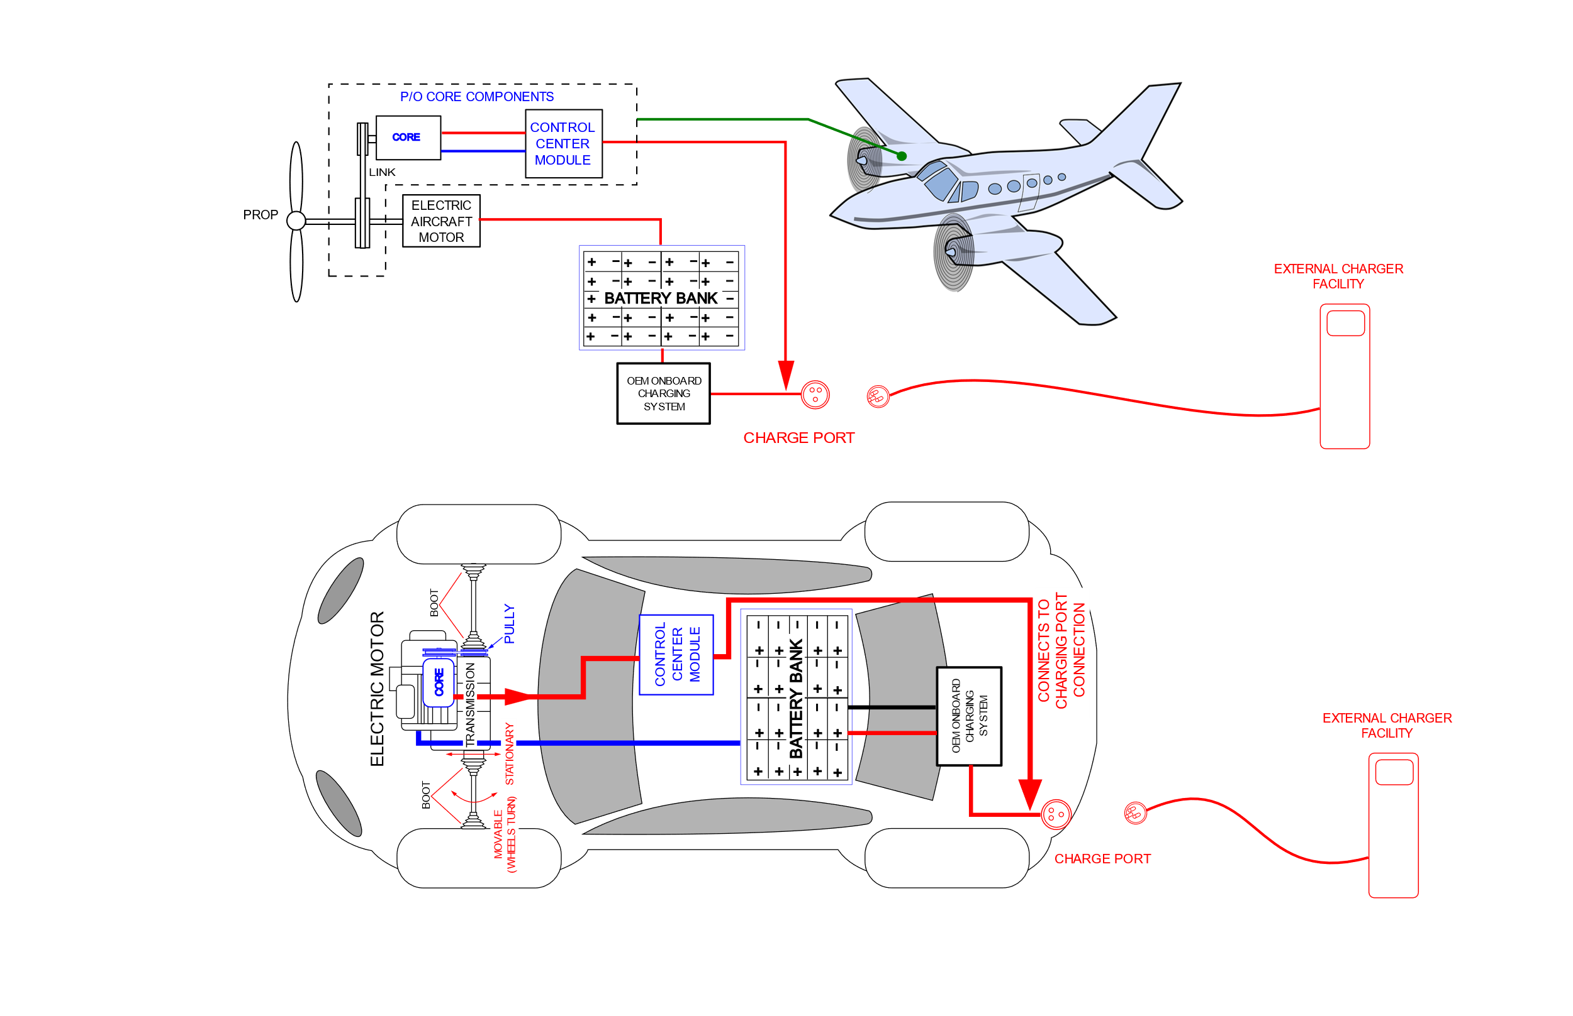

**Assembly and Connection Block Diagram 1**

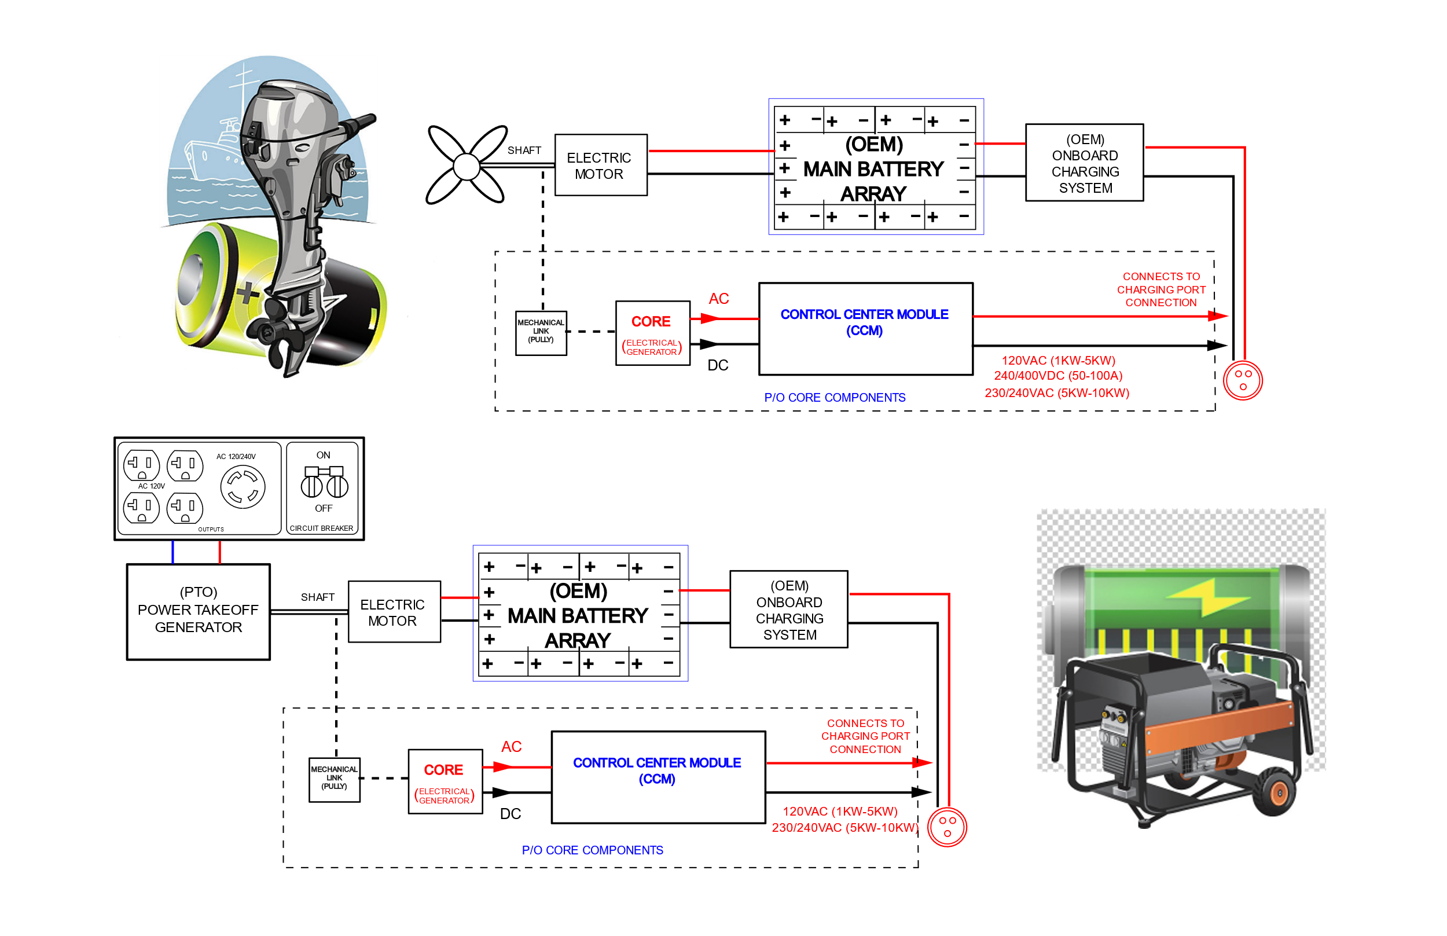

**Assembly and Connection Block Diagram 2**

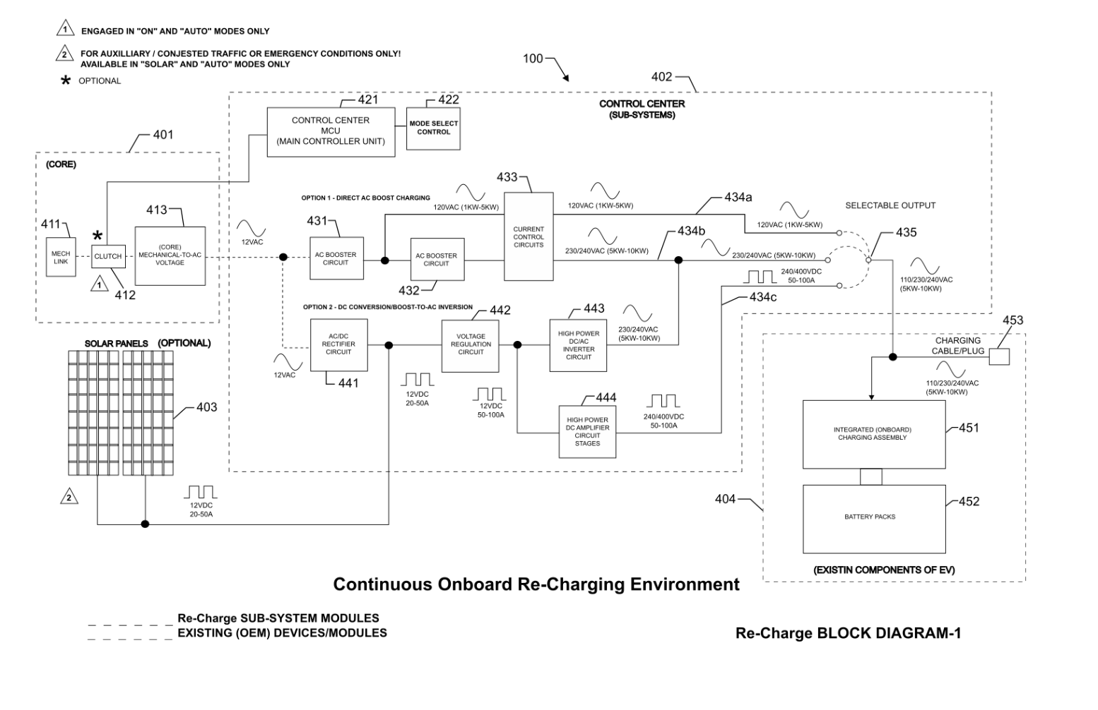

**CCM Block Diagram 1**