
“Welcome to Worship”
God is here for you,
In the word and sacraments, in the love of this community.

Welcome! Great to have you here! Thank you for choosing to worship with us at First Lutheran today.

18th Sunday after Pentecost
October 9th, 2022

GOD’S PEOPLE GATHER

Ministers: Members of First Lutheran Church
Pastor: Pastor Ann Zastrow
Organist: Paul Henriksen
Sound: Brandon Willey & Mark Zinnel
Reader: Dave Dulas
Acolyte:

CONTACT: 401 7th Ave SW,
Pipestone, MN 56164 507.825.5837
Email:
office @firstlutheranpipestone.org
Website: www.firstlutheranpipestone.org
Facebook: Google First Lutheran Church Pipestone Fb & hit the Fb link on the webpage

Scattering seeds of love
worship & service

Welcome/Announcements
Call to Worship: P: The Holy Spirit calls us together as the people of God. C: Amen.
Opening Hymn: #693 – Come Ye Thankful People Come

Confession and Forgiveness

P: God of all mercy and consolation, come to the help of your people, turning us from our sin to live for you alone. Give us the power of your Holy Spirit that we may confess our sin, receive your forgiveness, and grow into the fullness of Jesus Christ, our Savior and Lord.

C: Amen.
P: Most merciful God,
C: we confess that we are captive to sin and cannot free ourselves. We have sinned against you in thought, word, and deed, by what we have done and by what we have left undone. We have not loved you with our whole heart; we have not loved our neighbors as ourselves. For the sake of your Son, Jesus Christ, have mercy on us. Forgive us, renew us, and lead us, so that we may delight in your will and walk in your ways, to the glory of your holy name. Amen.

P: In the mercy of almighty God, Jesus Christ was given to die for us, and for his sake God forgives us all our sins. As a called and ordained minister of the church of Christ, and by his authority, I therefore declare to you the entire forgiveness of all your sins, in the name of the Father, and of the ☩ Son, and of the Holy Spirit. C: Amen.

Kyrie: Page 147
Hymn of Praise: Page 148

Prayer of the Day
P: Let us pray.
C: Almighty and most merciful God, your bountiful goodness fills all creation. Keep us safe from all that may hurt us, that, whole and well in body and spirit, we may with grateful hearts accomplish all that you would have us do, through Jesus Christ, our Savior and Lord. Amen

Hearing God’s Word

First Lesson: 2 Kings 5:1-15c
Naaman, commander of the army of the king of Aram, was a great man and in high favor with his master, because by him the LORD had given victory to Aram. The man, though a mighty warrior, suffered from leprosy. Now the Arameans on one of their raids had taken a young girl captive from the land of Israel, and she served Naaman's wife. She said to her mistress, "If only my lord were with the prophet who is in Samaria! He would cure him of his leprosy." So Naaman went in and told his lord just what the girl from the land of Israel had said. And the king of Aram said, "Go then, and I will send along a letter to the king of Israel."
He went, taking with him ten talents of silver, six thousand shekels of gold, and ten sets of garments. He brought the letter to the king of Israel, which read, "When this letter reaches you, know that I have sent to you my servant Naaman, that you may cure him of his leprosy." When the king of Israel read the letter, he tore his clothes and said, "Am I God, to give death or life, that this man sends word to me to cure a man of his leprosy? Just look and see how he is trying to pick a quarrel with me." But when Elisha the man of God heard that the king of Israel had torn his clothes, he sent a message to the king, "Why have you torn your clothes? Let him come to me, that he may learn that there is a prophet in Israel." So Naaman came with his horses and chariots and halted at the entrance of Elisha's house. Elisha sent a messenger to him, saying, "Go, wash in the Jordan seven times, and your flesh shall be restored and you shall be clean." But Naaman became angry and went away, saying, "I thought that for me he would surely come out, and stand and call on the name of the LORD his God, and would wave his hand over the spot, and cure the leprosy! Are not Abana and Pharpar, the rivers of Damascus, better than all the waters of Israel? Could I not wash in them, and be clean?" He turned and went away in a rage. But his servants approached and said to him, "Father, if the prophet had commanded you to do something difficult, would you not have done it? How much more, when all he said to you was, 'Wash, and be clean'?" So he went down and immersed himself seven times in the Jordan, according to the word of the man of God; his flesh was restored like the flesh of a young boy, and he was clean. Then he returned to the man of God, he and all his company; he came and stood before him and said, "Now I know that there is no God in all the earth except in Israel; please accept a present from your servant." Here ends the first lesson. C: Thanks be to God.

Psalm 111:
Hallelujah! I will give thanks to the Lord with my whole heart, in the assembly of the upright, in the congregation.
C: Great are your works, O Lord, pondered by all who delight in them.
Majesty and splendor mark your deeds, and your righteousness endures forever.
C: You cause your wonders to be remembered; you are gracious and full | of compassion.
You give food to those who fear you, remembering forever your covenant.
C: You have shown your people the power of your works in giving them the lands of the nations.
The works of your hands are faithfulness and justice; all of your precepts are sure.
C: They stand fast forever and ever, because they are done in truth and equity.
You sent redemption to your people and commanded your covenant forever; holy and awesome is your name.
C: The fear of the Lord is the beginning of wisdom; all who practice this have a good understanding. God’s praise
endures forever.
The word of the Lord. C: Thanks be to God.

Second Lesson: Timothy 2:8-15
Remember Jesus Christ, raised from the dead, a descendant of David - that is my gospel, for which I suffer hardship, even to the point of being chained like a criminal. But the word of God is not chained. Therefore, I endure everything for the sake of the elect, so that they may also obtain the salvation that is in Christ Jesus, with eternal glory. The saying is sure:
If we have died with him, we will also live with him; if we endure, we will also reign with him; if we deny him, he will also deny us; if we are faithless, he remains faithful - for he cannot deny himself.
Remind them of this, and warn them before God that they are to avoid wrangling over words, which does no good but only ruins those who are listening. Do your best to present yourself to God as one approved by him, a worker who has no need to be ashamed, rightly explaining the word of truth.
Here ends the second lesson. C: Thanks be to God.

P: Please stand in honor of the reading of the gospel.

The Holy Gospel is taken from Luke 17:11-19
C: Glory to you O Lord.
On the way to Jerusalem Jesus was going through the region between Samaria and Galilee. As he entered a village, ten lepers approached him. Keeping their distance, they called out, saying, “Jesus, Master, have mercy on us!” When he saw them, he said to them, “Go and show yourselves to the priests.” And as they went, they were made clean. Then one of them, when he saw that he was healed, turned back, praising God with a loud voice. He prostrated himself at Jesus’ feet and thanked him. And he was a Samaritan. Then Jesus asked, “Were not ten made clean? But the other nine, where are they? Was none of them found to return and give praise to God except this foreigner?” Then he said to him, “Get up and go on your way; your faith has made you well.”
The Gospel of the Lord. C: Praise to you, O Christ.

Children’s Sermon

Sermon

Hymn of the Day: Come To the Water of Life
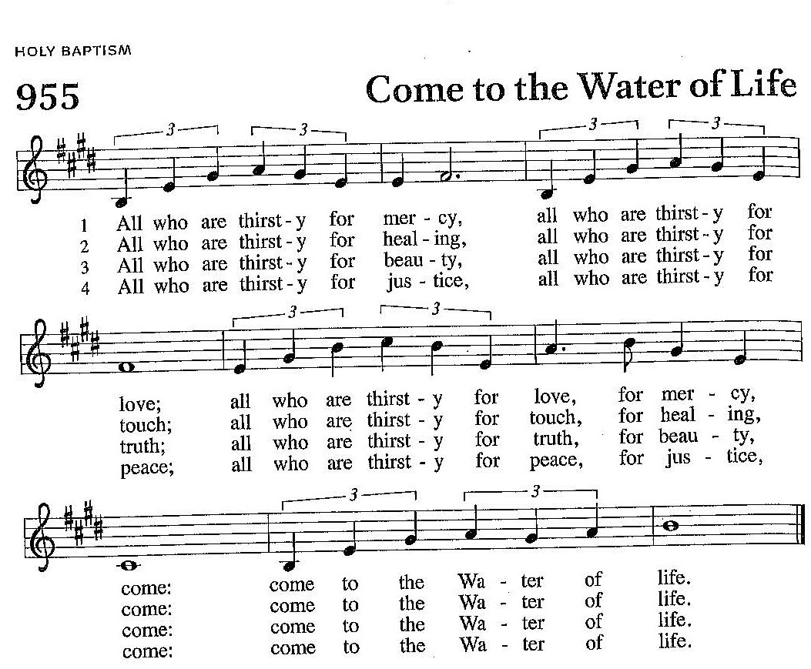

Responding to God’s Word
Apostles’ Creed

Prayers of the Church
P: Lord in your mercy, C: Hear our prayer

Offering / Offering Hymn: #801 – Change My Heart, O God

Offering Prayer
P: Let us pray.
C: God our provider, you have not fed us with bread alone, but with words of grace and life. Bless us and these your gifts, which we receive from your bounty, through Jesus Christ our Lord. Amen.

Lord’s Prayer
God’s People Sent Forth
Benediction
P: The Lord bless you and keep you. The Lord’s face shine on you with grace and mercy. The Lord look upon you with favor and ☩ give you peace. C: Amen.

Sending Hymn: #845 – Voices Raised To You (verses 1, 2 & 5)

Dismissal
P: Go in peace. Christ is with you. C: Thanks be to God.

Welcome! Great to have you here! Thank you for choosing to worship with us here today.

The Worship Radio Broadcast today is sponsored by Lori Ilse in honor of her kids and grandkids.

✞ Continuing Prayer Concerns: Janice Harkema and Jeanine Olson as they deal with health issues.
*** If you or someone you know has a Prayer Concern, please call the church office 825-5837 to have it listed in the bulletin and church webpage. Please email the church office@firstlutheranpipestone.org or call 825-5837 when someone is no longer needed to be on the prayer concerns list.

This Week’s Schedule (October 9th to Oct. 16th)
Today 9:30am Worship at the church & live streamed
Wednesday 6:15pmLIFT; 8:00pm Church Council meeting
Thursday 9:30am Quilting
Sunday 9:30am Worship/Holy Communion at the church & live streamed

October 2022 Offering
Monthly Income Needed to Operate | $17,800.00
Weekly Offering – Oct. 3rd | $7,342.33
Other Income – Parsonage – Oct. 3rd | $8,025.00

Additional offering envelope books are available on the table in the narthex. Please feel free to take another book if you are running low or contact the church office if you would like one sent to you!! Simply Giving is also available online. Contact the church office if you would like more information.

You are invited to the Fall Harvest Chicken Supper at Our Savior’s Lutheran in Flandreau on Sunday October 23rd from 4:00pm – 7:00pm. Menu: Fried chicken, real mashed potatoes & gravy, corn, molded salad, rolls/butter, pie/ice cream & coffee/drinks. Adults - $12; Kids (5-7) - $7; kids (4 & under) – FREE.

HELP WANTED!!! We are in looking for a Treasurer for First Lutheran Church. Knowledge of QuickBooks would be beneficial. Please contact the church office or Nancy Johnson if interested.

LIBRARY VOLUNTEERS NEEDED for the church library – We would like to update our church library in the Fireside room. We are looking for 2 volunteers to go thru the books that we currently have and to sort through them. Any books that need to be discarded, will either be sold, given away or recycled depending on their condition, etc. If you would be interested, please contact the church office.


IT’S TIME TO UPDATE OUR CHURCH DIRECTORY!!!!
This directory will all be done online! There are no sales and at no cost to you, the member. You simply submit a picture online and your family info and you are done. If you would be interested in helping with this project, please contact the church office. If you would like more information, please scan the QR code with your phone or go to https://members.instantchurchdirectory.com/


THE BANQUET
First Lutheran Church will be serving at the Banquet in Sioux Falls (west side) on Wednesday, October 26th . Please mark that date on your calendar. Keep watching for additional information as it becomes available.

Parsonage Project:
We are so thankful to have our new pastor in our parsonage and we are making progress with the project. Please consider donating toward the $80,000 project. Identify your check as going toward the parsonage project. We are lucky to be debt free as a church and would like to pay for the remodel entirely through generous donations from our members and from funds available in accounts held within the church. Having an updated home for our Pastor supports our ministry in the community. Please consider contributing to our mission in this way. The total amount donated to this date is $47,120.00. Thank you for your support of this mission.

Noisy Offering is currently being collected for: the Burkard family
The total amount collected for the Burkard family to this date is $3010.51. Thank you for your support of these important Outreach needs.

Fair Trade Close Out Sale “2 FOR 1”

Coffee 2-$9
Chocolate bars 2-$4
Teas 2-$4
Cups 2-$9

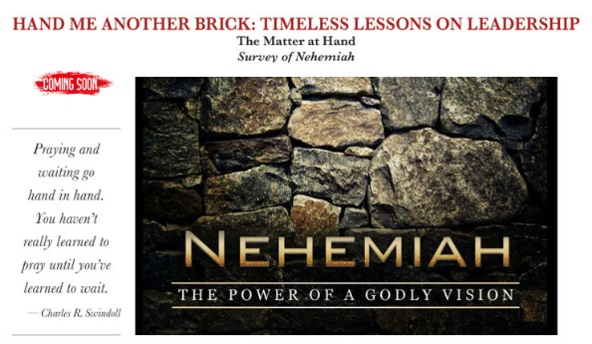

Books are available in the church office.
Cost is $10. The book study will begin
TODAY following worship.

First Lutheran Church “Partners in Ministry”
“Partners in Ministry” is a new program that is beginning at First Lutheran. We are excited to share with you that we have people who will be making home visits, provide a listening ear, and prayer support to members of First Lutheran Church. The “Partners in Ministry” servants are also willing to bring communion to people who are unable to attend worship. These volunteers are here to serve the greater community of First Lutheran. Are you facing surgery and want prayer? We are here for you. Would you like a friendly visitor to share in your journey of faith and life? We are here for you. Call the church office 825-5837 to find out more information. The people who are willing to serve as your “Partners in Ministry” are:
Nancy Finzen Carol Johnson Becky Kaffar
LaDonna Myers Mavis Pierson Judy Stubbe

Copyright permission for Hymns - One License # 727272 A
Copyright permission for Contemporary music - CCLI license # 11529036 A
Copyright permission for liturgy from Augsburg Fortress (Sundays & Seasons) license # SAS103

