BIGFOOT / CRYPTID 101:
There are many ways to investigate Bigfoot and other Cryptids. Some of the best methods that have been beneficial for my team over the years is common sense. Interviewing total strangers about something they may or may not have seen is difficult and there will be many times that you will think the person that you are talking to is certifiable. This is normal for Cryptid Investigators. The best thing to do in a situation like this is to take the report and keep it for your own archives. Many times, in an investigation you may hear things that sound completely ridiculous and unbelievable. However, the things you are hearing may be true. The following is a list of common behaviors for Bigfoot and other Cryptids:
Tree knocks
Wood knocks (two pieces of wood being struck together)
Tree Glyphs
Wood Glyphs anywhere on the property
Rocks being clapped together
Livestock disappearing
Food for livestock disappearing
Pets go missing
Food for pets goes missing
The feeling that you are being watched
Seeing shadows in the wood or tree line
Hearing strange noises at night or during the day that cannot be explained
Rocks being thrown at the House, Barn or other structures on the property
Thumps or slaps on the side of the House or other buildings on the property
Noises on the roof of the House or other buildings on the property
Rocks or small branches being thrown at property owners
Rocks being stacked in piles
Gifts of sticks or small animals that cannot be explained
A horrible or repugnant smell that comes from no where
Foot, hand or body prints that are unusually large
Garbage cans moved or missing, outdoor furniture missing or damaged, children’s toys moved or damaged
There are many other things that Cryptids may do this is just a small reference list that can be used to establish the possible presence of a Cryptid. If you find evidence always take at least three pictures of everything. The following list of items are the essentials for a Cryptid Investigator to have while doing a daytime investigation with at least one other person, for no more than three hours that does not involve hiking more than 25 yards into the woods, or tree line.
Cell phone
Protection (firearms are preferred but only if you are properly trained and licensed)
Note pad, pen or pencil
Tape measure
Small offerings (I use marbles, some people suggest food or sugary snacks, I don’t approve of that we don’t know what sugar does to Cryptids)
Flashlight
Digital recorder
Camera and equipment extra batteries, tripod etc.
Video Camera
Casting plaster
Water
Snacks
Compass
Maps of the area (try to get the most current one)
Gloves and a plastic bag for DNA and hair samples
If you are doing an overnight investigation for no more than three nights, the following items are also very necessary:
Food
Water
Camping equipment, tent, sleeping bag etc.
Weatherproof materials, like tarps

Rope or paracord
Extra batteries, flashlights, and glowsticks
Fire starting materials
Utility knife or tool
Extra maps and compass
Proper clothing
A GPS transponder
Extra ammunition if applicable
Always tell someone where you are going and when you will be back. Give them an amount of time to use as a buffer like three hours and if you have not contacted them, have your contact person alert the authorities. If things go bad time is not your friend, stay put if you can and let help find you.
NEVER EVER DO MORE THAN WHAT YOU FEEL YOU CAN. DON’T OVER ESTAMATE YOUR OWN ABILITIES. ALWAYS STAY CALM AND THINK!
As a Cryptid Investigator your best piece of equipment, is also your best weapon; it’s your own brain. This is true if you are 25 miles in the woods or if you are taking a report from a stranger in a trailer park off a major Interstate Highway.

Copyright © 2019 Asheville Cryptid And Paranormal Society, LLC. - All Rights Reserve

Asheville Cryptid And Paranormal Society, LLC

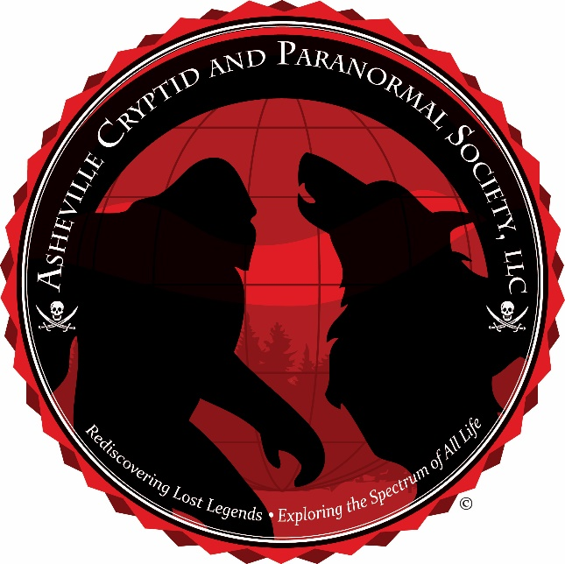
Mission Statement
The Asheville Cryptid And Paranormal Society LLC (A.C.A.P.S.) is dedicated to "Rediscovering Lost Legends; and Exploring the Spectrum of All Life." Our organization is open-minded and courteous towards every view of the cryptid and paranormal experience. The A.C.A.P.S. is based on the principals of rational science, with the use of the scientific method approach as the basis to every research endeavor. With over twenty-four years of dedicated experience in the investigative research of Cryptid and Paranormal Activity, we strive to offer the highest education in these areas, with our top priority being client safety and confidentiality.

Group Biography
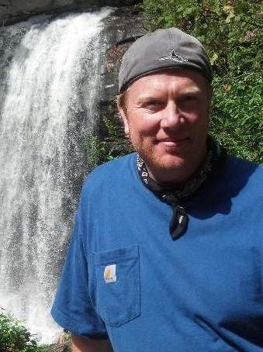
Christian MacLeod, Director and Lead Investigator of the A.C.A.P.S., has over twenty-four years of experience investigating Cryptid and Paranormal activities. With a passion for studying and preserving The Native American Tribe culture, folklore, and legends, he also knows about dealing with topics such as The Occult, UFO’s, Forbidden Archeology, The Freemasons, The Knights Templar, Secret Societies and many other Governmental cover-up allegations and Conspiracy theories.
Christian holds a Bachelor’s level degree in Psychology and minor in Criminology from the University of South Florida, and an advanced Masters of Arts and Teaching Degree from Western Carolina University, Christian is currently finishing a second Master’s Degree in American History from Western Carolina University and plans to continue into a PhD. program.

The Asheville Cryptid And Paranormal Society, LLC has worked in conjunction with Joshua P. Warren for many years in the effort to study fringe phenomena and discover scientific explanations to that which cannot be explained. This relationship has put the A.C.A.P.S. and Joshua. P. Warren on the forefront of many successful research endeavors and expeditions. Most currently this professional will lead to the uncovering a hidden tunnel system under the city of Asheville, North Carolina.
Alongside Joshua P. Warren, the A.C.A.P.S. has been working closely with Daniel “Tiny” Hurst, co- founder and lead investigator of M and D Paranormal and Cryptid Research, LLC to research, give credence too, and assist the clients of Western North Carolina with regards to their reports of Cryptid and Paranormal Activity. All three entities take great care in providing respect to their clients as well as the grounds and property on which they research. All reports are backed by a strict confidentiality agreement, in stating that no information of the story is discussed unless otherwise agreed upon while providing education and assistance in any way necessary.

The Asheville Cryptid And Paranormal Society, LLC has gained acclamation and been featured in many publications, including the Asheville Citizen-Times, News 40, The Mountain Express, The Daily Planet, The McDowell Times, and The New York Times. As well as being featured on various radio programs, such as Coast to Coast AM with George Noory, Joshua P. Warren’s Speaking of Strange Podcast, Vic Cundiffs Dogman Encounters Radio, and Bigfoot Eyewitness Radio, and many other media outlets.
Christian MacLeod is the host of Beyond Fringe, a very popular YouTube podcast, and host of the award-winning podcast Fringe Investigations, which was chosen podcast of the month for October 2018 by George Noory and Coast to Coast AM. In conjunction with being a featured podcaster, Christian MacLeod is also an official contributor for Coast to Coast AM.
With over twenty-four years of dedicated experience in the investigative research of Cryptid and Paranormal Activity, we strive to offer the highest education in these areas, with our top priority being client safety and confidentiality. We are always interested in collecting any Cryptid or Paranormal witness information or evidence. All reports are confidential and kept private. Thank You. Contact the Asheville Cryptid And Paranormal Society LLC: ashevillecryptidsociety@gmail.com or (828) 407-0046 or (828) 782-3766.

Copyright © 2019 Asheville Cryptid And Paranormal Society, LLC. - All Rights Reserved

