American Cryptid And Paranormal Society, LLC

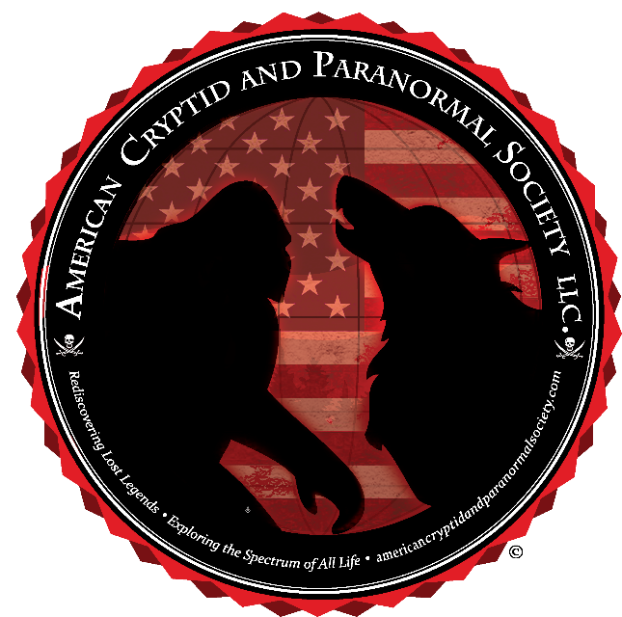
Mission Statement
The American Cryptid And Paranormal Society LLC (A.C.A.P.S.) is dedicated to "Rediscovering Lost Legends; and Exploring the Spectrum of All Life." Our organization is open-minded and courteous towards every view of the cryptid and paranormal experience. The A.C.A.P.S. is based on the principals of rational science, with the use of the scientific method approach as the basis to every research endeavor. With over twenty-four years of dedicated experience in the investigative research of Cryptid and Paranormal Activity, we strive to offer the highest education in these areas, with our top priority being client safety and confidentiality.

Biography
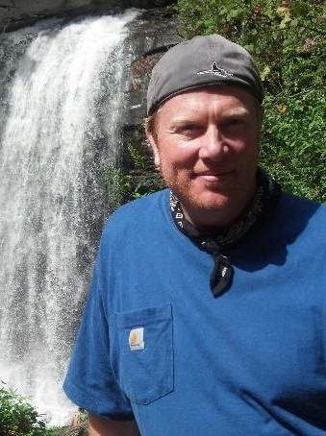
Christian MacLeod, Director and Lead Investigator of the A.C.A.P.S., has over twenty-five years of experience investigating Cryptid and Paranormal activities. With a passion for studying and preserving The Native American Tribe culture, folklore, and legends, he also knows about dealing with topics such as The Occult, UFO’s, Forbidden Archeology, The Freemasons, The Knights Templar, Secret Societies and many other Governmental cover-up allegations and Conspiracy theories.
Christian holds a Bachelor’s level degree in Psychology and minor in Criminology from the University of South Florida, and an advanced Masters of Arts and Teaching degree from Western Carolina University, Christian is currently finishing a second Master’s Degree in American History from Western Carolina University and plans to continue into a PhD. program.

The American Cryptid And Paranormal Society, LLC has worked in conjunction with Joshua P. Warren for many years in the effort to study fringe phenomena and discover scientific explanations to that which cannot be explained. This relationship has put the A.C.A.P.S. and Joshua. P. Warren on the forefront of many successful research endeavors and expeditions. Most currently this professional will lead to the uncovering a hidden tunnel system under the city of Asheville, North Carolina.
Alongside Joshua P. Warren, the A.C.A.P.S. has been working closely with Daniel “Tiny” Hurst, founder and lead researcher of Hurst Paranormal and Cryptid Investigations to research, give credence too, and assist the clients of Western North Carolina with regards to their reports of Cryptid and Paranormal Activity. All three entities take great care in providing respect to their clients as well as the grounds and property on which they research. All reports are backed by a strict confidentiality agreement, in stating that no information of the story is discussed unless otherwise agreed upon while providing education and assistance in any way necessary.

The American Cryptid And Paranormal Society, LLC has gained acclamation and been featured in many publications, including the Asheville Citizen-Times, News 40, The Mountain Express, The Daily Planet, The McDowell Times, and The New York Times. As well as being featured on various radio programs, such as Coast to Coast AM with George Noory, Joshua P. Warren’s Speaking of Strange Podcast, Vic Cundiffs Dogman Encounters Radio, and Bigfoot Eyewitness Radio, and many other media outlets.
Christian MacLeod is also the host of the very popular and award-winning podcast The American Cryptid And Paranormal Society Podcast, Fringe Investigations, which was chosen podcast of the month for October 2018 by George Noory and Coast to Coast AM. In conjunction with being a featured pod-caster, Christian MacLeod is also an official contributor for Coast to Coast AM.
With over twenty-three years of dedicated experience in the investigative research of Cryptid and Paranormal Activity, we strive to offer the highest education in these areas, with our top priority being client safety and confidentiality. We are always interested in collecting any Cryptid or Paranormal witness information or evidence. All reports are confidential and kept private. Thank You.
Contact the American Cryptid And Paranormal Society LLC: americancryptidandparanormalsociety.com or 1- (800)-329-4851 or (828) 782-3766.

