Armour of God
Discussion Summary, Notes and Presentation
For November 28, 2018
Topic summary:
Pope Saint John Paul II introduced to us the concept of “the Culture of Death”. Perhaps its opposite can be found in the Consistent Life Ethic.
Come out to our Armour of God discussion to learn more about issues of life, death, and dehumanization. We will examine what our Catholic faith says about the dignity of every human being and how we should respond.

Speaker: Taylor Hyatt
Taylor Hyatt brings some unique perspectives to our Armour of God discussions. She currently serves as the Policy Analyst and Outreach Coordinator of Toujours Vivant-Not Dead Yet (TVNDY) - a non-profit whose goal is to inform, unify, and give voice to disability rights advocates opposing assisted suicide, euthanasia, and other end-of-life practices. Previously, she worked as a legislative assistant to a member of Parliament, and as a writer for Campaign Life Coalition. Her articles have appeared on CBC, Global News, and in the Ottawa Citizen.

Armour of God – Human Dignity & The Consistent Life Ethic:
A Broader Pro-Life Vision – Taylor Hyatt – November 2018

In our present age, we must confront many ethical issues and violations of human dignity. How can we choose who is most deserving of our limited resources? I, my fellow activists, and the teachings of the Church see a way to bring them all together - the consistent life ethic.
Ten years ago, I astonished my relatively apolitical family by coming home for Thanksgiving dinner and telling them I voted Conservative in my high school’s mock election. As a teenage convert and wannabe pro-life activist, what choice did I have? Only one party on the ballot said they would do anything to protect the unborn.
But as I began to work in the pro-life movement during university, something never quite fit. My faith placed so much emphasis on the poor…why did I feel the need to choose between two disadvantaged groups of people – children before birth, and the poor - who both needed my attention?
Six years ago, Sr. Nuala Kenny – a member of the Sisters of Charity, physician, and bioethicist – declared to a gathering of Ottawa U students: “You’re not thinking outside the box! Being pro-life is not just about abortion!”
I remember being irritated with her – didn’t the good sister understand the purpose of the pro-life club she was addressing? (It was the now-defunct medical division of Ottawa U Students for Life.) Weren’t abortion and euthanasia – the two “typical” pro-life issues – the only ones a future doctor was likely to face directly in their practice?
We’ve all been confronted with the same disconnect at some point. How many times have we been accused of abandoning the poor when we stand up for the pre-born? How many times have we been tempted to say “but what about the 250 pre-born children who lost their lives today?” when we hear about yet another event supporting refugees?
In the 1970s, journalist and social justice advocate Eileen Egan thought she had the answer to this divide. She came up with the term seamless garment of life as a way to demonstrate the unity of the Church’s teaching on various issues. It was a reference to Christ’s crucifixion in the Gospel of John, chapter 19: “When the soldiers had crucified Jesus, they took his garments and made four parts, one for each soldier – and also his tunic. But the tunic was without seam, woven from top to bottom, so they said to one another, ‘Let us not tear it, but cast lots for it to see whose it shall be.’ This was to fulfill the scripture, ‘They parted my garments among them, and for my clothing they cast lots.’” I was never able to find where the image of a tunic came from, but I like the idea of not tearing Christ’s “royal” garment in two. Neither He nor our brothers and sisters should be used as means to a political end. To do so is a mockery of their dignity.
Cardinal Joseph Bernardin used the term consistent ethic of life in a series of lectures throughout the 1980s. At Fordham University in 1983, he said “Precisely because life is sacred, the taking of even one human life is a momentous event…In [a technological age] when we can do almost anything, how do we decide what we ought to do? Asking what we ought to do along every step in the spectrum of life from womb to tomb creates the need for a consistent ethic of life – one whole garment of life. The spectrum of life cuts across the issues of genetics, abortion, capital punishment, modern warfare and the care of the terminally ill…Consistency means we cannot have it both ways. We cannot urge a compassionate society and vigorous public policy to protect the rights of the unborn and then argue that compassion and significant public programs on behalf of the needy undermine the moral fiber of…society.³ They fit together.
Section 1937 of the Catechism of the Catholic Church tells us that “Respect for the human person proceeds by way of respect for the principle that ‘everyone should look upon his neighbor (without any exception) as 'another self,' above all bearing in mind his life and the means necessary for living it with dignity.’”
The idea of “another self” comes from Gaudium et Spes, the encyclical written by Pope Paul VI in 1965 as the last document of the Second Vatican Council. Addressing multiple injustices at the beginning, middle, and end of life is not new for the Church. Section 27 of Gaudium et Spes lists abortion as the third of about fifteen “infamies” that “[violate] the integrity of the human person” and “[insult] human dignity.” Others include coercion of the will, subhuman living conditions, slavery, and human trafficking.
Returning to the Catechism, section 1934 states that because they are “[created] in the image of the one God (see Genesis 1:27) and equally endowed with rational souls, all men have the same nature and the same origin. Redeemed by the sacrifice of Christ, all are called to participate in the same divine beatitude: all therefore enjoy an equal dignity.” Look at Psalm 139 – “For you formed my inward parts, you knit me together in my mother’s womb.”
We cannot be “un-made” or lose this great worth – no matter the crimes we commit, the sins we need to confess, or the circumstances of our lives. All three of the synoptic Gospels – Matthew, Mark and Luke – contain the commandment to love our neighbours as ourselves. We can’t ignore that, either. As consistent life activist Aimee Murphy wrote a few years ago, under this ethic, “the life of every human being is viewed as inherently and ultimately valuable and worthy of protection. [We cannot] selectively promote…the lives of the wanted, the innocent, the [nondisabled], or the free.”
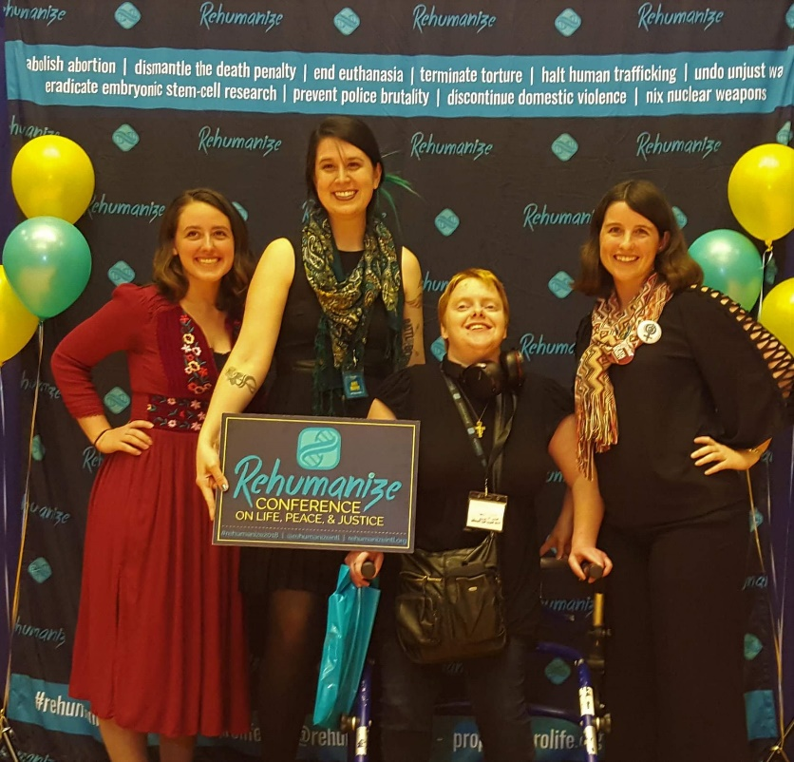
Activists like her strive to abolish abortion, dismantle the death penalty, end euthanasia, terminate torture, halt human trafficking, undo unjust war (as much as that can be done), eradicate embryonic stem cell research, prevent police brutality, discontinue domestic violence, nix nuclear weapons, and end aggressive violence towards human beings wherever it is found. A broader vision of life should not be new territory – the “traditional” pro-life movement has a history of aligning with other causes. As far back as the 1960s, groups like Pax Christi connected the anti-abortion view with opposition to war. Pro-life advocates already know that we need to communicate our love for women and their children in a crisis. In order to make progress, we need to build bridges. Andrea Mrozek, whom some of you might know through her work with Cardus and her pro-life writing (check out ProWomanProLife.org) said just last week that demonstrating our consistency is necessary if we want to attract “people of different persuasions” to the pro-life view.
I’m not exactly sure how I figured out that I wasn’t the only person fed up with these divisions. As I became more connected to the Canadian pro-life movement, other newer, younger groups caught my attention…but the relief I’ve found as I’ve become more committed to learning about this consistent worldview has not changed.
At the same time, actually living as if I believed in the dignity of my brothers and sisters is not easy. I look to St. Therese as a model for the smallest things – for her, a smile or “picking up a pin” could be an act of charity. I’d like to start looking into ethical fashion, and there are stores I make a point of avoiding because I know how the staff who put the clothes together are treated. We need to examine the consistency in our own hearts, our attitudes, and of course our wallets and election ballots.
On a larger scale, no current social policy or political party gets it right. Conservatives favour economic freedom, but also support the death penalty and war. Liberals are the ones promoting social safety nets, but they support abortion, euthanasia, and embryonic stem-cell research. Someone is always left out. And if we want to respect the lives of all of our brothers and sisters…I hate to be the bearer of bad news... but we’re going to be politically homeless.
I serve Christ first, not the left or the right. If you’re worried about a sudden swerve to the left, Cardinal Bernardin did tell the National Catholic Register “I don't see how you can subscribe to the consistent ethic and then vote for someone who feels that abortion is a 'basic right' of the individual ... That’s a misuse of the consistent [life] ethic, and I deplore it.”
Of course, it’s not a sin to be partisan…but be brave and be willing to remind people what their red, orange or blue tinted glasses might prevent them from seeing. When I worked on Parliament Hill, I was a thorn in the side of some of my colleagues. I came into the office one day to find a book on my desk – something along the lines of “Why Catholics Should Be Capitalists.”
And of course, we can’t right all the world’s wrongs ourselves. So many of them are too big for any one person to solve. Cardinal Bernardin acknowledged that “These [life issues] are all distinct problems, enormously complicated, and deserving individual treatment. No single answer and no simple responses will solve them.”

On another occasion, Bernardin said, “A consistent ethic does not say everyone in the Church must do all things, but it does say that as individuals and groups pursue one issue, whether it is opposing abortion or capital punishment, the way we oppose one threat should be related to support for a systemic vision of life. It is not necessary or possible for every person to engage in each issue, but it is both possible and necessary for the Church as a whole to cultivate a conscious explicit connection among the several issues.” ³
I like Sr. Nuala Kenny’s answer to the medical students at the University of Ottawa: pick one or two violations of human dignity that break your heart, and…essentially, get off your rear. Think about what it might be like to be in another person’s shoes – someone newly released from prison, or who has escaped domestic violence. Volunteer. Protest. Write to politicians. Donate.
The US-based organizations Rehumanize International and the Consistent Life Network are good places to start. Unfortunately, we don’t really have any consistent life organizations based in Canada.
Two staff members of Rehumanize wrote a book for beginner advocates, full of small things you can do every day for a year. A lot of the projects are written with Americans in mind, but researching provincial and federal laws, creating art with a focus on injustice, and preparing bags of goods for people without homes are little things most of us can do. What do we know about how local homeless shelters work? What language do we use to describe disadvantaged people – are criminals animals? Does a person with a severe brain injury really become a piece of cauliflower – a vegetable? Ultimately, does it make sense to fight for the life of one human being in the womb, and not extend our hand when he faces other forms of dehumanization later in life?
Embracing consistency in our pro-life outreach will bring new people into our circles, and form our hearts to be more like Christ’s. Christ teaches us a consistent life ethic. He did not pick and choose who among the disadvantaged was worthy of His respect and attention…why should we?

Leach, M. (2012, November 06). Cardinal Bernardin's gift fits all sizes. Retrieved November 10, 2018, from https://www.ncronline.org/blogs/soul-seeing/cardinal-bernardins-gift-fits-all-sizes
Akin, J. (2015, January 25). Intellectual dishonesty and the "Seamless Garment" argument. Retrieved November 10, 2018, from http://www.ncregister.com/blog/jimmy-akin/intellectual-dishonesty-and-the-seamless-garment-argument
Pope Paul VI. (1965, December 7). Pastoral Constitution on the Church in the Modern Word-Gaudium et Spes. Retrieved November 12, 2018, from http://www.vatican.va/archive/hist_councils/ii_vatican_council/documents/vat-ii_cons_19651207_gaudium-et-spes_en.html
Murphy, A. (2012, October 21). The Consistent Ethic of Life: Breaking Down Barriers. Retrieved November 12, 2018, from https://www.rehumanizeintl.org/single-post/2012/10/21/The-Consistent-Ethic-of-Life-Breaking-Down-Barriers-Speech
Kelly, J. R. (2012, December 09). Finding Renewal: Why the pro-life movement should return to its roots. Retrieved November 12, 2018, from https://www.americamagazine.org/issue/686/article/finding-renewal
Conlon, M. (2018, November 15). Feminists must 'reconcile with their roots', pro-life mission. Catholic Register. Retrieved November 22, 2018, from https://www.catholicregister.org/item/28439-feminists-must-reconcile-with-their-roots-pro-life-mission
Martin, T., & Clarke, J., O.C.D. (1996). Story of a soul: The autobiography of Saint Thérèse of Lisieux. Washington, DC: Institute of Carmelite Studies.
Isenhart, C. (1988, June 12). BERNARDIN: Chicago’s Pastor on Consistency and the ’88 Vote. National Catholic Register. Retrieved November 21, 2018, from http://www.ncregister.com/blog/tom-hoopes/bernardin_put_life_first
Bernardin, Cardinal J. (1983, December 4). A Consistent Ethic of Life: An American-Catholic Dialogue. Retrieved November 11, 2018, from http://www.priestsforlife.org/library/884-a-consistent-ethic-of-life-an-american-catholic-dialogue
Coltharp, M., & Murphy, A. (2018). A Consistent Life: The young advocate's guide to living peace and justice daily. Pittsburgh, PA: Rehumanize International.

