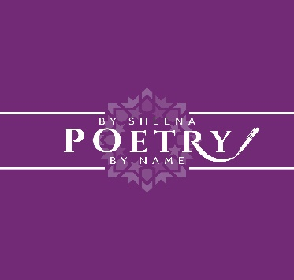

**Poem:99**

**Competition Rules**

Poems must be received on or before **Friday 31st October 2025** **by 12 Midnight (UK time)**

1. All poems must be the original work of the entrant and should not have been previously published, accepted for publication by a magazine, nor entered in other competitions that won a prize.
2. The competition is open to all children between the ages of 5-16 internationally.
3. The length of each poem **must not exceed 20 lines.**
4. One entry per child, however, more than one child from the same household can enter.
5. This year’s theme is **‘Spirituality’;** it will be given a wide interpretation by the judges.
6. Each individual poem, regardless of length, must be typed on a Microsoft document and sent as an attachment to **sheena4076@live.com**
7. The poem should be submitted in Times New Roman Font, Size 12.
8. The fee of £0.99 pence must be paid first before you submit your poem along with your entry registration form to the email at point 5 above. If you go to [www.poetrybysheenapoetrybyname.com](http://www.poetrybysheenapoetrybyname.com) find the 'Shop' tab, you will find Poem:99 listed as a product which you buy.
9. In the subject title of the email, you should include the title of your poem.
10. The **entrant’s name must NOT** appear on the poem. If it does your entry will be disqualified and you will forfeit your fee.
11. All poems must be accompanied by a fully completed entry registration form.
12. Please keep a copy of your poem, as it cannot be returned.
13. Copyright remains with the author, but **poetrybysheenapoetrybyname.com** reserves the right to have entries published/performed at local festivals, events, published on the internet, or used for publicity purposes to promote Poem:99 at any stage in the foreseeable future.
14. An acknowledgement email will be sent to confirm your entry.
15. The winners will be announced on poetrybysheenapoetrybyname.com website and will be notified by email by mid **November 2025.**
16. The decision of the judge (s) is final, and no correspondence will be entered into.
17. Poetrybysheenapoetrybyname.com reserves the right to withhold prizes if any action is justified as being suspicious and or any malpractice by the entrant.
18. Entries not complying with competition rules will be disqualified.
19. The winners in each category will be presented with their prize at an online zoom ceremony and the monies will be directly transferred into the winner’s nominated accounts. The winners must be accompanied online by an adult.
20. Please note the prize evening may be covered by local press, and by entering this competition your parent(s)/ guardian(s) are giving express permission to use your individual and or group photo for publicity purposes by the competition founder and or those affiliated to the competition.

**I HOPE YOU WIN!**

**(Sheena Hussain Founder of Poem:99)**