CONFIRMATION DISCUSSION GUIDE-WEEK 5

ACTIVITY:
(See the image attached; Would you Rather?)

Follow-Up Question: What helps you make decisions when you are faced with choices like this?

The Holy Spirit is what leads and helps us be more like Jesus. But the Holy Spirit is not the only thing that guides and helps us. We’ve learned about God creating the universe, Jesus being born, living, dying, and resurrecting, and the Holy Spirit living inside our hearts and helping us grow closer to God. But did you know they are all three the same thing?

(Play video)

ASK:
- Who are you? Remember, you cannot use words that describe what you DO but who you ARE?
- Who is God? (Not what God does).
  - Loving, Just, Merciful, Holy, etc.
- What are the three parts of the Holy Trinity?
  - Father, Son, Holy Spirit
- Read Genesis 1:26. What do we learn about God in this verse?
- Read Matthew 28:19. What is Jesus asking the disciples to do? What does this have to do with the Trinity?
- Why do you think the Trinity is so important to our Faith?
  - It’s something that is unique to Christianity. No other religion has something like it. The three parts cover and provide everythignwe need to follow God.
- What do you think the jobs of the 3 parts of the Trinity are?
  - God-Creates, Jesus-Redeems us of Sin, Holy Spirit-Leads us closer to God

WRITE: Ask Students to pull out their Student Guides and complete the activities:
TODAY WE LEARNED ABOUT THE 3 PARTS THAT MAKE UP THE HOLY TRINITY. USE THE SYMBOL BELOW TO WRITE WHAT YOU REMEMBER ABOUT TODAY’S LESSON. IN THE MIDDLE OF THE SYM- BOL WRITE WHAT YOU THINK THE HOLY TRINITY IS. WHEN THE FATHER, SON, AND HOLY SPIRIT ALL COME TOGETHER...WHAT HAPPENS?
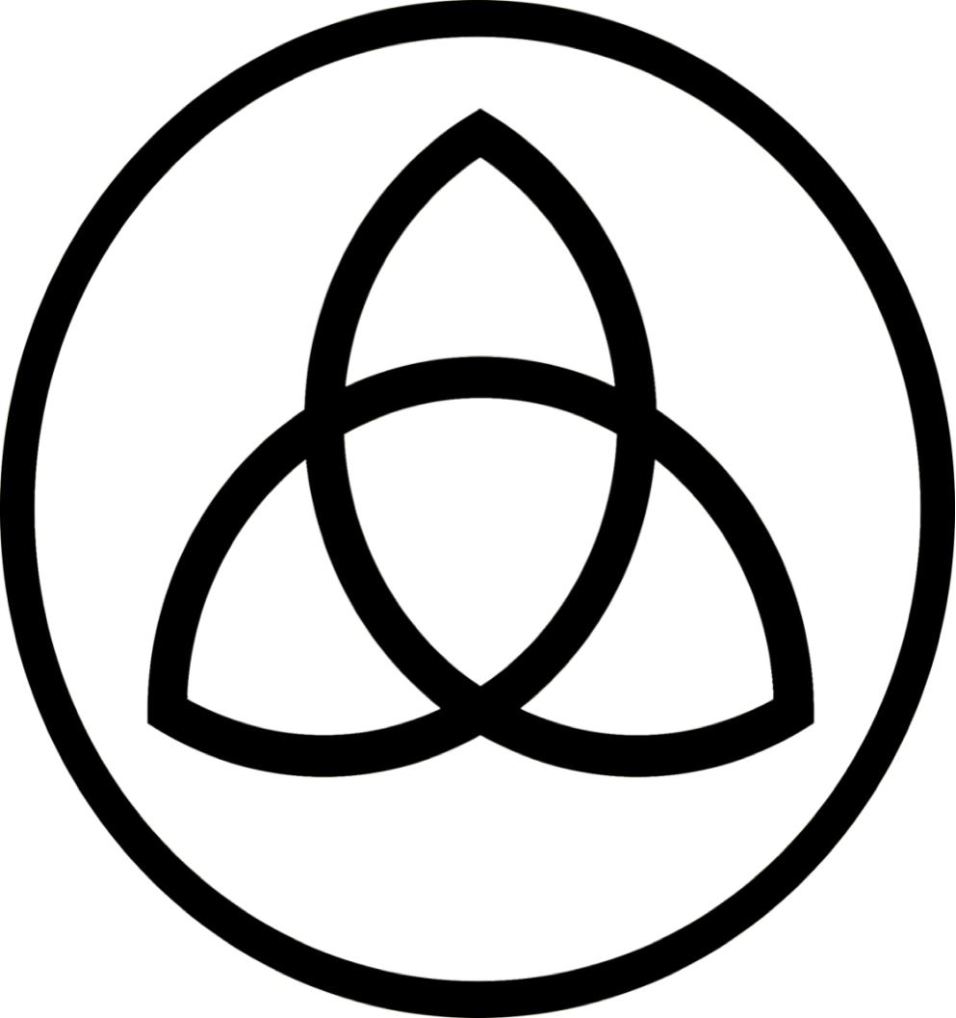
(This is what they see in their Student Guide)
PRAY:
God,
Thank you for the Holy Trinity! It’s a beautiful thing to have You, your Son, and your Spirit here with us. Thank you for creating us and this world, sending your son Jesus to die for our sins, and for your Holy Spirit that lives inside each one of us. We love you and it is in Jesus’ name we pray. Amen.

