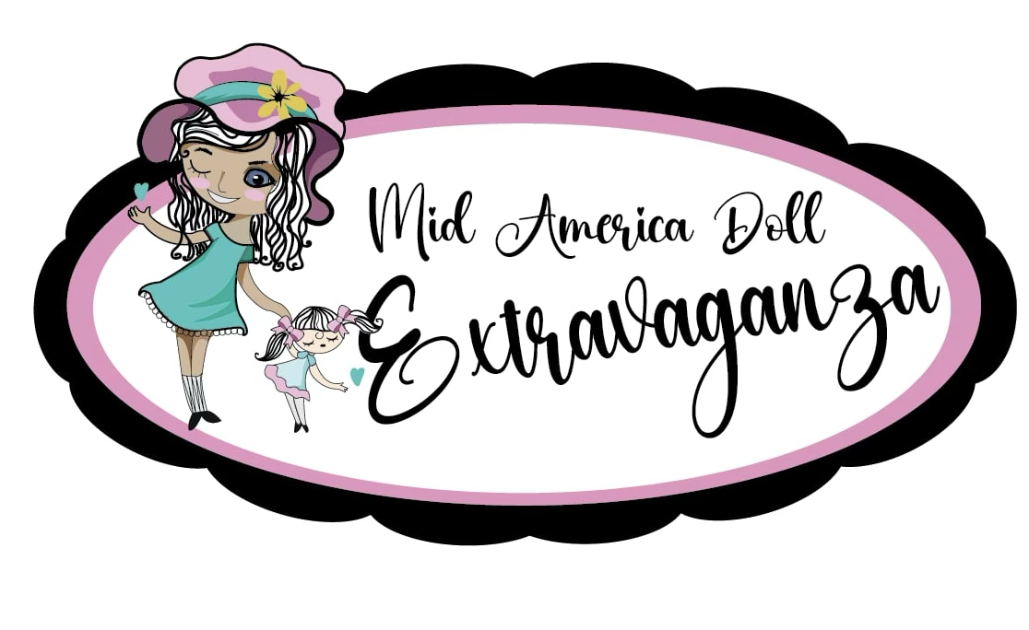
Mid America Doll Extravaganza
Symposium and Show
Registration
March 26-29, 2026

Complete one registration form for each attendee.
Name______________________________________________________________
Mailing Address_______________________________________________________
Phone________________________ Email_______________________________

REGISTRATION FEE - $150 (includes souvenir doll “Lillie” for the first 125 registrants.

Mark with an “x” the doll fun you want to experience below:
Thursday Welcome at Shakespeare’s Pizza ($15) ____

Friday Tour ($30) ______
Friday Lunch ($50) ____ Friday Dinner ($75) _____ Friday Movie ($10) _____
Friday Programs:
Dolls ARE Figurative Art (FREE) ___ Doll Appraisals ($10) _______ Spider Workshop (Free) ____ Friends on Film ($10) ____ Creating Your Doll’s World ($10) ____

Saturday Show Admission ($10) ______
Saturday Lunch ($50) _____ Saturday Final Banquet ($75) _______
Saturday Programs:
Literary Friends ($10) ____ Dolls in Competition ($10) ____ Missouri in Dolls ($10) ____

Sunday Farewell Breakfast ($40) _____

TOTAL ____________________

Send registration form and check made payable to: Mid America Heritage Alliance to:
Alana A. Smith
5322 Alden Street
Shawnee, Kansas 66216
Phone: 913-231-6742
Email:alana.a.smith@gmail.com

