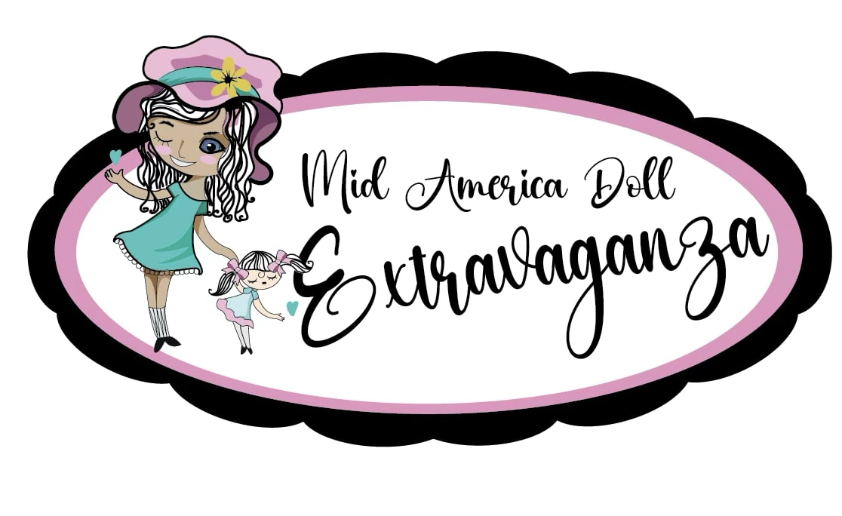
Mid America Doll Extravaganza
Vendor Application
Saturday, March 28, 2026
SHOW LOCATION
Stoney Creek Hotel and Convention Center
2601 South Providence Road Show Time: 10:00 am to 4:00 pm
Columbia, Missouri 65203
The Show will be held in Salon C.
Set up time is 7:00 am to 10:00 am. Please be at the Hotel and have items inside by 9:00 am. Take down will begin at 4:00 pm. Please do not take down early.
Tables and two chairs are supplied. Size of tables: 6’ and 8’
ONE TABLE: $125.00 _________________________
TWO TABLES: $100 each x 2 = $200 _______________
THREE TABLES OR MORE: Contact for availability and cost.
NO REFUNDS OR CANCELLATIONS AFTER FEBRUARY 25, 2026.
YOUR INFORMATION:
Name: ______________________________________________________
Address: _____________________________________________________
City, State and Zip Code: _________________________________________
Phone Number: _____________________
Email: ___________________________
Signature: _________________________
Helper’s Name: _________________________________________________
Missouri State Tax Number or Exempt Form MUST be sent with contract.
https://dor.mo.gov/faq/taxation/business/special-event-sales.html

Any questions about the show, contact: alisha@dollextravaganza.com

Participation and location are on a first come, first served basis.
Please be sure that all items are clearly priced and are displayed neatly.

MAKE CHECKS PAYABLE TO: Mid America Heritage Alliance
Mail Contract, Tax Form and Payment to:
Paul M. Cole
Mid America Heritage Alliance
912 W. 34th Street
Kansas City, Missouri 64111-3612
Phone: 816-589-6286
Email: pmcolecpa@gmail.com
REGISTRATON DEADLINE: February 15, 2026

