**REPORT ON THE MENFEEL CAMPAIGN AT AFROTOPIA CAFÉ AT THE ARTS GALLERY**

On November 8th, 2024, the Ndinewe Foundation, University of Zimbabwe’s Department of Social Work, and Varsity Mental Health Champions, YETT TRUST converged at the National Arts Gallery Afrotopia’s Café to celebrate Men's Mental Health Month. This important event brought together expert partners from various backgrounds and students from the Department of Social Work to engage in a compelling discussion on the topic.

The highlights of the event included a presentation by Ben Romondo, a Mental Health Advocate and Expert in Youth Programming, Men's Mental Health, and Suicide Prevention. Simbarashe Mhaka also delivered a compelling performance titled "Finding Your Voice," which addressed the significance of speaking out about men's mental health. Additionally, a panel discussion with Tawanda Murepa, Ronnie Nubi, and Eliah Kausiyo explored the role of Ubuntu in men's mental health and wellness, and Fidelis Cassper Moyo, the founder of Varsity Mental Health Champions, also participated.

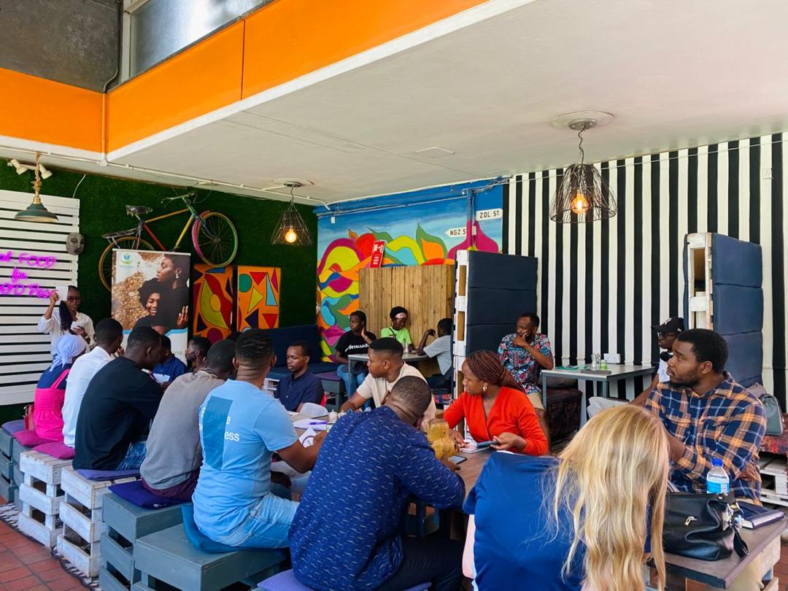 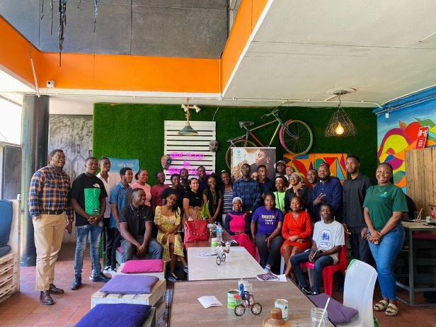

The event's central theme was to break down old barriers and redefine what it means to be strong as a man. It provided a safe space for men to share, heal, and speak their truth, emphasizing that talking about mental health is not a sign of weakness, but rather the boldest step one can take. The convergence of these organizations and the participation of expert speakers and performers created a powerful platform for addressing the critical issue of men's mental health.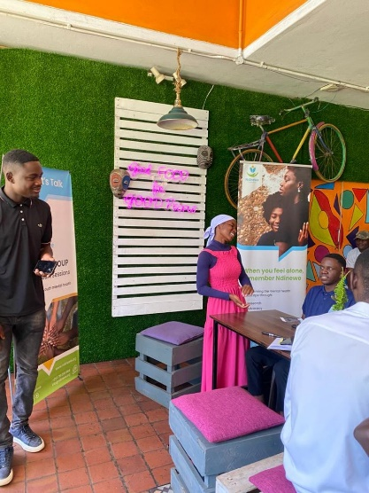

*A social work student contributing a point*

The Ndinewe Foundation, Department of Social Work, and Varsity Mental Health Champions' collaboration in hosting this Men's Mental Health Month celebration at the National Arts Gallery at Afrotopia café was a significant step forward in addressing this important topic. The event's impact and the insights shared will undoubtedly continue to have a lasting influence on the community's understanding and support for men's mental health.