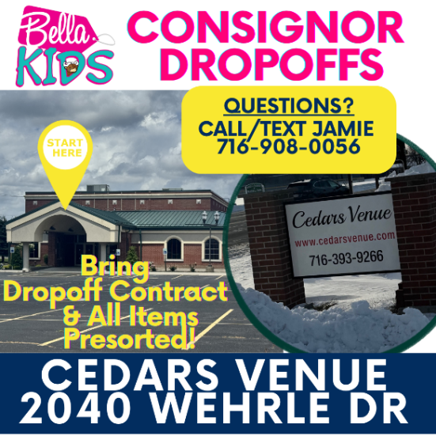

NOVEMBER 2026 SALE
Consignor #: ___________________
Name: _____________________________________
Phone #: ________________________
TYPE OF ACCOUNT? RESTOCK REGULAR BOTH

Bella Perks Program: Earn MORE Bella rewards! (circle one.)
VIP Helper Shifts Included? 0 1 2 3 shifts

Are You Donating Your Unsold Items? ALL SOME NONE

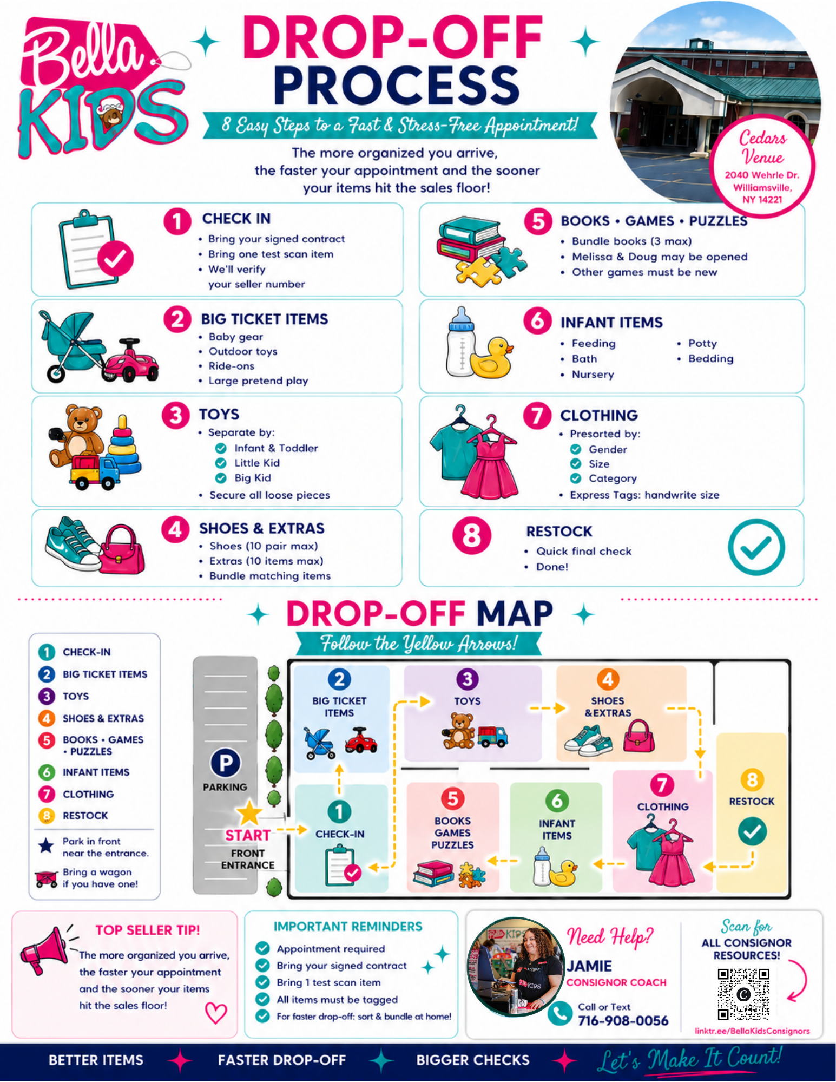

DROPOFF CHECKLIST: (INITIAL BELOW)
_____ PRE-SORT ITEMS IN 8 CATEGORIES: Bring in your items SEPARATED by 8 categories for a fast & easy dropoff experience at each table. (See 8 categories listed above.)
_____ RESTOCK INVENTORY will be dropped off at our designated #8 RESTOCK table for separation from sales floor.
_____ QUALITY INSPECTION: I have inspected my inventory BEFORE DROPOFF in a bright light for damage, stains, missing parts, signs of wear/tear, dirt etc to avoid a potential $5 rejection fee for 3 or more rejected items.
_____ TAGS: Printed one-sided on WHITE CARDSTOCK only in DRAFT MODE! No handwritten changes.
_____ CLOTHING: Items are GROUPED by gender, size, & rubber banded together.
_____ CLOTHING: All items are FRESHLY laundered and smell fresh & clean. Zippers are zipped; buttons are buttoned. I have checked my items & removed any with stains/damage/outdated/unaccepted brands or season.
_____ CLOTHING: My hanger hooks are facing left as a question mark ? and Tags are secured using safety pins or zip ties. (at seams or tag to prevent holes.)
_____ TOYS: Sets have ALL pieces & are SECURED TOGETHER! Toys requiring batteries have working batteries.
_____ PRICED TO SELL! All consigned Items are priced reasonably @ 20-40% OF RETAIL PRICE PAID!
_____ SETS: ALL bagged items are securely TAPED SHUT!
_____ CARSEATS: I’ve verified the carseat manufacturer label & the date is less than 5 years ago (if applicable)
_____ RECALL CHECK: I have reviewed & RECALLED items using cpsc.gov or safekids.org

=========================================================
GETTING PAID! MONITOR YOUR SALES! We will be uploading daily sales in your consignor accounts so you can view your sales! Click on the SETTLEMENT tab to view your items sold after approx. 2-3 hours after store closing! PROFIT CHECKS: Payments will be emailed within 7-10 business days AFTER sale. All you have to do is PRINT & deposit check within 90 days of issuance. After 90 days, store credit will be issued for use at future sales.

