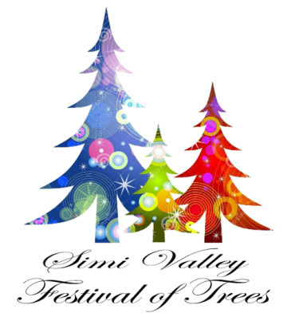
Gift Boutique Ideas 2018

START EARLY - Large numbers of quality handmade gifts are needed. Involve your friends, relatives, neighbors, and associates. Stress the importance of quality items, but graciously accept all gifts. Encourage donors to package items when appropriate.
TURN IN - We encourage all gifts to be completed by November 1, so they can be priced before Festival begins. Please check each item to make sure it is clean and in good condition. Turn gifts in to Board Members in sturdy boxes with lids.
PRICING - Include the cost of materials for each item. Our goal is to price items at market value. The quality of work, the cost of materials, and the colors influence the price. THANK YOU we appreciate every item donated. Please send a thank you note to each person who contributes to Festival of Trees.
GIFT IDEAS (Handmade items)
• NEIGHBORHOOD GIFTS - Candles, soaps, extension cords, towels, handmade dishcloths with dish soap, measuring cups, seasonings, or anything with a Merry Christmas themed tag.
• CHRISTMAS ITEMS - Nativity items, snowman kits, wall hangings, large wooden crafts, ornaments, tree skirts, pillows, glass blocks, stacked wood sayings, nice candles, standing porch items, things for pets.
• CRAFT ITEMS - Handmade note cards, necklaces and bracelets, embroidered samplers, teacher and neighbor gifts, vinyl lettered tiles, magnet boards.
• QUILTS - Quilts of all sizes, tied or quilted. There is a great demand for king and queen sizes and rag quilts.
• TOYS - High quality child-safe items, picture/quiet books, I-spy pillows, boys’ items, dress-up clothes, push toys, blocks, stuffed animals and dolls, puppets, stick horses, doll clothes for 18” dolls, cradles, doll furniture.
• HOME DÉCOR - Tablecloths, runners, aprons, appliqué dishtowels, nylon scrubbers, flour sack embroidered dish towels, pillows.
• BABY AND CHILDREN - Receiving blankets, burp cloths, chunky and fuzzy yarn hats and mittens, hooded bath towels, preemie items, baby headbands and jewelry, character hats (Minions, animals, super heroes, etc.)
• AFGHANS - Lap robes and afghans in white and off-white are always in demand. If your gift item is fragile, please deliver it directly to the Festival of Trees site, Tuesday, November 28th. For additional information call Barbara Reynolds, (805) 527-6377
or (760) 382-7592.

