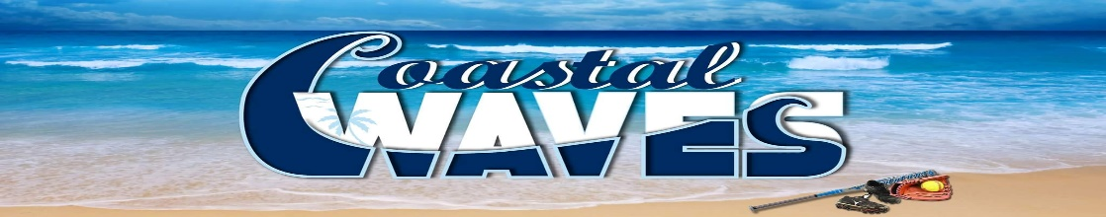

**COASTAL WAVES**

Fastpitch Softball Club

107 Avon Dr.

Hubert, NC 28539

910-381-1326

Coastal Waves Fastpitch Softball Club is a local non-profit (501.c.3) Organization whose mission is for our female athletes to play softball at a higher competitive level to prepare and assist our players in being recruited to the Collegiate level. We are home to three teams 12U, 14U, and High School ages ranging from 10 years old – 18 years old.

These girls travel all over North Carolina, South Carolina, and Virginia to play in tournaments to showcase their softball talent in front of College Coaches and Scouts and against some of the greatest softball players in the tri-state area.

We are sanctioned to play in USSSA, WFC, Top Gun, PGF, and TierOne (USA Softball) Softball programs which are Nationally Ranked Softball programs.

This is a very costly adventure for these ladies and their families with the cost of tournaments (avg of $325 / team / tournament), the expense of traveling, and not to mention the cost of team gear and equipment. However, this is the BEST way for these ladies to achieve an opportunity to fulfill their dreams of playing softball at the collegiate level.

We are asking you for a donation to help offset our costs for tournaments, travel, and equipment. Every dollar earned gets us one step closer to the next big tournament that could be the tournament that changes one or all of these young ladies lives forever!

They work hard and they play hard…They deserve your support!!

Each team carries a banner with our Logo / Team name and our Sponsors listed to every tournament. This banner is placed on our dugouts for all to see. Also, ALL sponsors are listed on our organization’s website <https://www.coastalwavesfastpitchsoftballclub.com> with a link to your business website or Facebook page for the period of one year (August – August).

Any sponsorship level selected would be greatly appreciated.

**Elite**- $500 – Logo is larger and on top of all (3) teams banners, Company name listed on all (3) teams banners as a sponsor, FREE Entry for (2) to tournaments in the Swansboro area, Link to your Business on our website, Thank you plaque from our organization

**Corporate**- $300 – Logo on a single team’s banner, business name listed on all (3) teams banners as a sponsor, Link to your business on our website

**Sponsor**- $100 – Business name listed on all (3) teams banners as a sponsor, Link to your business on our website

If sponsorship is not for you, any donation made would be greatly appreciated.

Make Checks Payable to: **Coastal Waves**

107 Avon Dr.

Hubert, NC 28539

910-381-1326 (Rob Keeney)

Your Sponsorship or any donation of $50 or more is tax deductible and we would gladly provide you with our EIN for your tax records.

Thank you in advance for your contribution to our organization, teams, players, and families.

Signed,

**Robert C. Keeney**

**Robert Keeney**

**Coastal Waves Founder / President**