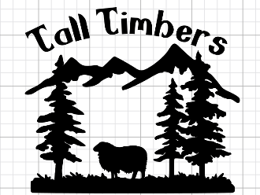
Forest Farm & Fiber
85 Hodgson Rd
Cathlamet, WA
98612
(360) 703-7291
Email: tall timbersfff@gmail.com
Website: www.talltimbersfarm.com
Owner & Shephard: Lori Cagle
CSA Wool Shares Include:
Cleaned and processed roving or felting roving, mill spun and handspun yarn
Updates from the farm in a quarterly newsletter
Kits and/or supplies when available
Free online tutorials when available
Annual “Life On The Farm” event picnic

Prices:

Roving Share $150.00 ______________
Felting Share $150.00 _______________
Rug Hooking Share $200.00 ____________
Name:____________________________________________
Address:__________________________________________
City:__________________________________
State:__________________ Zip:___________
Email Address:_____________________________________________
Phone Number________________
Payment Incuded:
Roving Share $150.00____________________
Felting Share $150.00____________________
Rug Hooking Share $200.00
Sorry , No International shares at this time.
________________________________________________________
Signature:_____________________________________________

Before each shipment, shareholders are e-mailed information on color choices, with occasionally natural or plant based dyed fiber options.(dyed fiber depends on growing season of our dye plants)

