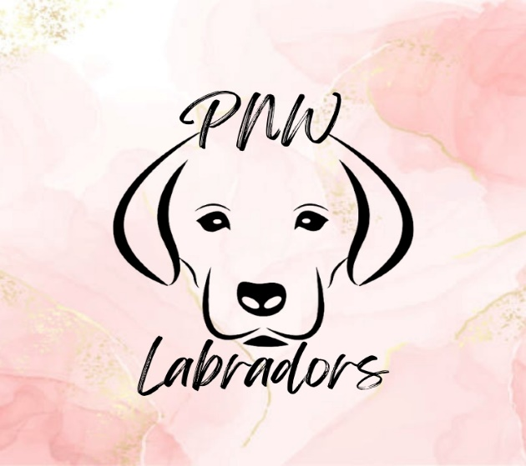

PNW Labradors puppy application

First and last name
Address
Phone number
E-mail address
Veterinarian name and address

1. Do you currently own any pets and if so, are you aware of the adjustment period and time required to allow pets to become acquainted? This is not an overnight process and often can require a few weeks of separation with supervised time before both pets feel comfortable.
2. Have you owned a labrador before?
3. Who will be the primary caretaker of this puppy?
4. Do you agree to use only positive enforcement training with this puppy?
5. Do you own a pool and if so, is it fenced in?
6. Do you own or rent? If you rent, please provide your landlord's name and number so we can verify that pets are allowed on the property.
7. Puppies require lots of attention and even though your new puppy is litter pan trained, do you acknowledge that potty training once in a new home will take time and accidents are bound to happen.
8. Do you agree to reach out to me if you are unable to care for your puppy? This puppy must never be placed in a shelter or another home.
9. Do you agree never to take this puppy to a dog park? Dog parks are dangerous places that can cause fear and harm to a dog.
10. Vaccinating a puppy with more than one vaccine at a time may cause adverse reactions and if you choose to do that the contract that each puppy goes home with is void and null.
11. It is highly recommended that you continue crate-training your puppy. We begin crate training at 5 weeks and make sure puppies have the basics to not fear the kennel and be able to use it as a safe place.
12. I highly recommend puppies be placed in a training program once they are fully vaccinated; it helps both you and your new puppy. These puppies come from working backgrounds (service work) and are eager to please. Instilling proper training methods is key for long-term success in the puppies' new home.
13. Pick up for this puppy is in Rogue River Oregon.
14. Puppy pick-up is scheduled for January 22nd. We are happy to hold your puppy beyond this date if needed; however, a $25 per-day boarding fee will apply to continue care and training.
15. A $400 non-refundable deposit is required via Venmo to reserve your puppy. The remaining $1,600 balance is due at the time of puppy pick-up.

