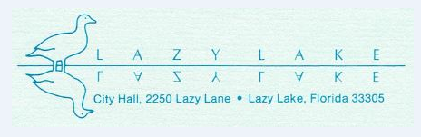

NOTICE OF CANCELLATION
OF MEETING

PLEASE BE ADVISED THAT THE VILLAGE OF LAZY LAKE COUNCIL MEETING SCHEDULED FOR TUESDAY, JANUARY 19, 2021 HAS BEEN CANCELED and TENTATIVELY RESCHEDULED FOR TUESDAY, FEBRUARY 2, 2021 VIA VIDEO/ZOOM

