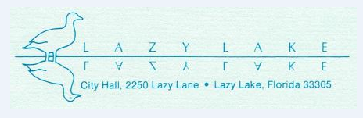

NOTICE OF CANCELLATION OF MEETING

PLEASE BE ADVISED THAT THE VILLAGE OF LAZY LAKE COUNCIL MEETING SCHEDULED FOR TUESDAY, JANUARY 21, 2020 HAS BEEN CANCELED*.
(*TO BE RE-NOTICED ON A DATE IN JANUARY TO BE ANNOUNCED, IF AVAILABLE. IF NOT, THE NEXT MEETING WILL BE THE REGULARLY SCHEDULED MEETING ON FEBRUARY 18, 2020.)

