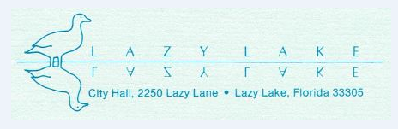

NOTICE OF CANCELLATION OF MEETING

PLEASE BE ADVISED THAT THE VILLAGE OF LAZY LAKE COUNCIL MEETING SCHEDULED FOR TUESDAY, APRIL 21, 2020 HAS BEEN CANCELED.

