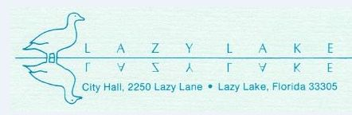

PUBLIC HEARING NOTICE

Please take notice that the Lazy Lake Village Council will consider the site plan application for a new single-family residence to be constructed at 20 Northeast 24th Street, during its Village Council Meeting.

When: Thursday, November 6, 2025 at 6:30PM
Where: Sunserve Building Conference Room,
2312 Wilton Manors, Drive, Wilton Manors, FL

Residents and interested parties may speak on this item at the designated time.
Details regarding the site plan application will be a part of the agenda packet or can be requested by email to admin@lazylakefl.us.

Pursuant to Chapter 286.0105, Florida Statutes, if a person decides to appeal any decision made by the Village Council with respect to any matter considered at such meeting or hearing, he or she may need to ensure that a verbatim record of the proceedings is made which record includes the testimony and evidence upon which the appeal is based.

