The First Step: Who Do I/We Want to Be?
- Study the situation and conduct assessment, where are the gaps between where we are now and where we want to be? What is the vision? Begin with the end in mind. Make notes here as an individual or brainstorm with the team on what this means.

In the work environment the following was noted in the DISCflex Leadership Profile.

Caution: Be careful not to overlook details as this can cause you to inadvertently fail to meet expectations. Dial up your Compliance when attention to detail is needed.

The Second Step: What Are My/Our Strengths and Gaps?
- What are my/our gaps between where I/we am now and my/our ideal vision of where I/we want to be as soon as possible? Be clear on this. Make notes here. A SWOT analysis is perfectly appropriate either personally, as a team, or as an organization. I have included a blank SWOT template and an example of one completed by a leader (fictional for illustration purposes).

Blank template for SWOT is on the web site.

TOWS template: This is how to turn your SWOT Matrix into strategies for yourself or your people to execute. There is much more about how to use a TOWS Matrix in Google, do a quick search and you can find free templates, etc.
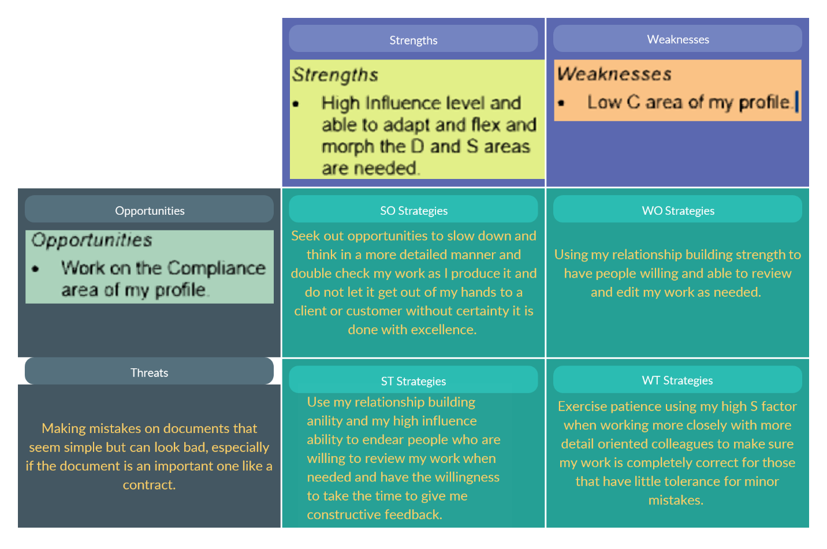

The Third Step: My Action Plan/Steps – How Can I/We Build on my Strengths while Reducing my/our Gaps?
- My/our learning agenda is a "Plan of Action" and is a detailed guide of what new things we will do with a timeline and people to hold us accountable for working the plan.

Action step? | Who/Team Name? | Desired Outcome? | Feedback Schedule/Timeline? | Changes/Progress Made? | Next Steps?
When working on the upcoming budget, slow down and get others to review it before I submit it. | Myself | An error free budget | Work with President after budget is reviewed to check for proper completion. | Budget was accepted without any rework. | Maintain care when working with any important task where meticulous details are essential.

The Fourth Step: Practicing New Behaviors, Thoughts, and Feelings to the Point of Mastery
- The fourth step involves trying out new behavior, thoughts, and feelings, and practicing these to build new neural pathways. This is the flexing and morphing of behaviors to make them second nature.

Work more closely with people who are more detail oriented than I tend to be and get better at being comfortable taking my time and having patience with all people in this behavioral circle.

The Fifth Step: Developing Supportive and Trusting Relationships that Create Job Satisfaction and Productivity
- Who can help me/us with each step of the self-directed learning process? Who can help me/us see what is missing, affirm whatever progress I/we have made, test my/our perceptions, and let me/us know how I/we are doing?

Work with my high C people more closely and get more comfortable relating to them and gaining their trust so they can help me assure my work is error free when it counts in areas like inspections, budgets, etc.

- How can I create, develop, and maintain relationships that help, support, and encourage me in each step in the process?

