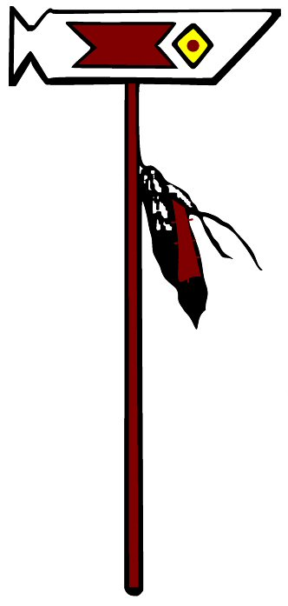
Ghost Dance Kennels
Alaskan Malamute Companion Puppy Contract
- We feel that the Alaskan Malamute is the best all-around large breed. However, Alaskan Malamutes are not for everyone. Be sure you are fully committed before you take on this responsibility.
- You must have suitable fencing for your Alaskan Malamute. You should not leave your K-9 out on a chain. Your K-9 should be on a suitable leash and collar when not confined to your yard.
- Your Malamute must have human companionship each day.
- Buyer must provide fresh, clean drinking water to your Malamute at all times. A large tank of water, such as a water trough, large wash tub, or small pool must be accessible to help them dissipate heat.
- You must provide a high quality, nutritious food to your Malamute. Your puppy has been fed Diamond Naturals Skin and Coat -All Life Stages, and we suggest feeding this or a comparable brand. Please consult with your vet regarding your Malamute’s nutritional needs during its different life stages.
- Buyer agrees to supplement puppy with a vitamin supplement until puppy is at least 1 year of age. Puppy has been given NuVet Plus while with the breeder. (www.nuvet.com/18265)
- You must keep all medical vaccinations current and comply with local, state and federal laws. Parvo, as well as other viruses, are killers. It is best to keep your Malamute away from other canines and where other canines have been until the vaccinations have had time to take effect. There are a number of theories on what is the best regimen for vaccinating against these diseases. We encourage you to study up on these viruses and to sit down with your Vet and formulate a plan before you bring your puppy home.
- Children must have direct adult supervision when interacting with your K-9, as we recommend supervision with all K-9's.
- Puppy must NOT be spayed/neutered before 8 months of age. Proof of alteration must be provided to Ghost Dance.
- Buyer agrees that at no time will the dog be involved in wolf hybrid breeding or any other breeding.
- Buyer assumes ALL responsibility and liability for the future actions of the K-9 and hereby relinquishes and waives any right to hold seller/breeder liable in any way. The seller/breeder does not intend to imply any faults with this animal in regard to temperament, but intends to advise buyer/new owner of the responsibility inherent in owning a canine of any breed.
- The buyer will abide by all local, state and federal laws concerning canines.
- Buyer agrees to provide training to Malamute to ensure good behavior. Training should begin the first day of ownership, including basic manners and house rules. Puppies start to learn at 5 weeks of age, so your puppy is ready to learn now. Training tips: Correcting your K-9 should consist of a strong verbal correction using the word “no.” You should not strike your K-9 with your hand or any object. Proper obedience training will teach your K-9 to respond to the word “no.” A quality choke collar and nylon or leather lead is usually the only equipment needed for basic obedience. We feel using a combination of leash training and food reward works best with Alaskan Malamutes and other related breeds.
- Early socialization with people of all races and ages and other canines is crucial for puppies’ normal development.
- Remember: your K-9 is your responsibility. You determine whether he turns out great, or is a menace.
- Buyer must supply, at his/her expense, a quality clear photo (hard copy or email acceptable) of said canine within the first 14 days of ownership, @ 6 months, @ 1 year, and @ 2 years of age. Noncompliance voids any/all guarantees/warranties.
- We provide a limited guarantee pertaining to Parvo, distemper, hip dysplasia, and /or any other serious genetic disorder. If your Malamute dies within 30 days from Parvo or distemper, we will replace him/her with another Malamute, of our choosing, when one is available. For the Parvo/distemper guarantee to be valid you must have: a letter from your Vet stating the cause of death and a copy of all vaccination records. If vaccinations were not given on schedule, by a Veterinarian, this guarantee is null and void. Buyer will be responsible for any shipping or other costs incurred for the Malamute replacement.
- For the hip dysplasia guarantee to be valid: you must have your Malamute’s hips x-rayed between 24 and 36 months of age by your vet and forwarded to OFA for certification. If your animal is found to have hip dysplasia, we will replace your animal with another AKC Alaskan Malamute of our choosing when one is available. We must have proof from OFA and a letter to verify that this reading was on the Malamute that came from Ghost Dance. Proof of spaying/neutering of the Malamute must be provided before a replacement animal will be given. Buyer will be responsible for any shipping or other costs incurred for the Malamute’s replacement.
- For the genetic disorder guarantee to be valid, a letter from your vet must be provided stating the disorder. ALL expenses incurred will be paid by YOU the buyer of the animal. Buyer will be responsible for any shipping or other costs incurred for the Malamute replacement.
- If at any time until the puppy/dog is 4 years of age, for any reason the buyer is unable to keep or maintain the dog as agreed to in this contract, buyer will return puppy/dog to seller. Return of the canine after 4 years of age will be at the discretion of the breeder. Buyer will be responsible for costs associated with the return of the dog and no refund will be issued.
- Buyer agrees to inform breeder of any health issues of the dog during its life to assist the breeder with future breeding decisions.
- Failure to comply with this contract voids any and all warranties, written or implied.
I (we) have read, understand and agree to comply with the above contract in it’s entirely.
____________________________________________________________________
Buyer’s Signature/Printed Name/Date
_____________________________________________________________________
Address
_____________________________________________________________________
Phone
_____________________________________________________________________
Email

