# ***Rank Advancements***

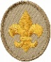

***Scout:***

***Landon Bates, Jaxson Riener***

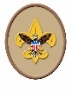

***Tenderfoot:***

***Chase Doggett***

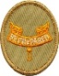

***Second Class:***

***Nick Dawson, Rohan Konda,***

***Maron Sfeir, Jake Royal,***

***Ian Schneider***

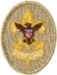

***First Class:***

***Andrew Block, Brooks Chalfant,***

***Nick Dawson***

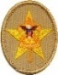

***Star:***

***Aaroosh Kolli, Connor Schulenberg***

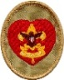

***Life:***

***Tyce Bogdon***

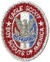 ***Eagle:***

***Arthur Blake 10/19/21***

***David N. “DJ” Brown 08/31/21***

***Trace Cottey 12/14/21***

***Jamie Ezell 08/17/21***

***John Gallagher 12/14/21***

***Parker Grovatt 12/15/21***

***Henry Kelbaugh 06/30/21***

***Brogan Leonard 09/22/21***

***Nick Longmore 04/13/21***

***Tarun Rajanala 01/05/21***

***Philip “Tommy” Wright 06/17/21***

**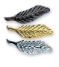 *Palms:  
Bronze – Arthur Blake***

***David N. “DJ” Brown***

***Brogan Leonard***

***Parker Grovatt***

***Gold – Parker Grovatt***

***Silver – Riley Farnsworth***

***Boy Scouts of America***

***Troop 52***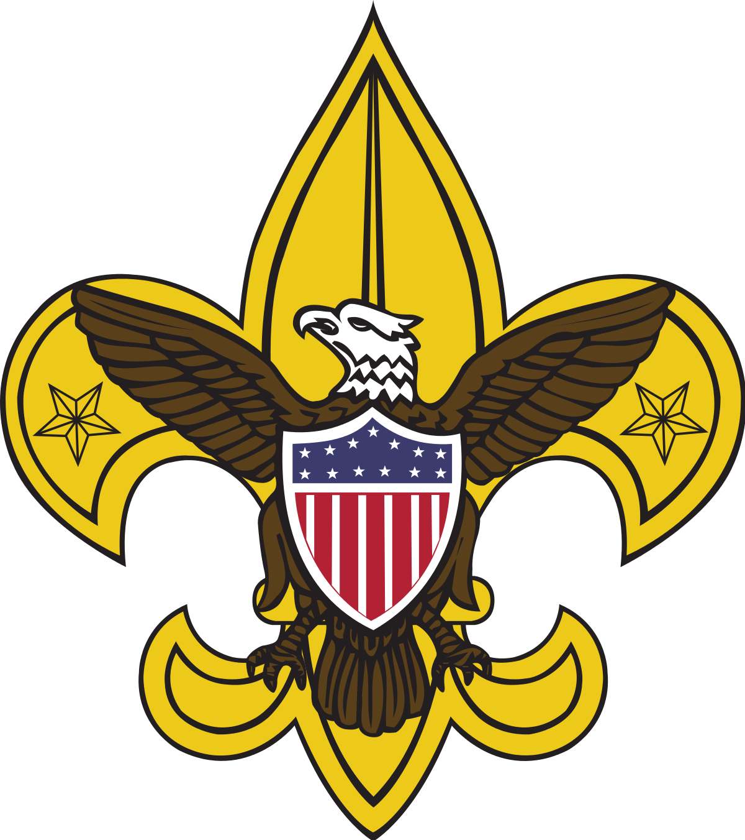

***Court of Honor Ceremony***

***Texas State Capitol Building***

***House Chambers***

***January 9th, 2022  
1:00 pm***

### Welcome and Invocation *John Gallagher – Junior Assistant Scoutmaster*

### *Keller Farnsworth – Chaplain’s Aid*

#### Opening Flag Ceremony *Martin Becker – Senior Patrol Leader*

#### *Aditya Rao – Assistant Senior Patrol Leader*

#### *Jonathan Schulenberg – Assistant Senior Patrol Leader*

#### *Nicholas Royal – Assistant Senior Patrol Leader*

#### *Layton Bates- Assistant Senior Patrol Leader*

#### Merit Badge Achievement Ceremony *Landon Bates*

#### *Drew Campbell*

#### Rank Advancement Ceremony

#### *James Ezell – Scoutmaster*

*Martin Becker – Senior Patrol Leader*

#### Closing Flag Ceremony *Martin Becker – Senior Patrol Leader*

#### *Aditya Rao – Assistant Senior Patrol Leader*

#### *Jonathan Schulenberg – Assistant Senior Patrol Leader*

#### *Nicholas Royal – Assistant Senior Patrol Leader*

*Layton Bates- Assistant Senior Patrol Leader*

**Merit Badge Achievements**

**Blake Bates:** Canoeing

**Landon Bates:** Wilderness Survival

**William Bates:** Canoeing

**Martin Becker:** Citizenship in the Community*

**Tyce Bogdon:** Camping*, Climbing

**Drew Campbell:** Backpacking

**Logan Campbell:** Wilderness Survival

**Brooks Chalfant:** Hiking*, Wilderness Survival

**Trace Cottey:** Backpacking

**Nick Dawson:** Climbing, Wilderness Survival

**Grayson Dehner:** Camping*, Wilderness Survival

**Brant Doggett:** Emergency Preparedness*

**Chase Doggett:** Wilderness Survival

**Tristan Evans:** Backpacking, Camping*, Citizenship in the Community*, Personal Fitness*

**Ethan Ezell:** Camping*, Climbing, Emergency Preparedness*, Personal Fitness*

**Jamie Ezell:** Climbing

**John Gallagher:** Communication*, Cooking*

**Srijan Jagarlamundi:** Citizenship in the Community*, Climbing

**Aaroosh Kolli:** Emergency Preparedness*, Environmental Science*, Personal Fitness*

**Rohan Konda:** Canoeing, Wilderness Survival

**Sarujen Manoharan:** Wilderness Survival

**Joey Meade:** Canoeing, Chess

**Jonathan Ojeda:** Archery

**Xander Palermo:** Swimming*

**Spencer Prow-Nemeroff:** Citizenship in the World*, Cooking*

**Aditya Rao:** Camping*, Climbing

**Jaxson Riener:** Animation, Archery, First Aid*, Game Design, Robotics, Wilderness Survival

**Owen Riener:** Kayaking, Rifle Shooting, Space Exploration

**Jake Royal:** Citizenship in the Nation*, Climbing, Wilderness Survival

**Nicholas Royal:** Climbing

**Hudson Russell:** First Aid*

**Ian Schneider:** Wilderness Survival

**Connor Schulenberg:** Athletics, Cooking*, Orienteering, Personal Fitness*, Sports

**Jonathan Schulenberg:** Backpacking, Citizenship in the Community*, Communication*

**Henry Semph:** Space Exploration, Wilderness Survival

**Maron Sfeir:** Indian Lore, Wilderness Survival

**Ankush Sudhakar:** Canoeing

**Nico Vugrincic:** Canoeing, Swimming*

**Philip “Tommy” Wright:** Backpacking

***\*Eagle Required Merit Badge***

# **Special Scout Awards**

**Totin’ Chip** – Jaxson Reiner

**Firem’n Chit –** Jaxson Reiner