Getting Started in Troop 52
Troop 52 Crossover Ceremony  When: March 3, 2025, 7:00 PM  Where: Barton Creek Preserve @ Nature Conservancy Pavillion  What: Cub Scouts from several local Packs will participate in a sacred ceremony conducted by Order of the Arrow members of Troop 52. Your Scout will cross a ceremonial rope bridge to signify the challenge of their advancement and transition into the Troop. It is a memorable event, and Troop 52 Scouts often spend more than a day constructing the temporary structure just for this ceremony! | 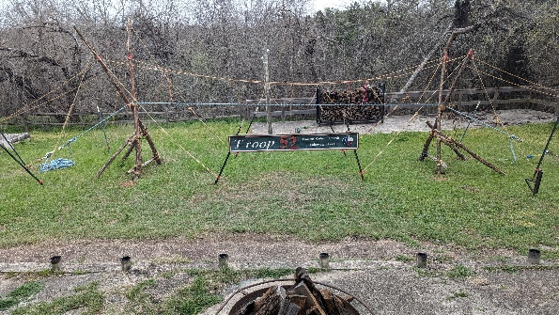  - Ceremonial Rope Bridge (March 4, 2024)
Essential Troop 52 Information
- Troop 52 Meetings: Every Monday at 7PM at the Emmaus Catholic Church - 1718 Lohmans Crossing Rd, Lakeway, TX 78734. Scouts and Adult leaders (“Scouters”) are required to wear Class A uniforms at all Troop Meetings.
- Troop 52 Parent Meetings: “many hands make quick work” – you will hear this saying often. While Troop 52 is a Scout-led organization, it will not thrive without the support and leadership of adult members. Please consider attending parent meetings even if only to provide feedback to the Troop leaders. Parent meetings are held every Tuesday following a campout usually at Emmaus Catholic Church.
- Monthly Campouts: “Scouting is Outing” - camping plays a central role in the Troop and provides focus for activities that help Scouts with rank advancement, merit badges and honing their skills in leadership and teamwork.
Get Started Now!
Before your son crosses over to Troop 52, there are a few tasks you can complete to ensure your he hits the ground running.
- Youth application: You do not need to submit a new application for 2025 (if you have already registered your Scout with Scouts BSA). Please let Bryan Weatherford know if your Scout plans to join Troop 52 and he will transfer your Scout in Scoutbook.
- Adult application: We have found the involvement of parents in their son's path through scouting to be essential. We strongly encourage at least one adult from a scout's family to register with Troop 52. Please download the adult application form (https://filestore.scouting.org/filestore/pdf/524-501.pdf) and turn in the completed application to the Troop Registrar (spears.briant@gmail.com).
- Scouts BSA dues: Required for each youth and adult application. You do not have to pay the annual dues if you have already done so for this calendar year. You can check this by going to https://my.scouting.org and checking under “My Application” section. Recharter will take place toward the end of this year.
- Troop 52 dues: Required for each youth and adult application and can be paid through the Troop 52 store (https://troop52lakeway.us/store/ols/products/2025-troop-52-dues); NOTE if paying by check you can bring it to the Treasurer – Raj Ganta at the crossover ceremony or at a Troop meeting.
- Medical A&B Forms: must be filled out for every participant on all Troop Campouts for both youth and adults; NOTE: form C is required for summer camp and high adventure activities (https://filestore.scouting.org/filestore/HealthSafety/pdf/680-001_AB.pdf)
- Code of Conduct: Scouts must sign the Scout Code of Conduct at ONCE during the school year. Adults planning to participate in Troop campouts, activities or become an adult leader (“Scouter”) must sign the Scouter Code of Conduct ONCE during the school year. Forms can be found on the Troop 52 website: https://troop52lakeway.us/registration-and-dues (under “Registration Forms”)
Adult Training
At Troop 52, we take the personal safety of our Scouts seriously!
- Parents and guardians planning to participate in Troop 52 campouts, activities or become an adult leader ("Scouter") in the Troop MUST HAVE up to date BSA Youth Protection Training (YPT): http://www.scouting.org/Training/YouthProtection.aspx
- Parents who want to become an adult leader (“Scouter”) will need to complete an Ethics & Integrity in Ministry (EIM) Workshop: https://www.austindiocese.org/eim-instructions; NOTE: you do NOT have to complete this workshop to attend Troop 52 campouts
More information can be found at https://troop52lakeway.us/registration-and-dues
Other Important Information
- New Parent Information: tips and tricks on how to survive and thrive in Scouts BSA and Troop 52 https://troop52lakeway.us/new-parent-information
- Camping and Events: https://troop52lakeway.us/camping-%26-events
- Volunteer opportunities: https://troop52lakeway.us/volunteer-opportunities
Parents, if you ever have a question, ask a uniformed adult (called a "Scouter”). A roster of all our adult leaders can be found once you've registered with the troop: https://troop52lakeway.us/org-chart. You may also contact Trevor Montgomery (trevmontgomery@yahoo.com) who is your Pack 442 liaison.

