Troop 52 Dues Renewal Instructions

1. Go to the troop store on the website: [Store](https://troop52lakeway.us/store)
2. Sign into the website
3. Click on “BSA Annual Dues”

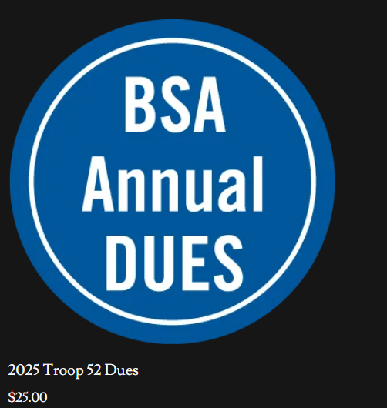

1. Choose scout, enter the scouts name, and click “Add to Cart”

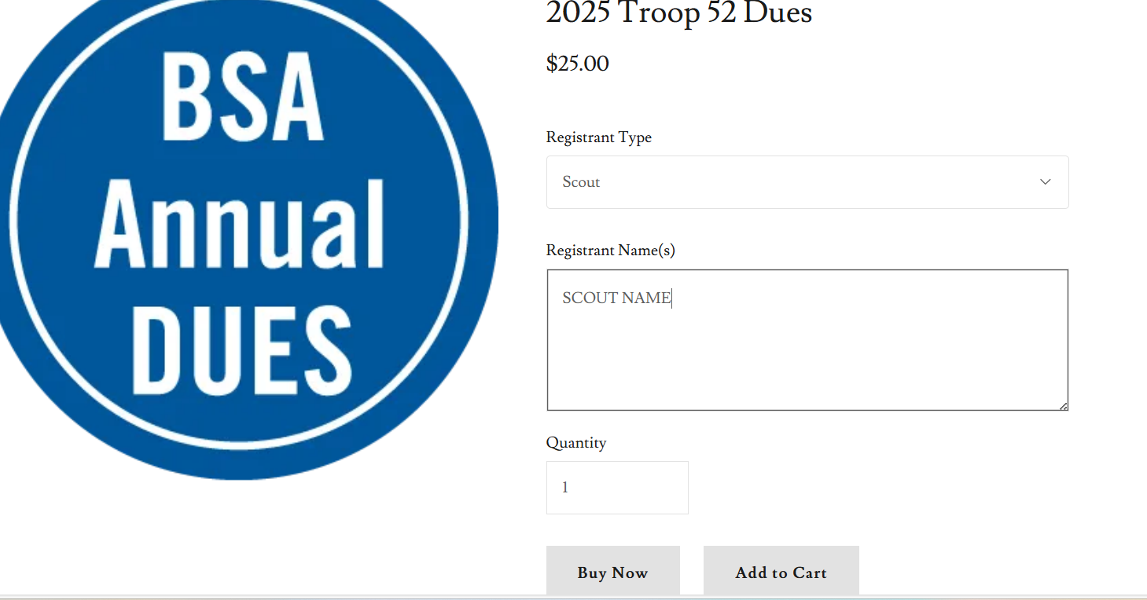

1. If you are an adult leader, repeat step 3 and 4 while selecting adult and entering your name
2. Select “checkout”
3. If you signed in, your info will be filled out. Otherwise fill out your information. Make sure you select “continue”

1. After clicking “continue”, then you can select “PayPal Checkout” (If this button doesn’t seem to work, please make sure you have selected “continue” in the image above.
2. Finalize checkout.