# ***Rank Advancements:***

***Scout: Nick Dawson, Chase Doggett, Jake Royal, Sonny Sciantarelli***

**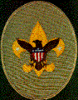 *Tenderfoot:******Mason Browning, Brooks Chalfant, Hudson Russell, Ian Schneider, Henry Semph***

**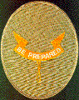 *Second Class: Brett Eaves,***

***Joey Meade, Connor Schulenberg***

**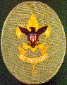 *First Class: Tyce Bogdon, Keller Farnsworth, Keaton Hampton, Aaroosh Kolli, Issac Might,***

***Connor Schulenberg***

**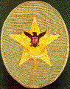 *Star: Martin Becker, Tyce Bogdon, Ethan Ezell, Srijan Jagarlamudi, Mikey Meade, Aditya Rao,***

***Andrew Segner***

**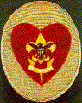 *Life: Tristan Evans, Nicholas Royal***

**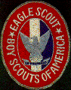 *Eagle:***

***Ryder Farnsworth (6/10/20)***

***Tarun Rajanala (1/5/21)***

***Trace Cottey (2/26/21)***

***Nick Longmore (4/13/21)***

**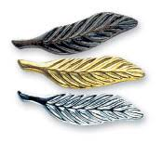*Palms:***

***Ryder Farnsworth (bronze, gold)  
Trace Cottey (bronze)***

***Nick Longmore (bronze)***

***Boy Scouts of America***

***Troop 52***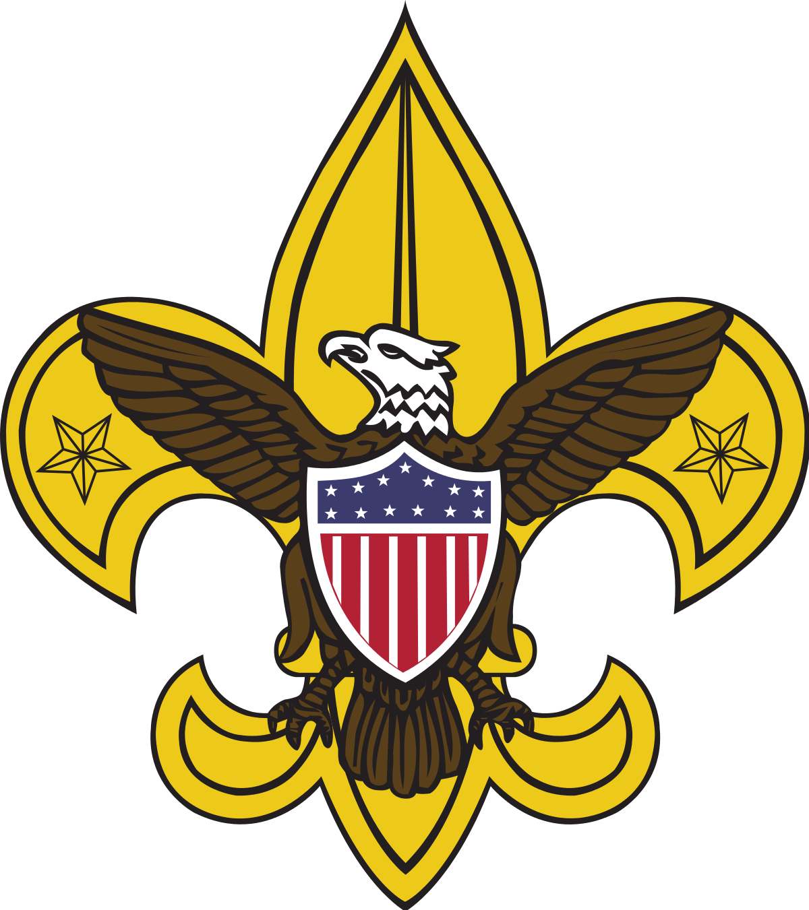

***Court of Honor Ceremony***

***Emmaus Catholic Church***

***April 26, 2021   
7:00 pm***

### Welcome and Invocation *Trace Cottey- Senior Patrol Leader*

### *John Gallagher - Chaplain*

#### Opening Flag Ceremony *Panthers Patrol- Color Guard*

#### Merit Badge Achievement Ceremony *Mikey Meade and Joey Meade* Rank Advancement Ceremony

#### *Andrew Segner and Tyce Bogdon*

#### Eagle Recognition *Matt Gomes - Scoutmaster*

**Awards and Special Recognition**

#### *Matt Gomes - Scoutmaster*

**Closing Flag Ceremony***Trace Cottey - Senior Patrol Leader*

#### *Panthers Patrol - Color Guard*

#### 

**Merit Badge Achievements:**

**Martin Becker:** Citizenship in the World*, Communication*, Cooking*, Welding

**Arthur Blake:** Communication*, Personal Fitness*

**Tyce Bogdon:** Cooking*, Emergency Preparedness*, Family Life*, Space Exploration

**Drew Campbell:** Welding

**Brooks Chalfant:** Space Exploration

**Brant Doggett:** Cooking*, Family Life*

**Brett Eaves:** Fishing

**Tristan Evans:** Welding

**Ethan Ezell:** Cooking*, First Aid*, Space Exploration

**Jamie Ezell:** Emergency Preparedness*, Personal Fitness*, Space Exploration

**John Gallagher:** Personal Management*, Family Life*

**Parker Grovatt:** Citizen in the Community*

**Keaton Hampton:** Citizenship in the Community*, Citizenship in the Nation*, Communication*, Fingerprinting, Leatherwork, Personal Fitness*, Personal Management*, Photography, Pottery, Cyber Chip

**Srijan Jagarlamudi:** Camping*, Citizenship in the World*, Communication*, Environmental Science*, First Aid*, Personal Management*

**Nick Longmore:** Cooking*, Citizenship in the Community*, Communication*

**Alejandro Loredo:** Citizenship in the Nation*

**Joey Meade:** Communication*, Family Life*, Space Exploration

**Mikey Meade:** Communication*, Family Life*, Fishing, Space Exploration

**Aditya Rao:** Communication*, Cooking*

**Nicholas Royal:** Communication*

**Jonathan Schulenberg:** Camping*, Cooking*, Personal Management*

**Sonny Sciantarelli:** Space Exploration

**Andrew Segner:** Digital Technology, Energy

**\*Eagle Required Merit Badge**

**Special Awards:**

**Firem’n Chit and Totin’ Chip**

Curt Beaird

Thomas Clark

Colton Colwell

Nick Dawson

Chase Doggett

Evan Johnsrud

Nirujen Manoharan

Sarujen Manoharan

Jonathan Ojeda

Dylan Ouellette

Gavin Ouellette

Xander Palermo

Thomas Pitts

Jackson Prehn

Jake Royal

Erik Schneider

Maron Sfeir

Evan Soto

Ankush Sudhakar

Nico Vugrincic

Leo Walters

**NYLT – March 2021**

Martin Becker

Tristan Evans