Merit Badge Achievements Continued…

Jeremy Suh: Backpacking, Scouting Heritage
Dominic Vugrincic: Fingerprinting, Chess
Leo Walters: Swimming*, Art, Fingerprinting, Leatherwork, Robotics, Chess, Kayaking, Game Design, Animation
*Eagle Required Merit Badge

Special Scout Awards:(not worn on uniform or sash)
Mile Swim – Tyce Bogdon
Snorkeling BSA – Tyce Bogdon, Dylan Chastain,
Brett Eaves, Riki Goss, Keaton Hampton, Nicholas Royal

Rank Advancements:
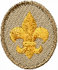
Scout: Evan Johnsrud, Rohan Konda, Nirujen Manoharan,
Sarujen, Manoharan, Xander Palermo,
Erik Schneider, Maron Sfeir,
Ankush Sudhakar, Dominic Vugrincic, Leo Walters
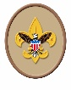
Tenderfoot: Nicholas Dawson, Rohan Konda, Jake Royal, Maron Sfeir
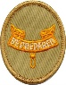
Second Class: Brooks Chalfant, Hudson Russell, Henry Semph
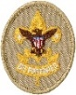
First Class: Logan Campbell,
Brett Eaves, Riki Goss, Henry Semph
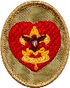
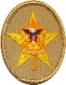
Star: Brant Doggett, Jacob Gomes, Keaton Hampton, Alejandro Loredo, Jeremy Suh
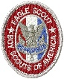
Life: Martin Becker, Ethan Ezell, Srijan Jagarlamudi, Aditya Rao, Andrew Segner
Eagle: Philip “Tommy” Wright
Henry Kelbaugh, Jamie Ezell

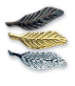
Palms:
Bronze – Philip “Tommy” Wright,
Henry Kelbaugh, Jamie Ezell
Gold – Henry Kelbaugh, Jamie Ezell

Boy Scouts of America
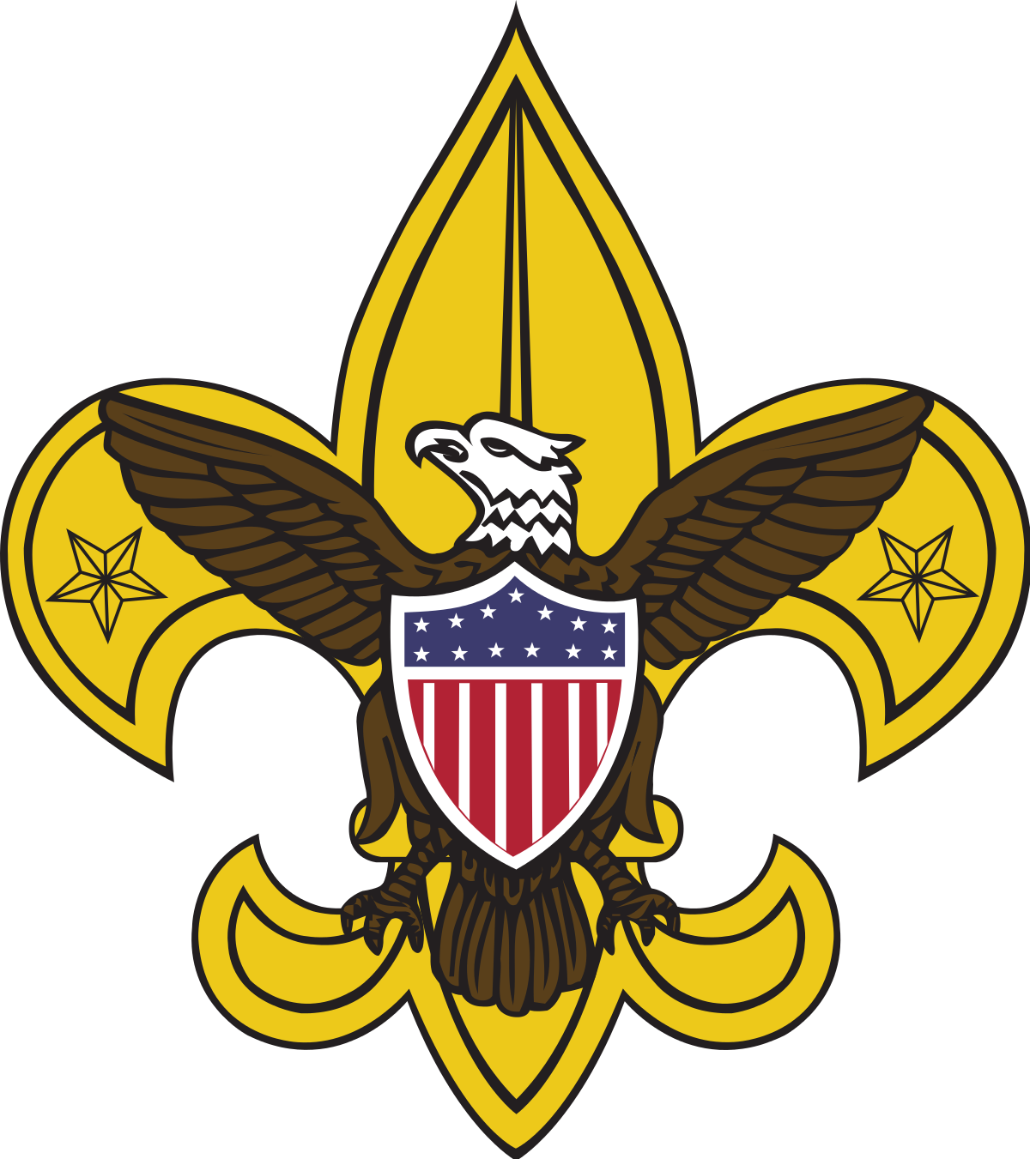
Troop 52
Court of Honor Ceremony
Emmaus Catholic Church
August 30th, 2021
7:00 pm

Welcome and Invocation
Tristan Evans - Senior Patrol Leader

Opening Flag Ceremony
Life Scouts - Color Guard

Merit Badge Achievement Ceremony
Jonathan Schulenberg and Connor Schulenberg
Rank Advancement Ceremony

Tristan Evans and Martin Becker

Awards and Special Recognition

Matt Gomes - Scoutmaster
New Scoutmaster Installation Ceremony
Matt Gomes - Scoutmaster
Closing Flag Ceremony
Tristan Evans - Senior Patrol Leader

Life Scouts - Color Guard

Merit Badge Achievements:
Blake Bates: Motorboating
Landon Bates: Motorboating
Curtis Beaird: Art, Leatherwork
Martin Becker: Environmental Science*, Swimming*, Fingerprinting, Pottery
Tyce Bogdon: Communication*, Environmental Science*, Personal Fitness*, Indian Lore, Oceanography, Shotgun Shooting
Keanan Butler: Oceanography
Logan Campbell: Climbing
Brooks Chalfant: Astronomy, Canoeing, Geocaching, Chess, Kayaking
Thomas Clark: Astronomy, Basketry, Pottery, Wilderness Survival, Wood Carving, Chess, Kayaking
Colton Colwell: Leatherwork, Wood Carving, Chess
Nicholas Dawson: Swimming*, Fingerprinting, Indian Lore, Leatherwork, Wood Carving, Chess, Kayaking
Grayson Dehner: First Aid*, Swimming*, Canoeing
Brant Doggett: Environmental Science*, First Aid*, Pottery, Kayaking
Chase Doggett: Swimming*, Water Sports, Robotics, Chess, Kayaking, Game Design, Animation
Brett Eaves: Environmental Science*, Lifesaving*, Swimming*, Canoeing, Motorboating, Oceanography, Wilderness Survival, Search and Rescue
Tristan Evans: Cooking*, Family Life*
Ethan Ezell: Environmental Science*, Personal Management*, Shotgun Shooting, Scuba Diving, Welding
Jamie Ezell: Astronomy, Backpacking, Scuba Diving, Scouting Heritage
Ryder Farnsworth: Kayaking
Owen Gab: Oceanography
John Gallagher: Personal Fitness*, Backpacking, Scouting Heritage
Jacob Gomes: Communication*, Environmental Science*, First Aid*, Swimming*
Parker Grovatt: Citizenship in the World*,
Communication*
Keaton Hampton: Emergency Preparedness*, Environmental Science*, Archery, Cooking*, Motorboating, Oceanography, Geocaching, Welding
Srijan Jagarlamudi: Citizenship in Nation*, Lifesaving*, Personal Fitness*, Cooking*, Leatherwork, Orienteering, Family Life*, Kayaking
Evan Johnsrud: Art, Basketry, Fingerprinting, Indian Lore
Henry Kelbaugh: Backpacking, Scouting Heritage
Aaroosh Kolli: Lifesaving*, Kayaking
Rohan Konda: Swimming*, Leatherwork, Motorboating, Wood Carving, Chess, Kayaking
Alejandro Loredo: Swimming*, Motorboating, Kayaking
Nirujen Manoharan: Swimming*, Fingerprinting, Indian Lore, Leatherwork, Wood Carving, Chess, Kayaking
Sarujen Manoharan: Swimming*, Canoeing, Fingerprinting, Indian Lore, Leatherwork, Wood Carving, Chess, Kayaking
Joey Meade: Environmental Science*, First Aid*, Personal Fitness*, Swimming*, Weather, Wilderness Survival
Mikey Meade: Personal Fitness*, Geology, Weather
Jonathan Ojeda: Leatherwork, Chess, Kayaking, Wood Carving
Xander Palermo: Fingerprinting, Chess, Kayaking
Thomas Pitts: Leatherwork, Wood Carving, Chess
Spencer Prow-Nemeroff: Cooking*
Aditya Rao: Citizenship in the Community*, Emergency Preparedness*, Environmental Science*, Lifesaving*, Personal Management*, Leatherwork, Photography, Space Exploration, Wood Carving, Kayaking, Search and Rescue
Michael Ray: Leatherwork, Wood Carving
Jake Royal: Swimming*, Canoeing, Fingerprinting, Indian Lore, Leatherwork, Wood Carving, Robotics, Chess, Kayaking, Game Design, Animation
Nicholas Royal: Citizenship in Nation*, Kayaking
Hudson Russell: Swimming*, Electronics, Indian Lore, Leatherwork, Nature, Wood Carving, Chess, Kayaking, Programming
David Schelling: Environmental Science*
Erik Schneider: Swimming*, Art, Fingerprinting, Indian Lore, Photography, Wood Carving, Chess, Kayaking
Ian Schneider: Swimming*, Astronomy, Fingerprinting, Geology, Indian Lore, Robotics, Chess, Kayaking
Connor Schulenberg: Camping*, Canoeing, Indian Lore, Motorboating, Wilderness Survival, Climbing
Jonathan Schulenberg: Citizenship in the World*, Environmental Science*, Lifesaving*, Indian Lore, Rowing
Andrew Segner: Citizenship in Community*, Communication*, Personal Fitness*,
Personal Management*, Swimming*, Cooking*,
Space Exploration
Henry Semph: Swimming*, Astronomy, Fishing, Chess
Maron Sfeir: Swimming*, Canoeing, Fingerprinting, Leatherwork, Small Boat Sailing, Wood Carving, Chess, Kayaking
Ankush Sudhakar: Swimming*, Fingerprinting, Indian Lore, Leatherwork, Wood Carving, Chess

*Eagle Required Merit Badge

