Port-o-can delivery 325-451-0720 - Dean

**Directions to Wood Ranch**

From Dillard’s Parking lot head West on Hwy 71 – 58 miles

Turn right in Llano on Hwy 16  -  33.7 miles

Turn left in downtown San Saba on Hwy 190  - 14.7 miles

Turn right on FM 45 in Richland Springs - .3 miles

Turn Left on West Main St. or FM 45, follow curve right  on FM 45 – 3 miles

Turn left on FM 2997   -  2.2 miles

Turn right on Cr 264   - 1.2 miles

Turn left at the T  on CR  262 – 2nd house on the right.

Entrance to camping area is right at the 90 degree curve

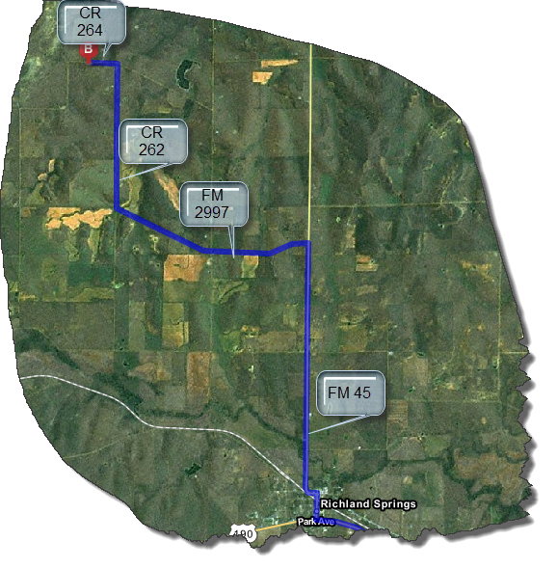

|  |  |  |  |
| --- | --- | --- | --- |
|  | 3. | Take the 1st **right** onto **W Highway 71/TX-71**. Continue to follow **TX-71**.  •         *Greenhouse Mall is on the corner*  •         *If you are on Shops Pkwy and reach Crosstown Pkwy you've gone about 0.3 miles too far* | 57.9 mi |
|  | 4. | Turn **right** onto **Ford St/TX-16/TX-71**. Continue to follow **TX-16**.  •         *TX-16 is 0.1 miles past Hickory St* | 33.7 mi |
|  | 5. | Turn **left** onto **E Wallace St/US-190 W**. Continue to follow **US-190 W**.  •         *US-190 W is just past E Commerce St*  •         *If you are on N High St and reach E Brown St you've gone a little too far* | 14.7 mi |
|  | 6. | Turn **right** onto **Wish St/FM-45**.  •         *Wish St is just past Church St*  •         *If you are on US-190 E and reach S Brown St you've gone a little too far* | 0.3 mi |
|  | 7. | Turn **left** onto **W Main St/FM-45**.  •         *United States Postal Service is on the left* | 0.09 mi |
|  | 8. | Turn **slight right** onto **FM-45/Brownwood St**. Continue to follow **FM-45**.  •         *FM-45 is just past Auburn*  •         *If you reach Marion St you've gone about 0.2 miles too far* | 2.6 mi |
|  | 9. | Turn **left** onto **FM-2997/FM 2997**.  •         *If you reach County Road 233 you've gone about 2.9 miles too far* | 2.2 mi |
|  | 10. | Turn **right** onto **County Road 262**.  •         *If you reach County Road 264 you've gone about 1.0 mile too far* | 0.7 mi |
|  | 11. | **County Road 262** becomes **unnamed road**. | 1.2 mi |
|  | 12. | **COUNTY ROAD 264**.  •         *If you reach FM-2997 you've gone about 2.1 miles too far* |  |

