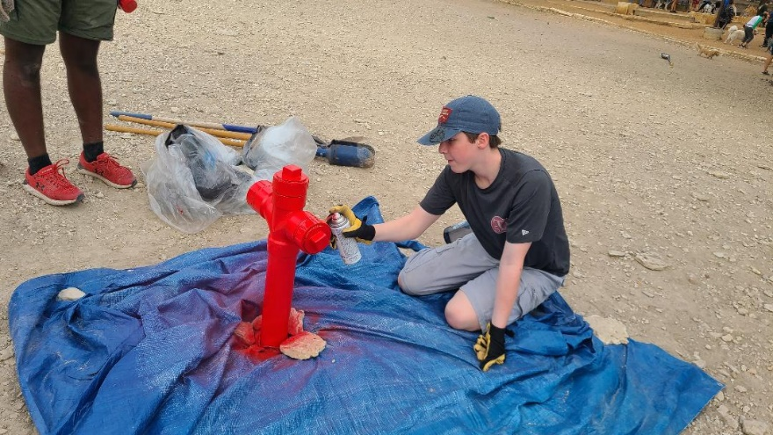

**Congratulations to Nicholas Royal on completing his Eagle Project!**

Thank you to all the volunteers who joined

**Join us on Monday, October 17, at 7:00 pm, for a visit from Lakeway PD and K-9 Officer “Rino”** 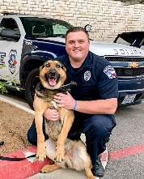

We will have a visitor to our next troop meeting. Officer Eric Sooter and K-9 “Rino” will give a brief talk to the boys about the dangers of narcotics. Then, we will move into beginning the Archery Merit badge.

for Second Class as well as Personal Fitness Merit Badge #1A2.

Don’t miss this meeting! We will start on time, so please arrive early! (I think it’s pronounced “Reno” FYI).

**Upcoming Troop Meetings – 7:00 pm – Emmaus**

10/10 – School holiday. No troop meeting.

10/17 – Officer Eric Sooter and K-9 Rino, then begin Archery Campout prep. Great meeting for Webelos. (I think it’s pronounced “Reno”).

10/24 – Archery Campout Prep – menu planning and archery safety. Scouts who need to be grubmaster for rank advancement will have first priority. Then, scouts working on Cooking merit badge will have priority at the Cooking Campout in November.

10/31 – Halloween – No troop meeting.

Note: Webelos dens are welcome to attend any troop meeting.

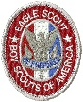

**Nicholas Royal Eagle Project Workday – October 15, 2022 – Bee Cave Central Park**

Please join me on October 15th, 8-3 for Nicholas Royal's Eagle Scout Project. Everyone in our troop is invited to attend the Eagle Project. We will be building a dog course at the Bee Cave City Dog Park. At the project we will have donuts, pizza, and attending will give you hours for Cavs in Service, NJHS, NHS, and rank advancement. We will be making 2 different size ramps, a bench, tire tunnels, and a fire hydrant. I will need a few adults to help cut some of the materials so this is a project for scouts and adults.

**Bring water bottles, gloves, shovels, eye protection, grubbing hoes, and power tools for screws and cutting if you have them.**

Address: City of Bee Cave Central Park, 13676 Bee Cave Pkwy, Bee Cave, TX 78738

Thank you,

Nicholas Royal

 

**Shred Day – Emmaus front parking lot – Saturday, October 22, 2022, 7:45 am – noon**

Please note corrected date!

We need all scouts to attend October Shred Day. It is a required event because it is our primary fundraiser. We don’t sell popcorn. We shred! All scouts should wear their Class A uniforms and big smiles as we offer this service to our community. Because it is a fundraiser, we do not count it as service hours toward advancement, but you may use it for Cavs in Service, NHS, NJHS, etc.

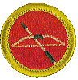

**Archery Campout – October 28-30, 2022 – Volunteers needed! – Lost Pines**

Attention parents:

We are confirmed for the first archery campout we’ve done since 2018. We have booked the archery range at Lost Pines for October 29, camping two nights. We are in need of lots of adult support. Boys will do cooking by patrols. Bats will eat separately.

Campsite Dacy:

<https://www.bsacac.org/wp-content/uploads/2021/02/LPSR-Map-2021.pdf>

Needs:

SIC – Mr. Howard – first time SIC – thanks!

Bat Grubmaster – Mr. Rao

Pull Troop Trailer: – ?

Pull Troop Smoker: – ?

Archery Instructors –Ms. Steele, Mr. Howard, Mr. Meade, Mr. Schulenberg, Mr. Schultz

**Introduction to Outdoor Leader Skills (IOLS) Training – November 5-6**

Attention Troop 52 Adults,

Good news! We have been granted permission by Bee Cave District leadership to conduct our own Introduction to Outdoor Leader Skills (IOLS) training course instead of sending our people to something like Mega Training or other council level events. This course will certify you to be a trained Assistant Scoutmaster (ASM). We need your attendance. Instructors will be existing Troop 52 adults who have already taken IOLS.

IOLS covers almost all the rank requirements for scouts up to First Class. Adults will learn the patrol method and the necessary skills to be an ASM to teach the scouts. Since IOLS requires an overnight stay, we have been given permission to camp at the Nature Conservancy on Saturday night, November 5, then departing Sunday before noon. This will be an all-day course. There will be no partial credit or leaving early.

There will be more details forthcoming along with a supply sheet, but I wanted to go ahead and get this on the calendar. Please RSVP to James Ezell. Your service to the boys is much appreciated. Our troop can only be as strong as the commitment of our adults to serve the boys, so thank you for your help.

NOTE: This is for adults only. No scouts.



**Cooking Merit Badge Campout – November 11-13, 2022 – Doggett Ranch in Goldthwaite**

Scouts will begin work on Cooking merit badge at the troop meeting on November 7. Patrols will choose grubmasters and do menu planning. There will be two contests at the campout: Dinner competition in a Dutch oven and dessert any way.

SIC: Mr. Doggett and Mr. Sfeir

Bat Grubmasters – Mr. Doggett and Mr. Russell

Pull Troop Trailer: – ?

Pull Troop Smoker: – ?

**Philmont 2024 Announcement!**

Thank you to Mr. Sfeir for heading up Philmont 2024! Crew sizes are 8-12 people, including scouts and adults. If you want to go to Philmont in 2024, now is your time to get organized and register. Please contact Mr. Sfeir. This is truly one of the most important and meaningful opportunities in Scouting and should not be missed. Scouts will need to be 14 years old by departure date (or have completed 8th grade). More info about signing up here: <https://registerphilmont.org/entry/2024>

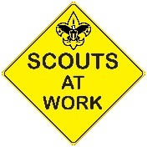

**Fall Service Hour Opportunities**

This fall there are many opportunities to earn service hours for both Troop and Community projects. Here are the current service hour opportunities for September, October, November and December.

Ongoing - Eagle Projects (Troop)

There are quite a few Life Scouts in our troop who are working hard on their Eagle projects this fall and they will need your help. Be on the lookout for separate emails regarding these unique Eagle project opportunities this fall. Remember someday you will need help from younger Scouts for your Eagle project - now is the time to *pay it forward*!

Sunday, October 23 (3 Hours - Community)

Volunteer to help to set up and clean up at the Lakeway *Arts in the Afternoon* concert. The City of Lakeway Arts Committee would like to have at least 4 Scouts volunteer for the upcoming concert at Hurst Creek Sculpture Garden (102 Cross Creek - next to the Lakeway Justice Center). Scouts should be at least Second Class rank for this event. Volunteer shift runs from 3-6 PM. If you are interested, please contact [Ms. Dawson](mailto:veldawson@gmail.com) to sign up.

Sunday, November 20 (2 Hours - Community)

Volunteer to help to set up and clean up at *The Lakeway Painters Annual Art Show*. They would like to have at least 3-5 older Scouts volunteer for the upcoming art exhibit at The Hills Country Club (26 Club Estates Parkway, The Hills). Scouts should be at least First Class and 13 years old for this event. You can volunteer in the 9-10 AM and/or 3-4 PM shift(s). If you are interested, please contact [Ms. Dawson](mailto:veldawson@gmail.com) to sign up.

Saturdays - Oct 8, Nov 12 and/or Dec 10 (3 Hours - Community)

Volunteer and help to clean up our local parks on the second Saturdays of the month from approx 8am-12noon. These opportunities can qualify for conservation service hours, depending on the projects worked on. Visit either the Lakeway or Bee Cave website below to find out more details about how you can volunteer.

* Friends of the Park Lakeway - [lakewayfop.org](http://lakewayfop.org/)
* Bee Cave Friends of the Park Foundation - [beecavefop.org](http://beecavefop.org/)

Saturday, December 17th - [Wreaths Across America](https://wreathsacrossamerica.org/pages/19583/Overview/?relatedId=19520).(3 Hours - Community)

Volunteer to help distribute holiday wreaths to honor the lives of US Veterans in the Texas State Cemetery in Austin. Scouts will meet at 11am on Saturday Dec 17th at Texas State Cemetery located at 909 Navasota Street, Austin, TX 78702. If you are interested, please contact [Ms. Dawson](mailto:veldawson@gmail.com) to sign up.

Understanding Troop vs Community Service Hours

Eagle projects are Troop-based and do not require pre approval. However before embarking on any Community service hours project, remember to fill out the [**Community Service Hours (CSH)**form](https://img1.wsimg.com/blobby/go/c9c78b66-b90a-463e-bd5d-f56d564ec7e4/downloads/T52-CommunityServiceHoursForm.pdf?ver=1650645685582) to get approval from your patrol's ASM or a Service Hours Coordinator (Ms Dawson or Ms Cooper). You will also be required to have approval from the community representative in charge of the service project. The CSH form explains it all.

Use this link to the download the Community Service Hours Form:

<https://img1.wsimg.com/blobby/go/c9c78b66-b90a-463e-bd5d-f56d564ec7e4/downloads/T52-CommunityServiceHoursForm.pdf?ver=1650645685582>

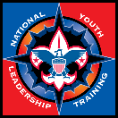

**NYLT winter spots are open**

Scouts, if you are interested in attending NYLT (National Youth Leadership Training) this winter between Christmas and New Year’s Day, please email Mr. Ezell. Troop 52 strongly encourages candidates for Senior Patrol Leader to attend the course.

The NYLT course centers around the concepts of what a leader must BE, what a leader must KNOW, and what a leader must DO. The key elements are then taught with a clear focus on HOW TO. The skills come alive during the week as the patrol goes on a Quest for the Meaning of Leadership. NYLT is a six-day course. In order to attend a NYLT course, a youth must have the following qualifications by the beginning of the course: be a registered member of a Scouting unit, have a current BSA Health and Medical Record form parts A, B, and C; must be at least 13, and have a Scoutmaster recommendation.

Details: <https://www.scouting.org/programs/scouts-bsa/troop-resources/nylt/>

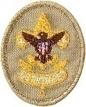

**Trail to First Class Activities**

November – TBD

December 14 Lakeway City Park, upper pavilion – TBD

Each month Mr. Schulenberg will be hosting Trail to First Class workshops at Lakeway City Park. Beginning on April 9, these workshops will take place on the second Saturday of every month from 9-11 AM at the upper pavilion. We will focus on rank advancement skills and knowledge from Scout through First Class. All scouts are welcome to join in, to listen, learn, and participate. For the older scouts, this is an opportunity to earn rank advancement by helping to lead these sessions by demonstration the EDGE method.

During these 2 hour sessions we will work together through each of the requirements in Scout, Tenderfoot, Second Class, and First Class, including some of the more challenging activities such as first aid, knots, fire building, nature hikes, and the physical fitness requirements. Our goal is to have fun and learn from each other. Please see the Troop Calendar for workshop details.



**Please use these photo albums to view and upload photos from our events:**

**Canoe Campout**

[**https://photos.app.goo.gl/uBtus44LmXdt13px7**](https://photos.app.goo.gl/uBtus44LmXdt13px7)

**Canyonlands Trailhead Hike**

[**https://photos.app.goo.gl/pnenBQqTbWBfp1sC7**](https://photos.app.goo.gl/pnenBQqTbWBfp1sC7)

**Jonathan Schulenberg’s Eagle Project**

[**https://photos.app.goo.gl/FY79VfNtTv2rodRN6**](https://photos.app.goo.gl/FY79VfNtTv2rodRN6)

**Aviation Merit Badge**

[**https://photos.app.goo.gl/aVNrJFkUN9GuYwwL8**](https://photos.app.goo.gl/aVNrJFkUN9GuYwwL8)

**Afghan Families Service**

[**https://photos.app.goo.gl/Lfhu4JVcUhctWY386**](https://photos.app.goo.gl/Lfhu4JVcUhctWY386)

**Electronics Lock-In**

[**https://photos.app.goo.gl/7iXfai3v5VXXf2Ug6**](https://photos.app.goo.gl/7iXfai3v5VXXf2Ug6)

**Motorboating Merit Badge Class**

[**https://photos.app.goo.gl/2twhWApMiL4xXhHL9**](https://photos.app.goo.gl/2twhWApMiL4xXhHL9)

**Court of Honor**

[**https://photos.app.goo.gl/xbZmLXKKma86BrUe7**](https://photos.app.goo.gl/xbZmLXKKma86BrUe7)

**Environmental Science Merit Badge Workshop**

[**https://photos.app.goo.gl/AkXijM6htso9VrgT6**](https://photos.app.goo.gl/AkXijM6htso9VrgT6)

**Summit at Bechtel Reserve**

[**https://photos.app.goo.gl/n7y2rm2YGkmAanx69**](https://photos.app.goo.gl/n7y2rm2YGkmAanx69)

**Troop Blog**

If you need to check for announcements on the troop web site, we do have a blog that gets updated by Tray Bates. You can access it here: <https://troop52lakeway.us/blog>

**Remember!**

