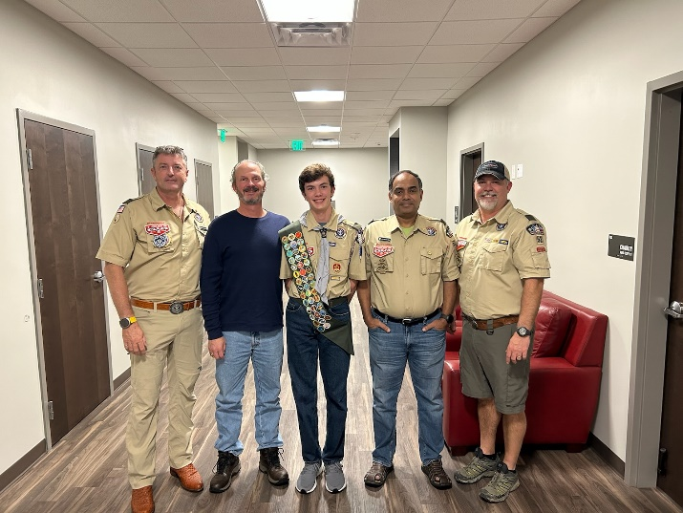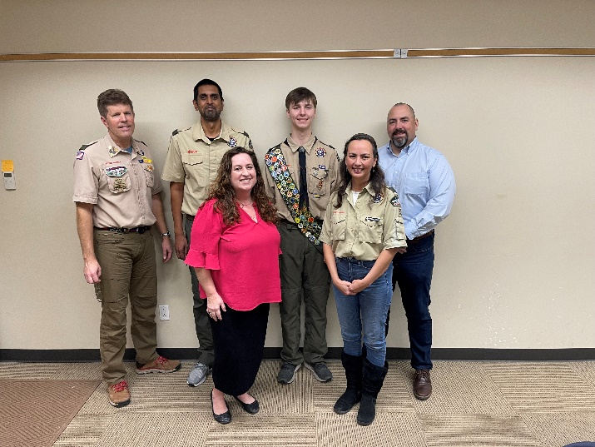

Two new Eagle Scouts!
Please congratulate and welcome the two newest Eagle Scouts for Troop 52! We had two BORs this week. Nicholas Royal - 2/7/2023 and Keaton Hampton - 2/8/2023! Congratulations, gentlemen! Nicholas’ project was building ramps and obstacles for the Bee Cave City Dog Park. Keaton’s project was building steps, a rail, and a manger for the Christmas pageant at The Lakeway Church. Everyone is proud of you. You are both joining a very distinguished list of scouts. These boys continue the long tradition of excellence at Troop 52. Thank you to the adults who served on their Boards of Review.

From the SPL
Hello Troop 52,
For the upcoming meeting on February 13th, we will have a day to talk about Wilderness Survival skills and have the younger scouts sign off on these skills. We should use the next troop meeting to go over the basics and plan for each of these stations. We can use the troop meeting on 02/20 to finish on the stations and also discuss with adults on logistics like trailer, water buffalo and smoker.

Feb 13 :- Basic Wilderness Survival Training
Feb 20 :- Sign-Off Day for Wilderness Survival Skills, and making sure Scouts are prepared.

--
Thanks,
Aditya Rao
adityavrao13@gmail.com

Troop Meeting – Monday, February 13, 2023 – 7:00-8:30 – Emmaus
Wilderness Survival Campout – February 24-26, 2023 – Inks Lake State Park

The February campout will be Wilderness Survival. We have several new Webelos who have already had their Blue and Gold Banquets early. They are welcome to join us at our troop meetings, but their official entry into the troop will be March 6 at the Crossover ceremony bridge. Our usual first campout for new scouts is in March for the Fishing merit badge to give them time to become accustomed to Troop 52. You may skip the Wilderness Survival campout if you would like. Another one will come next year. We will cover the classroom portions of Wilderness Survival at the two troop meetings leading up to the campout. Prior to the troop meeting, please print the merit badge worksheet: http://usscouts.org/usscouts/mb/mb117.asp

Thanks for your help in making this campout happen. Mr. Ezell and Mr. Chalfant will be out for this campout. Adults, please volunteer to assist Dustin Hoff, the SIC, by teaching a station at the campout. Many hands!

Important Dates:
Feb 13 – Troop Meeting – teach Wilderness Survival merit badge
Feb 20 – Troop Meeting – teach Wilderness Survival merit badge (Philmont crews are out in Big Bend) Need ASM to run meeting.
Feb 24-26 – Campout
Feb 27 – PLC – No Troop Meeting

SIC – Dustin Hoff
Grub Master –
Quarter Master –
Pulling Trailer –
Pulling Smoker –
Water Buffalo –
Activity Leader –
Campout SPL –
Closest Medical Facility –
Phone Tree Emergency Contact and Ph # –
Contact not at event --
Departure Time and Location –
Expected Return Time and Location –
Coffee has been checked? –
Google Maps – Inks Lake State Park:
https://www.google.com/maps/place/Inks+Lake+State+Park/@30.737281,-98.3693205,151m/data=!3m1!1e3!4m14!1m7!3m6!1s0x865afb95d363f72f:0xc99d574116003081!2sInks+Lake+State+Park!8m2!3d30.7373973!4d-98.3690256!16zL20vMDlzdDI0!3m5!1s0x865afb95d363f72f:0xc99d574116003081!8m2!3d30.7373973!4d-98.3690256!16zL20vMDlzdDI0

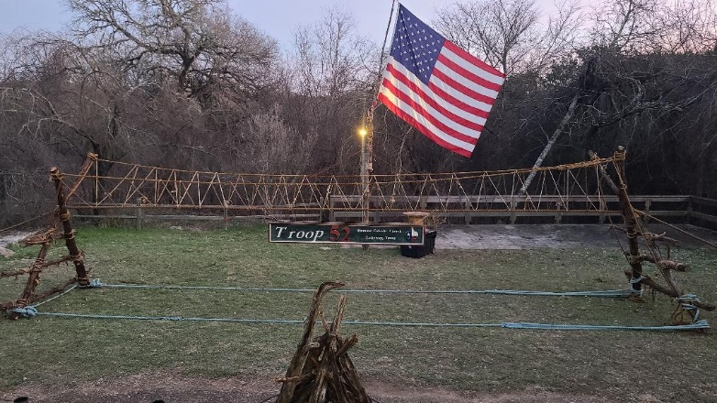

Bridge Build – Sunday, March 5, 2023 – 10:00 am-2:00 pm (or until finished)
Crossover Ceremony – Monday, March 6, 2023 – 7:00 pm
Scouts who are already members will arrive on Sunday to construct the bridge. You will get credit toward the Pioneering merit badge. All new Webelos crossing over may not attend Sunday. All scouts, including crossovers, will attend on Monday for the ceremony.

Monday, March 6, marks new scouts’ official entry into Troop 52 with our crossover ceremony at the Nature Conservancy. The entrance is located on Bee Cave Road near Lake Hills Church. Scouts will cross our rope bridge and shake hands with everyone. We will all enjoy some of that delicious Troop 52 cobbler. The troop registrar will take applications. Scouts and parents will sign code of conduct forms. You will have an opportunity to buy swag - hats, class B shirts, hoodies, cups, etc.

Adults, please bring a camp chair and a blanket if you get cold. New scouts will sit on benches up front. Please wear Class A uniforms.

If you have not used this entrance before to the Nature Conservancy, it is located at Resaca Boulevard and Bee Cave Road. Turn right on Resaca, left like you are entering the parking lot for Lake Hills Church, but instead take the dirt road labeled "The Nature Conservancy." Park in the upper area and walk down. The stairs are in need of repair, so avoid them. They are blocked off.

Map link:
https://www.google.com/maps/place/30%C2%B018'31.3%22N+97%C2%B055'02.8%22W/@30.308692,-97.9179882,193m/data=!3m2!1e3!4b1!4m14!1m7!3m6!1s0x865b37cad5ea6441:0xadd4c3fa3815d0c9!2s11521+Bee+Cave+Rd,+Austin,+TX+78738!3b1!8m2!3d30.3088452!4d-97.9160503!3m5!1s0x0:0xbfdf0ec65aa048d4!7e2!8m2!3d30.3086919!4d-97.9174409

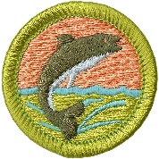

Fishing Campout – March 24-26, 2023 – Tom Wood Ranch
Our next campout will be the Fishing campout. Younger scouts will work on the Fishing Merit Badge. Older scouts will get an opportunity to work on another merit badge to be decided by the PLC. The cost is $20 per person. Please register by Wednesday evening on the troop web site in the troop store: https://troop52lakeway.us/

All registered adults are welcome to attend Troop 52 campouts. Prior to doing so, you must complete an adult BSA application, YPT (Youth Protection Training), and EIM (Ethics and Integrity in Ministry). Your existing Cub Scout YPT is sufficient. EIM is taught by the Austin Diocese. This training is mandatory and exceptions cannot be granted. It is good for three years. Instructions for taking the class are here: https://austindiocese.org/application

The fishing campout is located at 3605 CR 264, Richland Springs, Texas 76871. We will meet in the parking lot near the tennis courts at LTMS at 6:00 pm on Friday, March 4. We will make sure there are enough drivers before departing. You can use these directions: https://www.google.com/maps/place/3605+Co+Rd+264,+Richland+Springs,+TX+76871/@31.340591,-98.9872645,17z/data=!3m1!4b1!4m5!3m4!1s0x8650a7bc1c2a8e63:0x9eeee76c04f076d9!8m2!3d31.340591!4d-98.9850758

Camporee Logo Design Contest – From the Order of the Arrow Camporee Team:
We're designing our logo for our 2023 Bee Cave District Camporee! If you’d like a chance to design our patch, please email Henry Kelbaugh with your design within a couple weeks. Please include the following on your design:
- Some text indicating that this patch is for Bee Cave District’s 2023 Camporee
- Something related to the Night at the Museum theme (which we’re now calling Campout at the Museum: Battle of the Camporee)
- Must be Scout appropriate (no weapons, foul language, etc.) and legible at patch size (please submit a .pdf, .jpeg, .png, or .psd file)

Example patch designs can be found at https://www.beecavedistrict.org/node/1147

The designer of the winning patch will receive a $25 gift card to Apple!
- Although you are more than welcome to use existing images for inspiration, please do not simply plagiarize or copy existing images.
- The final patch will be 3.5 inches in diameter.

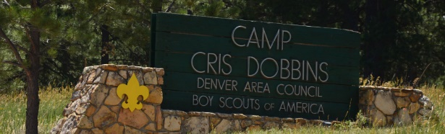

Sign up for Summer Camp 2023!
It is not too late to sign up for summer camp! See below. New crossover Scouts, you definitely want to go to summer camp. We have saved spots for you to attend.

Scoutmaster note: Going to summer camp as a first year scout is one of the most important things you can do. You will be amazed at how much your boys grow after spending a week away, learning to go to classes on their own. It is a great preparation tool for entering middle school.

Summer Camp 2023 will be at Camp Cris Dobbins at McNeil Scout Ranch outside of Elbert, CO (just northeast of Colorado Springs) the week of June 18-24, 2023. We will plan to depart on June 17 and return on June 25. A link to Camp Cris Dobbins can be found here: https://scoutingcolorado.org/camps/peaceful-valley-scout-ranch/camp-cris-dobbins/

Camp Cris Dobbins is nestled in the middle of the Black Forest at 7,000 feet, and offers sweeping views of Pikes Peak and the front range of the Rocky Mountains. Scouts will be able to choose between more than 50 merit badges being offered, and will have access to water slides at the outdoor pool (complete with a 17-foot climbing wall), an Olympic shooting range, sailing and canoeing, a 3,000-foot zipline, horses and ATVs (14+) and activities such as a movie making program and an archaeology dig site at the STEM lodge. We are also planning a rafting trip on Friday. Scouts and adults not attending the rafting trip will have an opportunity to visit the Air Force Academy for a self-guided tour on Friday.

Fees for Summer Camp 2023 for Scouts will be $680 + $100 for rafting = $780, and fees for Adults will be $540 + $100 for rafting = $640.

The first payment of $250 is due on or before January 1, 2023
Second payment of $250 is due on or before February 1, 2023
Third payment of $180/$40 (Scout/Adult) is due on or before March 1, 2023
Payment for rafting (optional) of $100 is due on or before April 1, 2023

Payments can be made by visiting the Troop 52 Scout Store at https://troop52lakeway.us/store
Please RSVP in Scoutbook

More information to follow over the next few weeks.

SICs - Mike Johnsrud, Tom Bolich, Mark Jackson, Paul Schultz

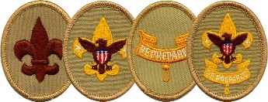
Trail to First Class Schedule:
All scouts who are not yet First Class are welcome to attend these sessions. They are especially geared toward new crossover scouts. The goal of our Trail to First Class (TTFC) program is to provide opportunities to learn scout skills to first and second year scouts. The first four ranks in scouting may all be worked on concurrently. This means that a TTFC session might include some or all the knots or first aid skills needed for Scout, Tenderfoot, Second Class, and First Class. In Troop 52, we believe boys who make it to First Class have more fun and are more likely to stick with the program, making their way toward Eagle Scout. These sessions will be conducted by Mr. Schulenberg with the assistance of the Troop Guides. Participation is optional, but you will advance quickly if you attend these sessions.

Date | Time | Topics | Requirement(s) | Location
4-Mar | 11:30 AM | Fitness, Oaths & Totin' Chip! | Scout Rank Requirements 1a-1f, 5; Tenderfoot Requirement 6a | Lakeway City Park
8-Apr | 9:00 AM | Fitness and Knots :-) | Scout Requirement 4a-b; Tenderfoot Requirement 6c | Lakeway City Park
6-May | 9:00 AM | Knots, Bandages and Leadership | Tenderfoot Requirement 3a-d, 4a-c; 8 | Lakeway City Park
3-Jun | 8:00 AM | Safe Hiking | Tenderfoot Requirement 4d, 5a-c | Serene Hills Trailhead
15-Jul | 9:00 AM | Knots and Fireman Chit | Second Class 2a-d, 2f-g | Lakeway City Park
5-Aug | 8:00 AM | Map Reading, Navigation and Hiking | Second Class 3a-d, 4 | Serene Hills Trailhead
2-Sep | 9:00 AM | First Aid & Emergency Preparedness | Second Class 6a-e | Lakeway City Park
7-Oct | 9:00 AM | Knot Fest! | First Class 3a-d | Lakeway City Park
4-Nov | 8:00 AM | Hiking and Hazards | First Class 5a-d | Serene Hills Trailhead
2-Dec | 9:00 AM | Advanced First Aid & Emergency Preparedness | First Class 7a-7e | Lakeway City Park

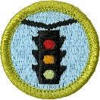
Traffic Safety Merit Badge Workshop
I will be holding a Traffic Safety Merit Badge Workshop on Monday, February 20th, from 1:00 -2:30 PM. (This is a LTISD school holiday.) This merit badge pairs well with learning to drive or being a new driver… but it is also good for someone who hasn’t started this process.

We will complete these items together: 2a, 3a, 3b, 3c, 3d, and 4a. You will need to complete these items on your own: 1a, 1b, 1c, 1d, 2b, 4b, 4c, 4d, 5b. The items you complete on your own can be done either before or after attending the workshop.

We need at least 3 participants to hold the workshop. Please email Josi Bogdon at easonj@sbcglobal.net to sign up or get more information. Please remember to cc a parent.

Hope to see you there!

Josi Eason Bogdon
512.971.8141
Upcoming Service Hour Opportunities
This winter there are many opportunities to earn service hours for both Troop and Community projects. Here are the current service hour opportunities for this month.

Ongoing - Eagle Projects (Various Hours - Troop)
There are quite a few Life Scouts in our troop who are working hard on their Eagle projects and they need your help. Be on the lookout for separate emails regarding these unique Eagle project opportunities. Remember someday you will need help from younger Scouts for your Eagle project - now is the time to pay it forward!

Special Olympics Texas - Feb 17-19 (hours vary - Community)
Volunteer opportunities for scouts and adults are available at the upcoming Special Olympics Texas Winter Games in Lakeway and Bee Cave this February. Volunteers are the backbone of this organization; so on behalf of the athletes they serve across the state, thank you for your interest and commitment. To sign up, please visit the Special Olympics Texas website https://www.sotx.org/winter-games-volunteer

Second Saturdays - Mornings (2-3 Hours - Community)
Volunteer and help to clean up our local parks on the second Saturdays of the month. These opportunities can qualify for conservation service hours, depending on the projects worked on. Visit either the Lakeway or Bee Cave website below to find out more details about how you can volunteer.
- Friends of the Park Lakeway (8-11am) - lakewayfop.org
- Bee Cave Friends of the Park Foundation (8-10am) - beecavefop.org

Understanding Troop vs Community Service Hours
Eagle projects are Troop-based and do not require preapproval. However before embarking on any Community service hours project, remember to fill out the Community Service Hours (CSH) form to get approval from your patrol's ASM or a Service Hours Coordinator (Ms. Dawson). You will also be required to have approval from the community representative in charge of the service project. The CSH form explains it all.

Use this link to the download the Community Service Hours Form:
https://img1.wsimg.com/blobby/go/c9c78b66-b90a-463e-bd5d-f56d564ec7e4/downloads/T52-CommunityServiceHoursForm.pdf?ver=1650645685582

Please use these photo albums to view and upload photos from our events:

Wilderness Survival Campout (upcoming)
https://photos.app.goo.gl/nC2VtbToGcWh2zKW9
Court of Honor
https://photos.app.goo.gl/ce2EW4HDmNZncrmc6
First Aid Campout
https://photos.app.goo.gl/dfBjaAns55weWbGi9
Sea Base Trip
https://photos.app.goo.gl/DS36maNLsFMrYAUDA
Srijan's Eagle Project
https://photos.app.goo.gl/GexZFHpXe1ghMzGB7
Martin Becker’s Eagle Project
https://photos.app.goo.gl/79q3k4hAbvp21zr57
Webelos Woods & Pot Luck
https://photos.app.goo.gl/4z7MV4ACxFpoKHfg7
Keaton Hampton’s Eagle Project
https://photos.app.goo.gl/vgkJuyFJJbKoJ7nM8
Cooking Merit Badge Campout
https://photos.app.goo.gl/pRtMcKSxRWM1eRo8A
Archery Campout
https://photos.app.goo.gl/Uog6Wtzef8ooC9gDA

Troop Blog and follow us on Facebook
If you need to check for the latest info or announcements, follow us on Facebook at https://www.facebook.com/groups/T52Lakeway/ or on the troop web site blog: https://troop52lakeway.us/blog

Remember!

