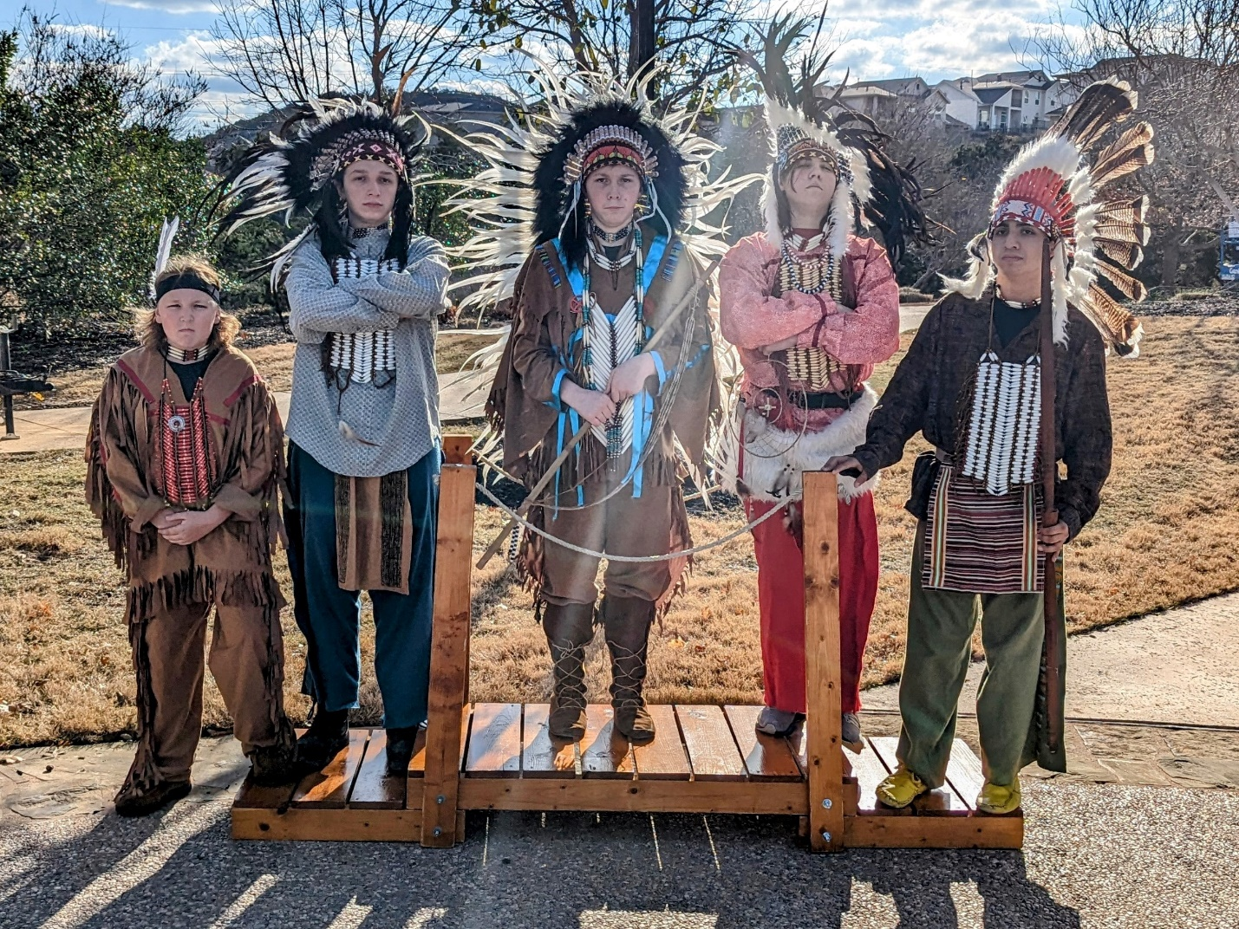

**2023 Ceremony Team**

Please congratulate our Ceremony Team for performing at the Blue and Gold Banquet for Pack 442 on Saturday, February 4. This year’s team is, left to right, Brooks Chalfant (Drummer), Spencer Prow-Nemeroff (East Wind), Ethan Ezell (North Wind), Logan Campbell (West Wind), and Alejandro Loredo (South Wind). This is one of the longest standing Troop 52 activities. We are the only troop in the area who continues to perform the traditional pack crossover ceremony in full regalia. Thank you to Mr. Beneski and Mr. Kelbaugh for continuing to maintain this standard of excellence. The boys all did a fantastic job. We welcomed 13 new crossover scouts to Troop 52.

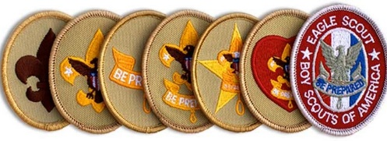

**Court of Honor – February 6, 2023 – 7:30 pm – Emmaus**

**Scouts and families, please arrive 15 minutes early! The COH will begin promptly at 7:30!**

**PLEASE NOTE CHANGE OF TIME TO 7:30 TO ALLOW EVERYONE TO ARRIVE!**

We will be holding the next Troop 52 Court of Honor on Monday, January 30th at 7:30 pm at Emmaus. The troop holds a COH twice a year to recognize scouts who have earned merit badges and advanced in rank since the last COH. The cutoff date for completing merit badges and rank advancement was Monday, January 23rd.

We have quite a few families coming from school activities on Monday, so the start time of the COH is sliding backward to begin at 7:30. This will give everyone time to arrive and get things set up.

The SPL has requested the leadership patrol arrive at 7:00 or earlier to help get ready for flags and arrange chairs. All scouts should be there by 7:15 to assemble in the Bat Cave area. We will begin promptly at 7:30. Remember, scouts will all sit by patrol on the left side of the audience. Parents and guests will be seated on the right. Thank you for your cooperation!  
  
All scouts are expected to be in full dress Scout attire in Class A, merit badge sash, and neckerchief. And comb your hair! Your mom wants pictures!

SIC: Mr. Johnsrud

**From the SPL**

Hello Troop 52,

We will no longer be able to attend the Shooting Campout at Mr. Cottey's ranch as he has a memorial service for a family member that weekend. The Shooting Campout will be moved to May, based on Mr. Cottey's convenience.

The Campout will now be Wilderness Survival. The adult committee members are trying to find a place to camp and a SIC. We will use upcoming meetings to prepare for the campout. The plan for the February troop meetings is below

Feb 13 :- Basic Wilderness Survival Training

Feb 20 :- Meal Planning and Sign-Off Day for Wilderness Survival Skills, and making sure Scouts are prepared.

Tomorrow's Meeting is the Court of Honor, so all scouts are required to show up in full Class A's to receive their awards and merit badges. I would like the Leadership patrol & quartermasters to come at least 20 minutes early to the COH.

Thank you,

Aditya Rao – SPL



**Wilderness Survival Campout – February 24-26, 2023 – Urgently Need Adults**

We need an SIC to take ownership of the troop campout this month and a location to camp. Please contact the Key 3 to discuss (James, Pete, and Hank). I asked the SPL and PLC what they would like to do instead of shooting. They voted for teaching the Wilderness Survival merit badge. All that requires is a place to camp. We are possibly looking at Inks Lake at their group site, but we need someone to book it and take the boys camping. If we do not have an SIC and location this week, there will be no February campout.

Thanks for your help in making this campout happen. Mr. Ezell and Mr. Chalfant are out with the OA ceremony team on Saturday, the 25th.

Important Dates for proposed itinerary:

Feb 6 – COH

Feb 13 – Troop Meeting – teach Wilderness Survival merit badge

Feb 20 – Troop Meeting / Meal Planning (Philmont crews are out) Need ASM to run meeting.

Feb 24-26 – Campout

**Camporee Logo Design Contest – From the Order of the Arrow Camporee Team:**

We're designing our logo for our 2023 Bee Cave District Camporee! If you’d like a chance to design our patch, please email Henry Kelbaugh with your design within a couple weeks. Please include the following on your design:

- Some text indicating that this patch is for Bee Cave District’s 2023 Camporee

- Something related to the Night at the Museum theme (which we’re now calling Campout at the Museum: Battle of the Camporee)

- Must be Scout appropriate (no weapons, foul language, etc.) and legible at patch size (please submit a .pdf, .jpeg, .png, or .psd file)

Example patch designs can be found at <https://www.beecavedistrict.org/node/1147>

The designer of the winning patch will receive a $25 gift card to Apple!

- Although you are more than welcome to use existing images for inspiration, please do not simply plagiarize or copy existing images.

- The final patch will be 3.5 inches in diameter.

 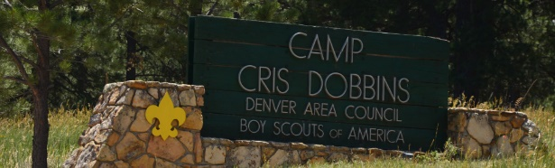

**Sign up for Summer Camp 2023**

**It is not too late to sign up for summer camp! See below.**

Summer Camp 2023 will be at Camp Cris Dobbins at McNeil Scout Ranch outside of Elbert, CO (just northeast of Colorado Springs) the week of June 18-24, 2023. We will plan to depart on June 17 and return on June 25. A link to Camp Cris Dobbins can be found here: <https://scoutingcolorado.org/camps/peaceful-valley-scout-ranch/camp-cris-dobbins/>

Camp Cris Dobbins is nestled in the middle of the Black Forest at 7,000 feet, and offers sweeping views of Pikes Peak and the front range of the Rocky Mountains. Scouts will be able to choose between more than 50 merit badges being offered, and will have access to water slides at the outdoor pool (complete with a 17-foot climbing wall), an Olympic shooting range, sailing and canoeing, a 3,000-foot zipline, horses and ATVs (14+) and activities such as a movie making program and an archaeology dig site at the STEM lodge. We are also planning a rafting trip on Friday. Scouts and adults not attending the rafting trip will have an opportunity to visit the Air Force Academy for a self-guided tour on Friday.

**Fees for Summer Camp 2023 for Scouts will be $680 + $100 for rafting = $780, and fees for Adults will be $540 + $100 for rafting = $640.**

The first payment of $250 is due on or before January 1, 2023

Second payment of $250 is due on or before February 1, 2023

Third payment of $180/$40 (Scout/Adult) is due on or before March 1, 2023

Payment for rafting (optional) of $100 is due on or before April 1, 2023

Payments can be made by visiting the Troop 52 Scout Store at <https://troop52lakeway.us/store>

Please RSVP in Scoutbook

More information to follow over the next few weeks.

SICs - Mike Johnsrud, Tom Bolich, Mark Jackson, Paul Schultz

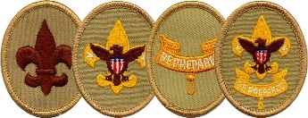

**Trail to First Class Schedule:**

All scouts who are not yet First Class are welcome to attend these sessions. The goal of our Trail to First Class (TTFC) program is to provide opportunities to learn scout skills to first and second year scouts. The first four ranks in scouting may all be worked on concurrently. This means that a TTFC session might include some or all the knots or first aid skills needed for Scout, Tenderfoot, Second Class, and First Class. In Troop 52, we believe boys who make it to First Class have more fun and are more likely to stick with the program, making their way toward Eagle Scout. These sessions will be conducted by Mr. Schulenberg with the assistance of the Troop Guides. Participation is optional, but you will advance quickly if you attend.

|  |  |  |  |  |
| --- | --- | --- | --- | --- |
| **Date** | **Time** | **Topics** | **Requirement(s)** | **Location** |
| 4-Mar | 11:30 AM | Fitness, Oaths & Totin' Chip! | Scout Rank Requirements 1a-1f, 5; Tenderfoot Requirement 6a | Lakeway City Park |
| 8-Apr | 9:00 AM | Fitness and Knots :-) | Scout Requirement 4a-b; Tenderfoot Requirement 6c | Lakeway City Park |
| 6-May | 9:00 AM | Knots, Bandages and Leadership | Tenderfoot Requirement 3a-d, 4a-c; 8 | Lakeway City Park |
| 3-Jun | 8:00 AM | Safe Hiking | Tenderfoot Requirement 4d, 5a-c | Serene Hills Trailhead |
| 15-Jul | 9:00 AM | Knots and Fireman Chit | Second Class 2a-d, 2f-g | Lakeway City Park |
| 5-Aug | 8:00 AM | Map Reading, Navigation and Hiking | Second Class 3a-d, 4 | Serene Hills Trailhead |
| 2-Sep | 9:00 AM | First Aid & Emergency Preparedness | Second Class 6a-e | Lakeway City Park |
| 7-Oct | 9:00 AM | Knot Fest! | First Class 3a-d | Lakeway City Park |
| 4-Nov | 8:00 AM | Hiking and Hazards | First Class 5a-d | Serene Hills Trailhead |
| 2-Dec | 9:00 AM | Advanced First Aid & Emergency Preparedness | First Class 7a-7e | Lakeway City Park |

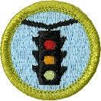

**Traffic Safety Merit Badge Workshop**

I will be holding a Traffic Safety Merit Badge Workshop on Monday, February 20th, from 1:00 -2:30 PM. (This is a LTISD school holiday.) This merit badge pairs well with learning to drive or being a new driver… but it is also good for someone who hasn’t started this process.

We will complete these items together: 2a, 3a, 3b, 3c, 3d, and 4a. You will need to complete these items on your own: 1a, 1b, 1c, 1d, 2b, 4b, 4c, 4d, 5b. The items you complete on your own can be done either before or after attending the workshop.

We need at least 3 participants to hold the workshop. Please email Josi Bogdon at [easonj@sbcglobal.net](mailto:easonj@sbcglobal.net) to sign up or get more information. Please remember to cc a parent.

Hope to see you there!

Josi Eason Bogdon

*512.971.8141*



**Upcoming Service Hour Opportunities**

This winter there are many opportunities to earn service hours for both Troop and Community projects. Here are the current service hour opportunities for this month.

**Ongoing - Eagle Projects (Various Hours - Troop)**

There are quite a few Life Scouts in our troop who are working hard on their Eagle projects and they need your help. Be on the lookout for separate emails regarding these unique Eagle project opportunities. Remember someday you will need help from younger Scouts for your Eagle project - now is the time to *pay it forward*!



**Special Olympics Texas - Feb 17-19 (hours vary - Community)**

Volunteer opportunities for scouts and adults are available at the upcoming Special Olympics Texas Winter Games in Lakeway and Bee Cave this February. Volunteers are the backbone of this organization; so on behalf of the athletes they serve across the state, thank you for your interest and commitment. To sign up, please visit the Special Olympics Texas website <https://www.sotx.org/winter-games-volunteer>

**Second Saturdays - Mornings (2-3 Hours - Community)**

Volunteer and help to clean up our local parks on the second Saturdays of the month. These opportunities can qualify for conservation service hours, depending on the projects worked on. Visit either the Lakeway or Bee Cave website below to find out more details about how you can volunteer.

* Friends of the Park Lakeway (8-11am) - [lakewayfop.org](http://lakewayfop.org/)
* Bee Cave Friends of the Park Foundation (8-10am) - [beecavefop.org](http://beecavefop.org/)

**Understanding Troop vs Community Service Hours**

Eagle projects are Troop-based and do not require preapproval. However before embarking on any Community service hours project, remember to fill out the [Community Service Hours (CSH) form](https://img1.wsimg.com/blobby/go/c9c78b66-b90a-463e-bd5d-f56d564ec7e4/downloads/T52-CommunityServiceHoursForm.pdf?ver=1650645685582) to get approval from your patrol's ASM or a Service Hours Coordinator (Ms. Dawson). You will also be required to have approval from the community representative in charge of the service project. The CSH form explains it all.

**Use this link to the download the Community Service Hours Form:**

<https://img1.wsimg.com/blobby/go/c9c78b66-b90a-463e-bd5d-f56d564ec7e4/downloads/T52-CommunityServiceHoursForm.pdf?ver=1650645685582>



8 Parker Grovatt

10 Henry Kelbaugh

12 Jaxson Bacorn

24 Jamie Ezell

25 Caleb Schultz



**Please use these photo albums to view and upload photos from our events:**

**Court of Honor (upcoming)**

Court of Honor (upcoming)

<https://photos.app.goo.gl/ce2EW4HDmNZncrmc6>

First Aid Campout

<https://photos.app.goo.gl/dfBjaAns55weWbGi9>

Sea Base Trip

<https://photos.app.goo.gl/DS36maNLsFMrYAUDA>

Srijan's Eagle Project

<https://photos.app.goo.gl/GexZFHpXe1ghMzGB7>

Martin Becker’s Eagle Project

<https://photos.app.goo.gl/79q3k4hAbvp21zr57>

Webelos Woods & Pot Luck

<https://photos.app.goo.gl/4z7MV4ACxFpoKHfg7>

Keaton Hampton’s Eagle Project

<https://photos.app.goo.gl/vgkJuyFJJbKoJ7nM8>

Cooking Merit Badge Campout

<https://photos.app.goo.gl/pRtMcKSxRWM1eRo8A>

Archery Campout

<https://photos.app.goo.gl/Uog6Wtzef8ooC9gDA>

Shred Day

<https://photos.app.goo.gl/1tYY1MMW6h9Dna5FA>

**Troop Blog and follow us on Facebook**

If you need to check for the latest info or announcements, follow us on Facebook at <https://www.facebook.com/groups/T52Lakeway/> or on the troop web site blog: <https://troop52lakeway.us/blog>

**Remember!**

