**Shred Day – April 22, 2023**

Thank you to all the scouts and parents who came out to Shred Day! We had a constant stream of cars coming through the parking lot. One truck was filled entirely and the other reached about 90+% capacity, so we had a great day. Shredding is our primary fundraiser for the troop so we can keep delivering an awesome Scouting program. Ethan Ezell served as SPL for the day and chose Cooper Bacorn and Ankush Sudhakar as the most enthusiastic volunteers. More photos are available here: <https://photos.google.com/share/AF1QipPqi7KXpNMRGKtYZIRP5far6KTT6lgONp8IgjG7MIl5hpIp39HjaMemk-tbBHfeqg?key=dHRNaHVtN2o0YUJnZVFUb1R2MEphNlFBeVR3X1pR>

We will see you at the next one in October!

**Next Campout – Camporee 2023 – April 28-30, 2023 – Smilin’ V Ranch**

**Theme: Night at the Museum**

**Please register for Camporee and pay on the troop web site and RSVP on Scoutbook. This is important to be done by Wednesday evening so we have a roster to turn in to Camporee staff and so that the grubmasters can buy enough food.**

The Camporee Guide has been published. Please have a look at what we will be doing:

<https://docs.google.com/document/d/e/2PACX-1vS6zC139GJqODSSunEKVjakI3QnyMnyWG3F0Ahaj1wEBmqJBTnbQ7ldi33ITdkdhGa1MAaxfjvWfFS8/pub>

As part of the Apr 24 meeting, the leadership scouts will get the patrols prepped for Camporee by practicing skills. “Scout spirit” will be a contest worth points at Camporee. Each patrol will need to work on teamwork and have a patrol yell or chant by the end of the meeting.

**All OA members are instructed to bring their sash and wear it this weekend.**



**SIC University: Monday, April 24, 2023 – Bat Cave at Emmaus**

Bats, we are prepping for Camporee on Monday night. We will need several adults to assist the boys in camp. Please see the link above for the Camporee schedule.

**We have begun a document / checklist on being the SIC. Have a look:**

<https://docs.google.com/document/d/e/2PACX-1vTyfP3tn6kGxFWzLbp48UFuhAq0YmjW7gA6CI5dje7OItMqM4oiJkqXZMl3FVijQha_YKIuIAgD3Aq2/pub>

 

**Order of the Arrow News – Ordeal and Brotherhood at Camporee**

OA Ordeal Members and Candidates,

The tapout / callout ceremony for those elected into OA at the troop meeting in January will take place Saturday night at Camporee after the campfire. The results are secret until the ceremony. If you were up for election, you are strongly advised to attend Camporee.

**All OA members are instructed to bring their sash and wear it this weekend.**

To those already in OA as Ordeal members, there will be an opportunity to earn your Brotherhood at Camporee on Friday night at 10:00 pm. You must register in advance at this link. You will be contacted by the lodge with further details. This opportunity is only for members who have completed their Ordeal and been members for at least six months. Register for Brotherhood here:

<https://docs.google.com/forms/d/e/1FAIpQLScM9IcJrb8E99enuCICmJWqMNaCazLM0DBpy9Vlj3h7yoJp8w/viewform>

**Shred Day Treasures**

Scouts and Parents, often at Shred Day we receive unusual donations. Some leave us speechless. This year, we received a suitcase full of old scouting memorabilia from a local Lakeway resident. Pictured above are just some of them. The scout’s name was Konrad Riley from Orange, Texas. He passed away in 2019. However, he lives on through this amazing set of scouting treasures he left behind. Konrad was a member of Troop 4 in Orange, Texas in the Sabine Area Council. He received his Eagle Scout in 1965. He was a member of the OA, attended the BSA National Jamboree in Valley Forge in 1964, and must have gone to Philmont at some point. Never forget that the memories you make in Scouting will be with you forever. Scouting had such an impact on this man that he kept all these items for 60 years. What memories are you making?

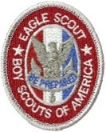

**Tyce Bogdon’s Eagle Project – Saturday & Sunday, May 6-7, 2023 – Austin Pets Alive**

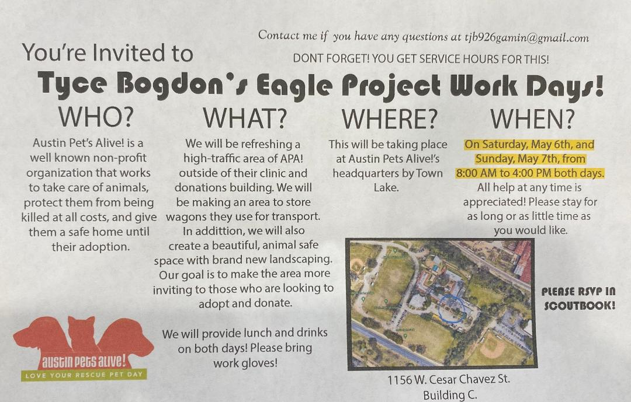

 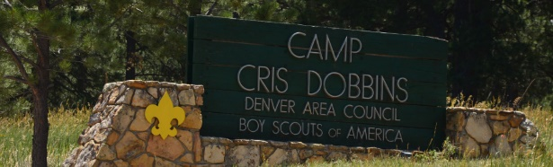

**There is one spot left for a scout to attend summer camp at Cris Dobbins! Please RSVP to Mike Johnsrud!**

Email: hookemhawk@yahoo.com

SICs - Mike Johnsrud, Tom Bolich, Mark Jackson

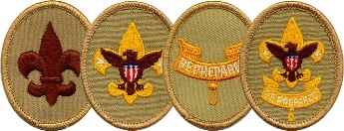

**Trail to First Class Schedule:**

All scouts who are not yet First Class are welcome to attend these sessions. They are especially geared toward new crossover scouts. The goal of our Trail to First Class (TTFC) program is to provide opportunities to learn scout skills to first and second year scouts. The first four ranks in scouting may all be worked on concurrently. This means that a TTFC session might include some or all the knots or first aid skills needed for Scout, Tenderfoot, Second Class, and First Class. In Troop 52, we believe boys who make it to First Class have more fun and are more likely to stick with the program, making their way toward Eagle Scout. These sessions will be conducted by Mr. Schulenberg with the assistance of the Troop Guides. Participation is optional, but you will advance quickly if you attend these sessions.

|  |  |  |  |  |
| --- | --- | --- | --- | --- |
| **Date** | **Time** | **Topics** | **Requirement(s)** | **Location** |
| 4-Mar | 11:30 AM | Fitness, Oaths & Totin' Chip! | Scout Rank Requirements 1a-1f, 5; Tenderfoot Requirement 6a | Lakeway City Park |
| 8-Apr | 9:00 AM | Fitness and Knots :-) | Scout Requirement 4a-b; Tenderfoot Requirement 6c | Lakeway City Park |
| 6-May | 9:00 AM | Knots, Bandages and Leadership | Tenderfoot Requirement 3a-d, 4a-c; 8 | Lakeway City Park |
| 3-Jun | 8:00 AM | Safe Hiking | Tenderfoot Requirement 4d, 5a-c | Serene Hills Trailhead |
| 15-Jul | 9:00 AM | Knots and Fireman Chit | Second Class 2a-d, 2f-g | Lakeway City Park |
| 5-Aug | 8:00 AM | Map Reading, Navigation and Hiking | Second Class 3a-d, 4 | Serene Hills Trailhead |
| 2-Sep | 9:00 AM | First Aid & Emergency Preparedness | Second Class 6a-e | Lakeway City Park |
| 7-Oct | 9:00 AM | Knot Fest! | First Class 3a-d | Lakeway City Park |
| 4-Nov | 8:00 AM | Hiking and Hazards | First Class 5a-d | Serene Hills Trailhead |
| 2-Dec | 9:00 AM | Advanced First Aid & Emergency Preparedness | First Class 7a-7e | Lakeway City Park |

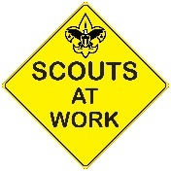

**Upcoming Service Hour Opportunities**

There are many opportunities to earn service hours for both Troop and Community projects. Here are some upcoming service hour opportunities:

**Ongoing - Eagle Projects (Various Hours - Troop)**

There are quite a few Life Scouts in our troop who are working hard on their Eagle projects and they need your help. Be on the lookout for separate emails regarding these unique Eagle project opportunities. Remember someday you will need help from younger Scouts for your Eagle project - now is the time to *pay it forward*!

**Second Saturdays - Mornings (2-3 Hours - Community)**

Volunteer and help to clean up our local parks on the second Saturdays of the month. These opportunities can qualify for conservation service hours, depending on the projects worked on. Visit either the Lakeway or Bee Cave website below to find out more details about how you can volunteer.

* Friends of the Park Lakeway (8-11am) - [lakewayfop.org](http://lakewayfop.org/)
* Bee Cave Friends of the Park Foundation (8-10am) - [beecavefop.org](http://beecavefop.org/)

**Understanding Troop vs Community Service Hours**

Eagle projects are Troop-based and do not require preapproval. However before embarking on any Community service hours project, remember to fill out the [Community Service Hours (CSH) form](https://img1.wsimg.com/blobby/go/c9c78b66-b90a-463e-bd5d-f56d564ec7e4/downloads/T52-CommunityServiceHoursForm.pdf?ver=1650645685582) to get approval from your patrol's ASM or a Service Hours Coordinator (Ms. Dawson). You will also be required to have approval from the community representative in charge of the service project. The CSH form explains it all.

**Use this link to the download the Community Service Hours Form:**

<https://img1.wsimg.com/blobby/go/c9c78b66-b90a-463e-bd5d-f56d564ec7e4/downloads/T52-CommunityServiceHoursForm.pdf?ver=1650645685582>



**Please use these photo albums to view and upload photos from our events:**

Camporee (upcoming)

<https://photos.app.goo.gl/k7uBwRqwzTjbbbv1A>

Shred Day

<https://photos.app.goo.gl/tKDWv1XDxC5b84g6A>

Aditya Rao’s Eagle Project

<https://photos.app.goo.gl/pmUhRsrey7FoSwQu5>

Fishing Campout

<https://photos.app.goo.gl/YjogReTDEtxS1TBv9>

Sea Base

<https://photos.app.goo.gl/SxWFW4gTxH2xxBLEA>

Crossover

<https://photos.app.goo.gl/eAhuykYVmua18JTDA>

Crossover Bridge Build (upcoming)

<https://photos.app.goo.gl/CngHoWgbTZhMcszf6>

Wilderness Survival Campout

<https://photos.app.goo.gl/nC2VtbToGcWh2zKW9>

Traffic Safety Merit Badge Workshop

<https://photos.app.goo.gl/WeoHpukdYggmNLSVA>

Court of Honor

<https://photos.app.goo.gl/ce2EW4HDmNZncrmc6>

**Troop Blog and follow us on Facebook**

If you need to check for the latest info or announcements, follow us on Facebook at <https://www.facebook.com/groups/T52Lakeway/> or on the troop web site blog: <https://troop52lakeway.us/blog>

**Remember!**

