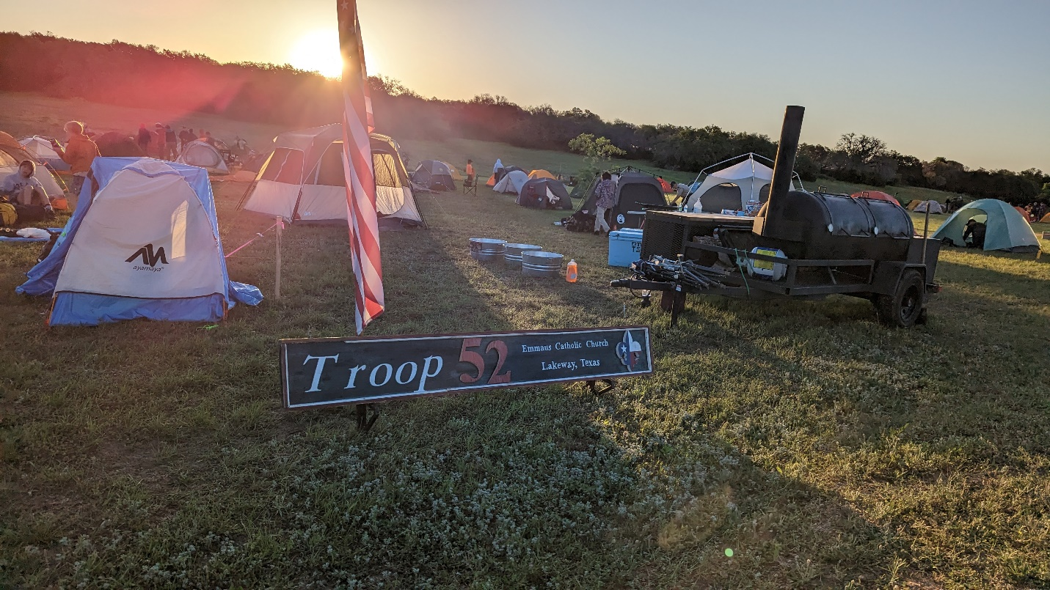

Camporee 2023!
Scouts, we had a great camporee this week competing against all the other Bee Cave District troops. Although we did not pull off the overall victory, we had an outstanding showing from all our patrols. And, of course, the ultimate goal was to have fun which we did. I would especially like to recognize all those OA scouts who were on staff at Camporee or who ran a station. This was truly a youth-led event. Troop 52 had a huge impact on this event in the sheer number of scout and adult volunteers present behind the scenes. We had many troop adults who made this event possible from SIC Mr. Semph to grubmasters Mr. and Mrs. Doggett and so many others. And Ethan Ezell got his first shot as being SPL for the weekend. Thank you to everyone!

Order of the Arrow News – Ordeal and Brotherhood at Camporee
Congratulations to all our new Ordeal and Brotherhood members. We had three scouts and two adults who were chosen by their peers as new candidates for the OA. Remember, you are not a full member of the OA until you attend your Ordeal. Details will be sent to you and your parents on dates. A big congratulations goes to those scouts who successfully moved from Ordeal to Brotherhood on Friday night in a very memorable ceremony.

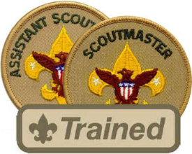

New Assistant Scoutmasters at IOLS
While the scouts were attending events, several Troop 52 adults were on the other side of camp at IOLS training. Troop 52 IOLS trainers Tray Bates, Pete Chalfant, James Ezell, Matt Gomes, and Vamsee Konda taught the course to multiple troops.

We would like to welcome the following new Assistant Scoutmasters to Troop 52: David Bacorn, Duncan Berlin, Nick Kersting, Brett Nemeroff, and Nico Sfeir. Congratulations and thank you for serving our boys with your commitment.

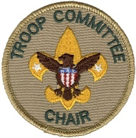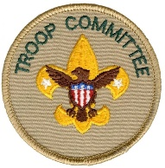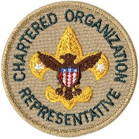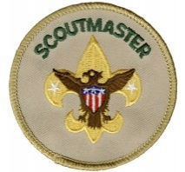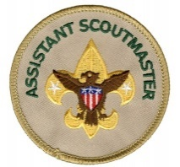

Committee Meeting – Tuesday, May 2, 2023 – 7:00 – Emmaus Room Multi B/C

Please welcome incoming Committee Chair George Popa! Thank you for serving the boys! We thank Pete Chalfant for his excellent leadership as Committee Chair for the past two years.

Please attend the Troop Committee Meeting. It is open to all adults who want to take an interest in assisting the boys in planning their activities. We need your participation. Troop 52 is a boy-led troop, which means the boys set the agenda and the adults of the committee find the resources for them to accomplish their goals. This is a great way for adults to participate in troop organization. We are in Room Multi B/C, which is upstairs overlooking the main hall. March Committee Meeting will be Tuesday, from 7-9p in Multi B/C at Emmaus.

Topics: We need to identify several open jobs for the Shooting Campout; Summer Camp details; Possible end of school potluck/party; High Adventure; and a new September Canoe Trip. Looking forward to seeing everyone then!

YIS,

Pete Chalfant
Committee Chair
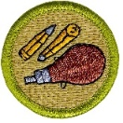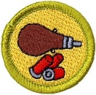

Shooting Campout – Saturday-Sunday, May 12-14, 2023 – Cottey Ranch

Troop Meeting – May 1, 2023 – Safety and Rifle Instruction
Troop Meeting – May 8, 2023 – Shotgun Instruction followed by Patrol Meal Planning

We will be doing the training in the bat cave.

NOTE: We are having a regular troop meeting instead of PLC because we need the shooting training.

This is one of our most popular campouts, so we expect high attendance. Life and Eagle Scouts will be allowed to come on Friday night to help set up the ranges. The rest of the troop will depart from LTMS near the tennis courts on Saturday morning at 8:00 am sharp to arrive at the ranch at 9:00 am. Please arrive early at LTMS. Departing at 8:00 means arrive at 7:30 for planning car drivers/riders. We expect all scouts to stay for the entire campout. No exceptions. There is a lot of cleanup. Departing early and leaving a mess for others is not the Scout way. Registration is due on the Wednesday night before all campouts for buying enough food.

We will do patrol cooking. Patrol grubmasters are chosen by their patrols at the troop meeting. Grubmasters, please follow the instructions given to you. If you do not do the shopping, your patrol does not eat. Your budget is $12 per scout. You will be reimbursed after the campout when you turn in your expense sheet and receipts to Mr. Konda, the troop treasurer.

We will have two stations at the campout: Rifles and Shotgun. The gun cleaning station will be on Sunday morning before departure. First year scouts will not be able to do shotgun qualifying yet (hit 12 out of 25 clays twice) unless they have already successfully completed the Rifle Shooting merit badge). We would like for you to grow a bit and get stronger before attempting to shoot that many clays.

NOTE: A huge thank you goes to Dr. Cottey for allowing us to use his ranch once again. Gun safety is a very serious matter. Please be advised that as the property owner, he has the authority to exclude you from an activity or remove you from the campout for a safety violation. All shooting is done at the discretion of the Chief RSO and rangemasters. Any scout (or adult) exhibiting unsafe behavior will be removed from the range, his parents called, and asked to leave. Waiver forms will be required to attend.

“The Chief Range Safety Officer is God’s Own Emissary on Earth inside the range.” – Walter Lee, Capitol Area Council Shooting Sports Instructor

SIC – Ashwin Rao, Matt Gomes
Grub Master – James Ezell Friday Night / Jeff Schneider Saturday
Quartermaster -- Ken Semph
Pulling Trailer – James Ezell
Pulling Smoker – TBD
Water Buffalo – N/A
Activity Leader – Ashwin Rao, Matt Gomes
Campout SPL – Aditya Rao
Google Map Coordinates or Directions – Cottey Ranch, 1809 CO Rd 110, Burnet, TX 78611 (30°49'16.0"N 98°18'27.1"W)
Closest Medical Facility – Seton Highland Lakes, 3201 South Water St, Burnet, TX 78611
Phone Tree Emergency Contact and Ph # – John Cottey, 512 417 2388
Contact not at event -- TBD
Departure Time and Location – 8:00 AM, Saturday, 05/13/23
Expected Return Time and Location – 12 PM, Sunday, 05/14/23
Coffee has been checked? – No
Tyce Bogdon’s Eagle Project – Saturday & Sunday, May 6-7, 2023 – Austin Pets Alive

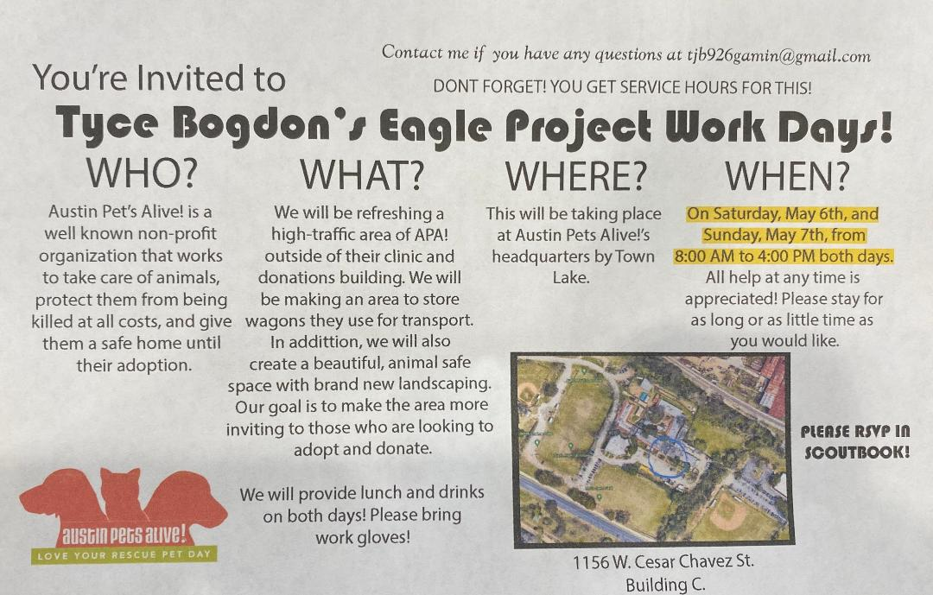

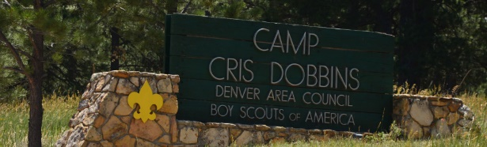

Cris Dobbins Update – June 5
We will have a summer camp packing and prep meeting June 5. Stay tuned.
Email: hookemhawk@yahoo.com
SICs - Mike Johnsrud, Tom Bolich, Mark Jackson

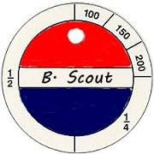
Swim Test Makeup Date at Lakeway Pool!
I would like to run a make up swim test Saturday May 20th 300pm at Lakeway Swim Center pool. Anyone attending will pay the pool fee for admission.

SIC – Tom Bolich tombolich@gmail.com - 703.629.8740

Daily Rate | Resident Daily Rate
Infants (0-2) - Free | Infants (0-2) - Free
Children (3-17) - $6 | Children (3-17) - $5
Adults (18-54) - $7 | Adults (18-54) - $6
Seniors (55+) - $6 | Seniors (55+) - $5

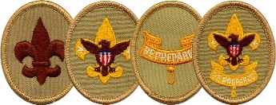
Trail to First Class Schedule:
All scouts who are not yet First Class are welcome to attend these sessions. They are especially geared toward new crossover scouts. The goal of our Trail to First Class (TTFC) program is to provide opportunities to learn scout skills to first and second year scouts. The first four ranks in scouting may all be worked on concurrently. This means that a TTFC session might include some or all the knots or first aid skills needed for Scout, Tenderfoot, Second Class, and First Class. In Troop 52, we believe boys who make it to First Class have more fun and are more likely to stick with the program, making their way toward Eagle Scout. These sessions will be conducted by Mr. Schulenberg with the assistance of the Troop Guides. Participation is optional, but you will advance quickly if you attend these sessions.

Date | Time | Topics | Requirement(s) | Location
4-Mar | 11:30 AM | Fitness, Oaths & Totin' Chip! | Scout Rank Requirements 1a-1f, 5; Tenderfoot Requirement 6a | Lakeway City Park
8-Apr | 9:00 AM | Fitness and Knots :-) | Scout Requirement 4a-b; Tenderfoot Requirement 6c | Lakeway City Park
6-May | 9:00 AM | Knots, Bandages and Leadership | Tenderfoot Requirement 3a-d, 4a-c; 8 | Lakeway City Park
3-Jun | 8:00 AM | Safe Hiking | Tenderfoot Requirement 4d, 5a-c | Serene Hills Trailhead
15-Jul | 9:00 AM | Knots and Fireman Chit | Second Class 2a-d, 2f-g | Lakeway City Park
5-Aug | 8:00 AM | Map Reading, Navigation and Hiking | Second Class 3a-d, 4 | Serene Hills Trailhead
2-Sep | 9:00 AM | First Aid & Emergency Preparedness | Second Class 6a-e | Lakeway City Park
7-Oct | 9:00 AM | Knot Fest! | First Class 3a-d | Lakeway City Park
4-Nov | 8:00 AM | Hiking and Hazards | First Class 5a-d | Serene Hills Trailhead
2-Dec | 9:00 AM | Advanced First Aid & Emergency Preparedness | First Class 7a-7e | Lakeway City Park

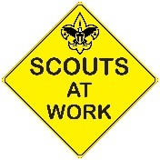
Upcoming Service Hour Opportunities
There are many opportunities to earn service hours for both Troop and Community projects. Here are some upcoming service hour opportunities:

Ongoing - Eagle Projects (Various Hours - Troop)
There are quite a few Life Scouts in our troop who are working hard on their Eagle projects and they need your help. Be on the lookout for separate emails regarding these unique Eagle project opportunities. Remember someday you will need help from younger Scouts for your Eagle project - now is the time to pay it forward!

Second Saturdays - Mornings (2-3 Hours - Community)
Volunteer and help to clean up our local parks on the second Saturdays of the month. These opportunities can qualify for conservation service hours, depending on the projects worked on. Visit either the Lakeway or Bee Cave website below to find out more details about how you can volunteer.
- Friends of the Park Lakeway (8-11am) - lakewayfop.org
- Bee Cave Friends of the Park Foundation (8-10am) - beecavefop.org

Understanding Troop vs Community Service Hours
Eagle projects are Troop-based and do not require preapproval. However before embarking on any Community service hours project, remember to fill out the Community Service Hours (CSH) form to get approval from your patrol's ASM or a Service Hours Coordinator (Ms. Dawson). You will also be required to have approval from the community representative in charge of the service project. The CSH form explains it all.

Use this link to the download the Community Service Hours Form:
https://img1.wsimg.com/blobby/go/c9c78b66-b90a-463e-bd5d-f56d564ec7e4/downloads/T52-CommunityServiceHoursForm.pdf?ver=1650645685582

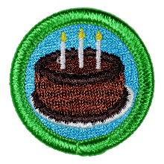
May Birthdays:
11 Alejandro Loredo
13 Michael Berger
13 Benjamin Shen
19 Riki Goss
26 Joey Meade
27 Ethan Ezell
27 Ankush Sudhakar

Please use these photo albums to view and upload photos from our events:

Tyce Bogdon’s Eagle Project (upcoming)
https://photos.app.goo.gl/tsQLhyGoZxABip538
Camporee
https://photos.app.goo.gl/k7uBwRqwzTjbbbv1A
Shred Day
https://photos.app.goo.gl/tKDWv1XDxC5b84g6A
Aditya Rao’s Eagle Project
https://photos.app.goo.gl/pmUhRsrey7FoSwQu5
Fishing Campout
https://photos.app.goo.gl/YjogReTDEtxS1TBv9
Sea Base
https://photos.app.goo.gl/SxWFW4gTxH2xxBLEA
Crossover
https://photos.app.goo.gl/eAhuykYVmua18JTDA
Crossover Bridge Build
https://photos.app.goo.gl/CngHoWgbTZhMcszf6
Wilderness Survival Campout
https://photos.app.goo.gl/nC2VtbToGcWh2zKW9
Traffic Safety Merit Badge Workshop
https://photos.app.goo.gl/WeoHpukdYggmNLSVA

Troop Blog and follow us on Facebook
If you need to check for the latest info or announcements, follow us on Facebook at https://www.facebook.com/groups/T52Lakeway/ or on the troop web site blog: https://troop52lakeway.us/blog

Remember!

