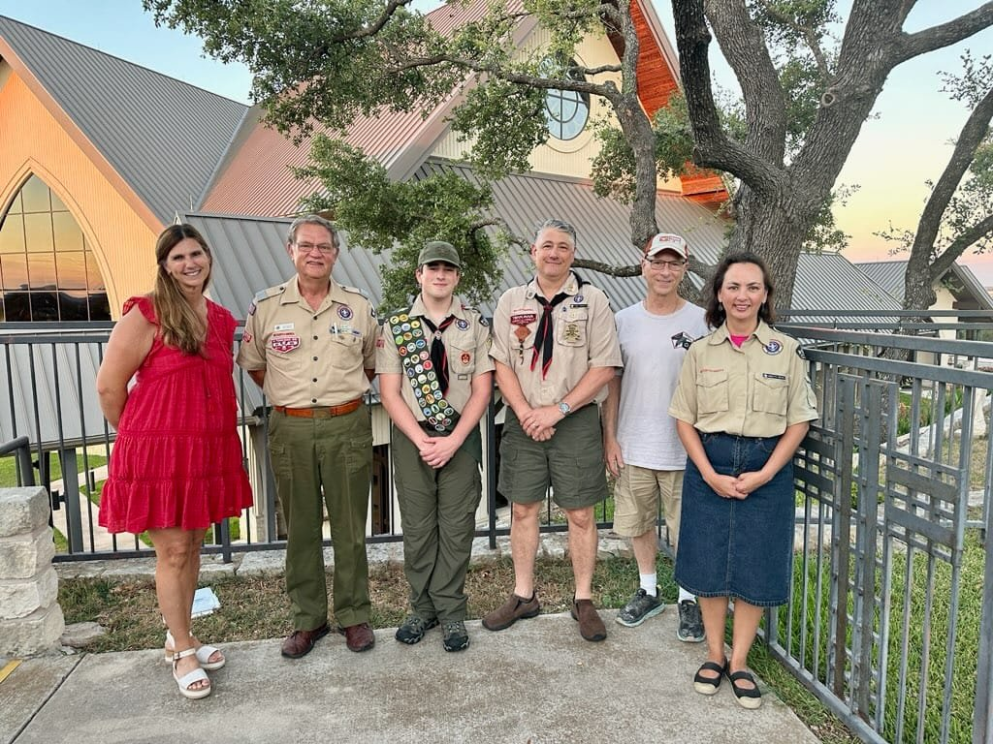

**Please congratulate Troop 52’s newest Eagle Scout, Tyce Bogdon!**

Tyce’s Eagle project was renovating the entry area for Austin Pets Alive at their downtown location.

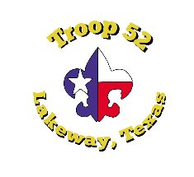

**Summer Troop Meeting Roundup – Monday, July 10, 2023 – Lakeway City Park**

This will be an important meeting to kick off the rest of the summer. All parents are invited to come to this troop meeting to wrap up summer camp and high adventure. Mr. Johnsrud, SIC for summer camp, will distribute patches and discuss merit badge completion updates from camp. ASMs will meet with their patrols to ensure each scout receives credit for summer camp activities and then enter the items in Scoutbook. We will also be doing a map and compass exercise for rank advancement. This is especially important for all scouts who need it for ranking up to First Class. Please being a compass if you have one. Older scouts will arrive at 6:00 pm to assist in setting up the course. **EVERYONE BRING YOUR SCOUT HANDBOOK!**

We will also install new Positions of Responsibility so that those boys may begin serving and leading. As a reminder, Class B uniforms are fine during the summer, **UNLESS** you are doing a Scoutmaster Conference or Board of Review. Class A is still expected for SMC or BOR.

**From the SPL:**

Howdy Troop 52, I am Ethan Ezell, I am your new Senior Patrol Leader. Today I set up the orienteering course that we will be running at tomorrow’s troop meeting. We will be running the course for two meetings so that we will have enough time to run everyone through. We will also be counting paces and teaching compasses tomorrow.

**Upcoming Important Troop Meeting Dates:**

July 10 – Troop Meeting – Lakeway City Park, lower level – TTFC Map & Compass for rank

July 17 – Troop Meeting – Lakeway City Park – Complete Orienteering. Scout and Tenderfoot.

July 24 – Troop Meeting – Emmaus – Cooking demo of troop stoves for rank. Make patrol flags.

July 31 – Troop Meeting – Lakeway City Park, lower level – Geocaching MB

August 7 – Troop Meeting – Emmaus – Cyberchip for rank and Electronics Lock-in

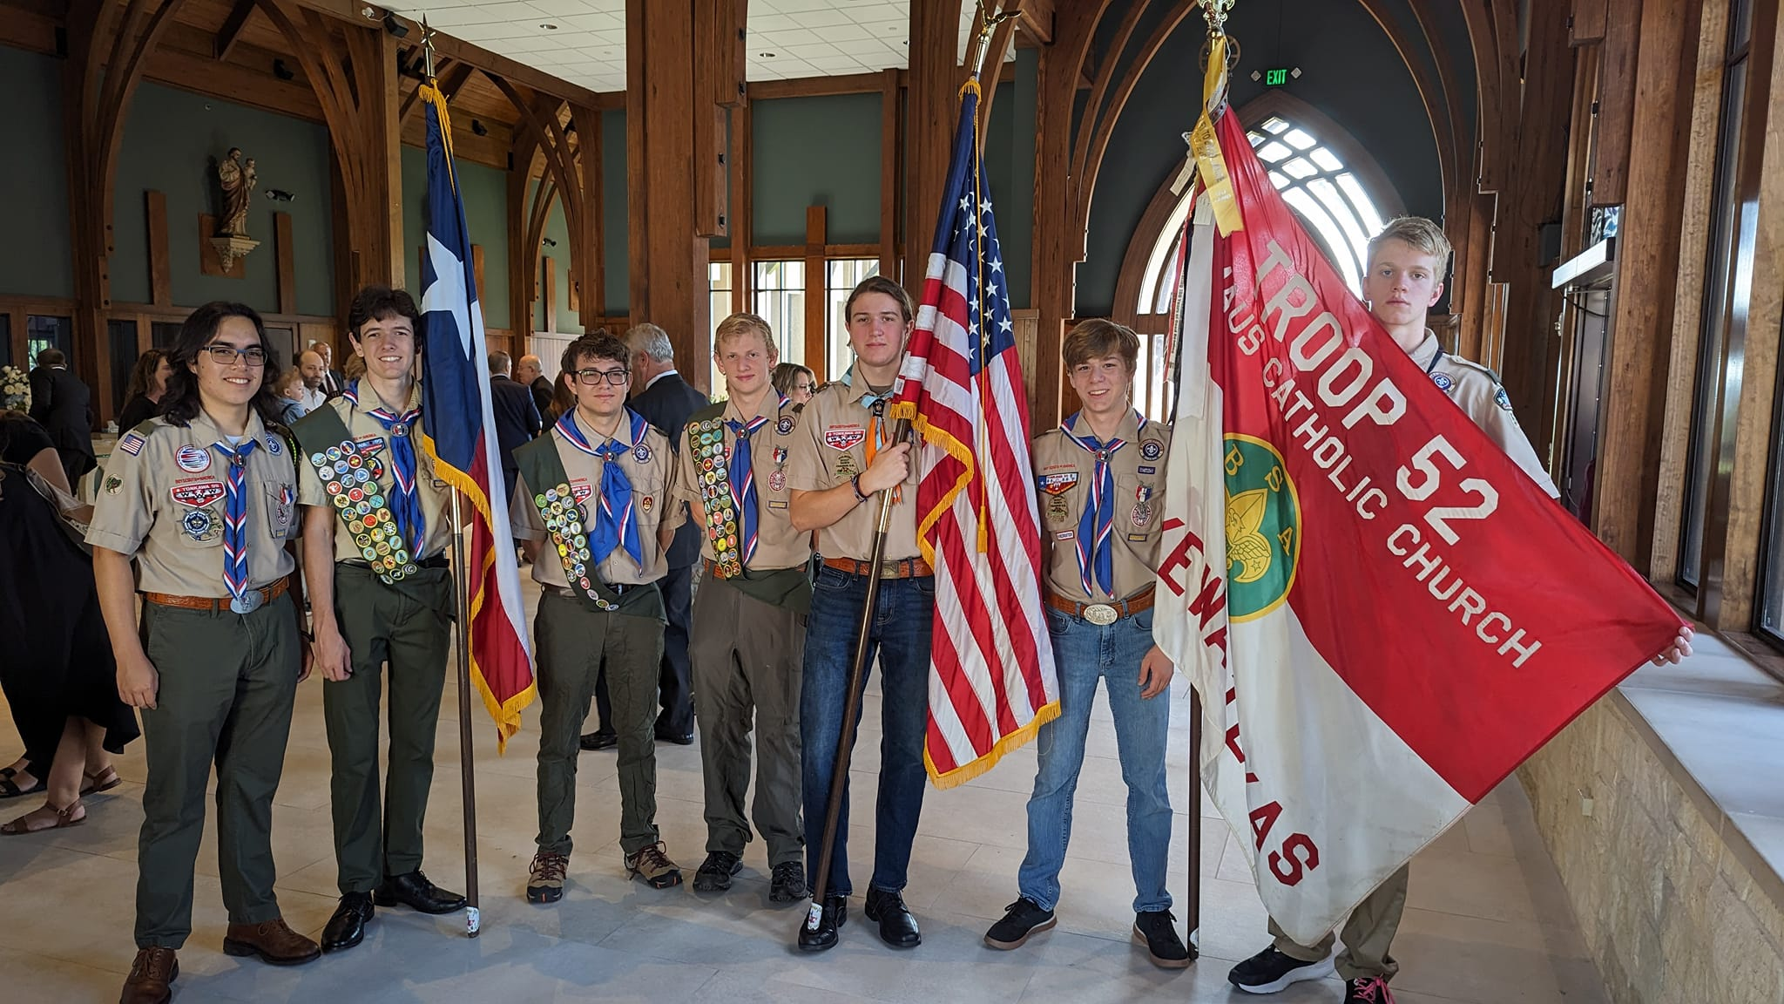

**Troop 52 Eagles at Memorial Service for Michael Cotton**

Thank you to these gentlemen for handling the posting of the colors at the memorial service for Michael Cotton on Saturday. (Pictured L-R, John Gallagher, Parker Grovatt, Martin Becker, Henry Kelbaugh, Tristan Evans, Jamie Ezell, and Trace Cottey). We lift up the Cotton family in prayer. We were glad to represent Troop 52 and do our small part. The family has created The Michael James Cotton Foundation. They ask in lieu of flowers you consider a donation to the foundation in his memory. <https://themjcfoundation.org/>



**Ethan Ezell’s Eagle Project – Saturday, July 15, 2023, 8:00-2:00 – Happy Hooves Healing Hearts**

Dear Troop 52, I have my Eagle project coming up on July 15. Please save the date. We are going to be building a goat stanchion, an A-frame, a goat table, and demolishing a rabbit pen at Happy Hooves Healing Hearts in Hudson Bend at 15603 Checotah Dr, Austin, TX 78734. They take in animals like goats and pigs and help find them a home. I hope you can make it. **Please RSVP on Scoutbook.**

Please bring drills, hammers, circular saws, sledge hammers, pry bars, speed squares, gloves, hat, and water bottle. Doughnuts and pizza will be provided. Thank you to my sponsors McCoy’s, Shipley’s, and CraigO’s.

YIS,

Ethan Ezell

Life Scout - Troop 52



**Stop the Bleed Course – July 22 or October 21**

Scott & White Medical Center in Lakeway is offering a free "Stop the Bleed" class on July 22nd and also on October 21st if Scouters might be interested. Classes are 9am-11am.

<https://events.bswhealth.com/event/stop-the-bleed---lakeway-5/>



**Electronics Lock-in – Lakeway Church – Friday, August 11, 2023, 6:00 pm – Saturday, 8:00 am – 2203 Lakeway Blvd. in Youth Building D**

Scouts are permitted to bring their electronic devices and stay up all night playing games. We will serve pizza and drinks. Scouts may only bring age and scout appropriate games for play. Inappropriate games and/or internet use will be disallowed and the scout will be asked to leave. To ensure BSA compliance, all scouts must have their Cyberchip for their rank and grade level up to date here: <http://usscouts.org/advance/cyberchip.asp>

This event is open to Webelos scouts interested in joining Troop 52, but Webelos must depart at 10:00 pm Friday night. Please RSVP on Scoutbook so we know how much pizza to order. The cost is $10 to cover pizza. Please pay on the troop website under the store tab. Webelos may attend for free.



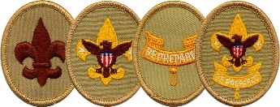

**Trail to First Class Schedule:**

All scouts who are not yet First Class are welcome to attend these sessions. They are especially geared toward new crossover scouts. The goal of our Trail to First Class (TTFC) program is to provide opportunities to learn scout skills to first and second year scouts. The first four ranks in scouting may all be worked on concurrently. This means that a TTFC session might include some or all the knots or first aid skills needed for Scout, Tenderfoot, Second Class, and First Class. In Troop 52, we believe boys who make it to First Class have more fun and are more likely to stick with the program, making their way toward Eagle Scout. These sessions will be conducted by Mr. Schulenberg with the assistance of the Troop Guides. Participation is optional, but you will advance quickly if you attend these sessions.

|  |  |  |  |  |
| --- | --- | --- | --- | --- |
| **Date** | **Time** | **Topics** | **Requirement(s)** | **Location** |
| 4-Mar | 11:30 AM | Fitness, Oaths & Totin' Chip! | Scout Rank Requirements 1a-1f, 5; Tenderfoot Requirement 6a | Lakeway City Park |
| 8-Apr | 9:00 AM | Fitness and Knots :-) | Scout Requirement 4a-b; Tenderfoot Requirement 6c | Lakeway City Park |
| 6-May | 9:00 AM | Knots, Bandages and Leadership | Tenderfoot Requirement 3a-d, 4a-c; 8 | Lakeway City Park |
| 3-Jun | 8:00 AM | Safe Hiking | Tenderfoot Requirement 4d, 5a-c | Serene Hills Trailhead |
| 15-Jul | 9:00 AM | Knots and Fireman Chit | Second Class 2a-d, 2f-g | Lakeway City Park |
| 5-Aug | 8:00 AM | Map Reading, Navigation and Hiking | Second Class 3a-d, 4 | Serene Hills Trailhead |
| 2-Sep | 9:00 AM | First Aid & Emergency Preparedness | Second Class 6a-e | Lakeway City Park |
| 7-Oct | 9:00 AM | Knot Fest! | First Class 3a-d | Lakeway City Park |
| 4-Nov | 8:00 AM | Hiking and Hazards | First Class 5a-d | Serene Hills Trailhead |
| 2-Dec | 9:00 AM | Advanced First Aid & Emergency Preparedness | First Class 7a-7e | Lakeway City Park |



**Upcoming Service Hour Opportunities**

There are many opportunities to earn service hours for both Troop and Community projects. Here are some upcoming service hour opportunities:

**Saturday, August 26 (Community)**

Volunteer to help to set up and/or clean up for the Lakeway Cool Arts Show. The City of Lakeway Arts Committee would like to have at least 4 older Scouts volunteer for the upcoming art exhibit on Saturday August 26, 2023 at the Lakeway Activity Center (105 Cross Creek, Lakeway). Scouts should be at least First Class and 13 years old for this event. Scouts will be assisting artists move their artwork into and out of the Activity Center. You can volunteer in the AM (11am-1pm) and/or PM (4-6pm) shifts. If you are interested, please contact Ms. Walters at [sarahwalters1974@yahoo.com](mailto:sarahwalters1974@yahoo.com). For more information about the Cool Arts Show, visit [lakewayartsdistrict.com](https://lakewayartsdistrict.com/)

**Ongoing - Eagle Projects (Various Hours - Troop)**

There are quite a few Life Scouts in our troop who are working hard on their Eagle projects and they need your help. Be on the lookout for separate emails regarding these unique Eagle project opportunities. Remember someday you will need help from younger Scouts for your Eagle project - now is the time to *pay it forward*!

**Second Saturdays - Mornings (2-3 Hours - Community)**

Volunteer and help to clean up our local parks on the second Saturdays of the month. These opportunities can qualify for conservation service hours, depending on the projects worked on. Visit either the Lakeway or Bee Cave website below to find out more details about how you can volunteer.

* Friends of the Park Lakeway (8-11am) - [lakewayfop.org](http://lakewayfop.org/)
* Bee Cave Friends of the Park Foundation (8-10am) - [beecavefop.org](http://beecavefop.org/)

**Understanding Troop vs Community Service Hours**

Eagle projects are Troop-based and do not require preapproval. However before embarking on any Community service hours project, remember to fill out the [Community Service Hours (CSH) form](https://img1.wsimg.com/blobby/go/c9c78b66-b90a-463e-bd5d-f56d564ec7e4/downloads/T52-CommunityServiceHoursForm.pdf?ver=1650645685582) to get approval from your patrol's ASM or a Service Hours Coordinator (Ms. Dawson). You will also be required to have approval from the community representative in charge of the service project. The CSH form explains it all.

**Use this link to the download the Community Service Hours Form:**

<https://img1.wsimg.com/blobby/go/c9c78b66-b90a-463e-bd5d-f56d564ec7e4/downloads/T52-CommunityServiceHoursForm.pdf?ver=1650645685582>



**2023 Troop 52 Photo Albums:**

**Ethan Ezell’s Eagle Project (upcoming)**

[**https://photos.app.goo.gl/qaaRwpUYoUkVb9yN9**](https://photos.app.goo.gl/qaaRwpUYoUkVb9yN9)

**Motorboating Merit Badge Workshop**

[**https://photos.app.goo.gl/RGWjztxeb9V3MqLRA**](https://photos.app.goo.gl/RGWjztxeb9V3MqLRA)

**Philmont Scout Ranch**[**https://photos.app.goo.gl/ZrboHCQQRpq38rgu9**](https://photos.app.goo.gl/ZrboHCQQRpq38rgu9?fbclid=IwAR2RpYXkFPEAFj4o_4nPMTnxo8bic0b_AO1NG1Eq_6XrRTAuNSefJ185bxk)

**Camp Cris Dobbins**[**https://photos.app.goo.gl/ijevsqPVhtRdceGD6**](https://photos.app.goo.gl/ijevsqPVhtRdceGD6?fbclid=IwAR1waq_EefRoY2VkgLFBz2EgoM1_LbeDZpGLPE9AwOd7xnO9FjKYpH4UByc)

**Summit Experience**

[**https://photos.app.goo.gl/BSd3VsVHYAKnzJ5U6**](https://photos.app.goo.gl/BSd3VsVHYAKnzJ5U6?fbclid=IwAR17ljJcuoJvvwMGJq3woNjRtIzDzKUvoSM-ZU1wXaJLHAowVBF4yZDLhnw)

**Layton Bates' Eagle Project**[**https://photos.app.goo.gl/vWCG1ahzjvmW9voX9**](https://photos.app.goo.gl/vWCG1ahzjvmW9voX9?fbclid=IwAR17ljJcuoJvvwMGJq3woNjRtIzDzKUvoSM-ZU1wXaJLHAowVBF4yZDLhnw)

**Blake Bates' Eagle Project**[**https://photos.app.goo.gl/prqtSWMjbed5yN9C9**](https://photos.app.goo.gl/prqtSWMjbed5yN9C9?fbclid=IwAR1mGpFT9SYhiSqenkxuCE8LQmqXuR2HnfNYY0LW6AI-ftVlfx9LwBdGIwk)

**Connor Schulenberg’s Eagle Project**[**https://photos.app.goo.gl/ggSuoM5GPqYYEtup9**](https://photos.app.goo.gl/ggSuoM5GPqYYEtup9?fbclid=IwAR3928bYYzdz8w7s_pg7Ke9R9eQZyLxF_2jIvfAB2ED9wwObsHF9yj2dmAo)

**Tyce Bogdon’s Eagle Project**[**https://photos.app.goo.gl/tsQLhyGoZxABip538**](https://photos.app.goo.gl/tsQLhyGoZxABip538?fbclid=IwAR1BzaduYDe_qI19FYSnsuD21A4DguFG8Lg2KLV2dUeHvgqL-kP-n3gQPtk)

**Camporee**[**https://photos.app.goo.gl/k7uBwRqwzTjbbbv1A**](https://photos.app.goo.gl/k7uBwRqwzTjbbbv1A?fbclid=IwAR2qMkMNWOhGLz5drJ1m-Qgt7V1kmh9FJT3RU5i6JrNiH9wtCoZvqKccOiU)

**Troop Blog and follow us on Facebook**

If you need to check for the latest info or announcements, follow us on Facebook at <https://www.facebook.com/groups/T52Lakeway/> or on the troop web site blog: <https://troop52lakeway.us/blog>

**Remember!**

