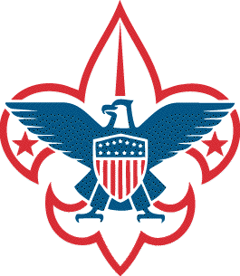
Troop 52
Trail to Eagle Merit Badge Plan 202__
Eagle Required Merit Badges*

Year | Citizenship  in the Community | Family Life | Communications | Personal Fitness | Personal Management | Emergency Preparedness | Citizenship in the Nation | Environmental Science | Camping | Citizenship in the World | First Aid | Cycling or Hiking
202_ | Fall | Fall | Fall
202_ |  |  |  | Spring | Spring | Spring | Fall | Fall | Fall
202_ | Fall | Fall | Fall |  |  |  |  |  |  | Spring | Spring | Spring

* Plan does not include Swimming or Lifesaving merit badges as these are best suited for summer camp.

