Instructions for Renewing a Scout and/or Adult
- You can click on the link in the email (as above) or you can log into my.scouting.org.
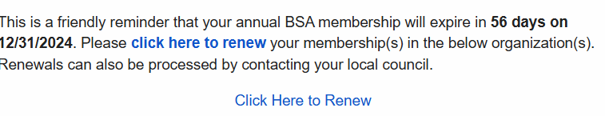

- If you log into my.scouting.org, there is a bell in the top right with an alert icon. Clicking on this will show this a screen:
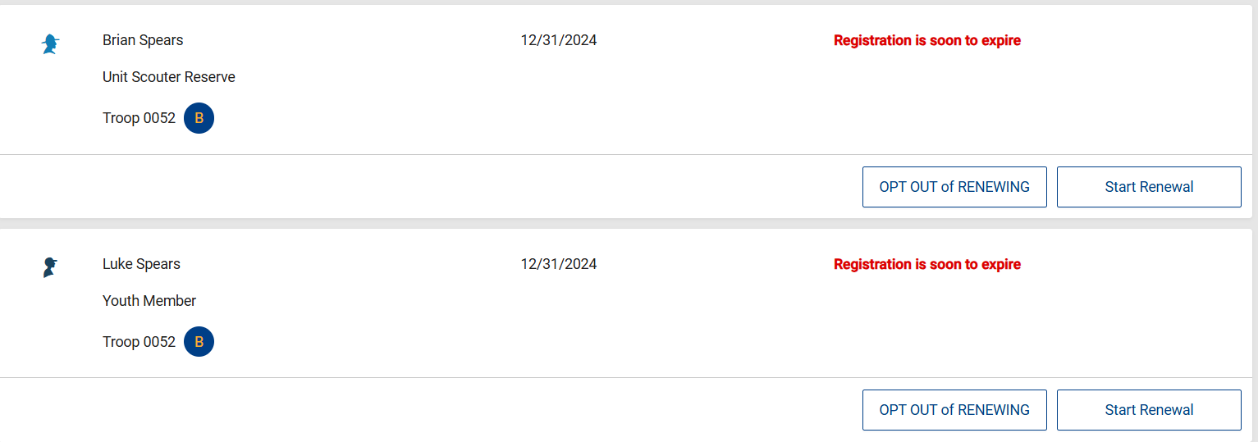
- Click start renewal
- You will see this screen:
Scouts:
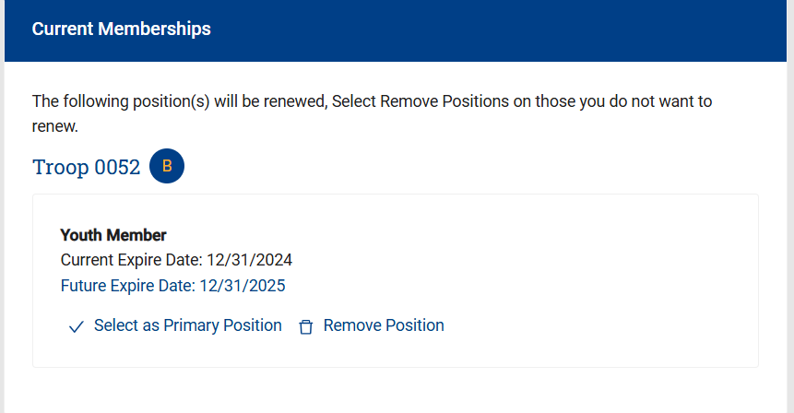
Adults:
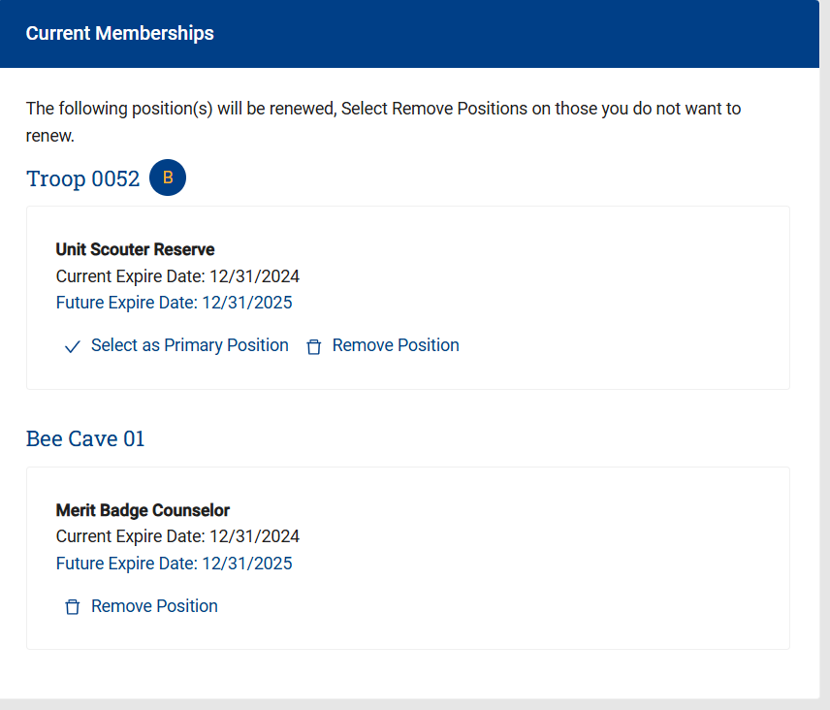
- Click on “Select as primary position”
- Then click on “go to payment”
- Review the “Terms and Conditions” by scrolling to the bottom.
- Sign your name
- Click on “Go To checkout summary”
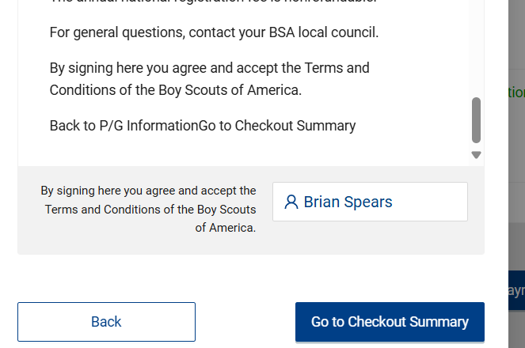
9)Fill in your payment information and click “Place Order”
10) Click complete registration

