**[DONATE](https://anthropedia.org/donate" \t "_blank)**

September 18, 2022

**The Importance of Well-Being in Troubled Times**

This article explores well-being, the history of the concept, its future, and why well-being matters today.

[[](https://anthropedia.org/instructors/kevin-cloninger)](https://anthropedia.org/instructors/kevin-cloninger)

**[Kevin Cloninger](https://anthropedia.org/instructors/kevin-cloninger)**

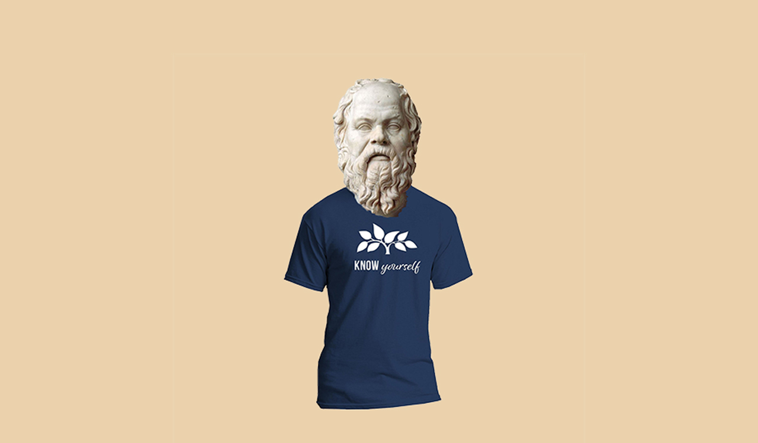

**Why Well-Being Matters in Troubled Times**

**I’d like to** try to explain concisely why this work on health, wellness, and well-being is so important for those of us looking to be healthy and resilient in the face of the tremendous adversity in our era. Simply stated, if we want to be resilient in the face of a complicated world, it’s important to ensure that each part of our being—body, mind, and spirit—should we want it to be well, is attended to on a regular basis and not only when there is a problem or a crisis. If we focus on our own well-being each and every day we will be more capable of assisting those we work with or serve, better able to engage in our family life, more resilient in the face of the challenges of our time, and more able to be a part of solving some of the world’s major crises be it the mental health care crisis, issues of social justice, climate change, economic equality, or others.

To have a being that is well, each aspect of the human being needs to be attended to. In fact, each of our three aspects has its own needs that must be addressed for them to function well. For example, the body requires nutrition, exercise, and sleep; our thoughts need healthy stimulation and intellectual development; and the human spirit needs elevated things that inspire us and provide our lives with meaning. It’s also important to recognize that our personal well-being is not disconnected from the well-being of a community, a culture, a society, and the planet as a whole.

To complicate the issue, the work on well-being is often considered to be an indulgence, a bourgeois luxury, or a privilege. This notion is reinforced by a whole industry of superficial, unfulfilling approaches to well-being that make outlandish promises, or simply equate well-being with physical beauty, or other problematic ideas. That said, nothing could be further from the truth. Everyone, regardless of age, class, gender identity, culture, or political persuasion invariably seeks greater health, happiness, and self-understanding. It is like the air we breathe; everyone wants to be well. To understand better why, it is interesting to look back at the roots of our thinking on the pursuit of well-being.

‍



**A Brief History of the Search for Well-Being**

The pursuit of well-being is as old as the hills. The Egyptians for example had a deep and complex understanding of the mind-body-spirit relationship. They practiced medicine, philosophy, religion and science in an attempt to fully describe and address these various aspects of the human being. Other cultures in Africa, like the Nigerian Igbo also looked at participation in the community as essential for personal well-being. Similar traditions exist in all parts of the world from the far east to aboriginal tribes in Oceania. This makes the pursuit of well-being something that essentially transcends issues of culture and ideology. As John Bowker and others have described it, well-being is a “cultural universal” or a “cultural constant.” These are “recurring elements, in human behaviour, which arise as a consequence of the fact that we are all conceived and born in, broadly speaking, the same way.”

All roads in the Western tradition lead back to the ancient Greeks, who—particularly in the moral and ethical philosophy of Socrates, Plato, and Aristotle—asked many questions about what was necessary to live “the good life.”

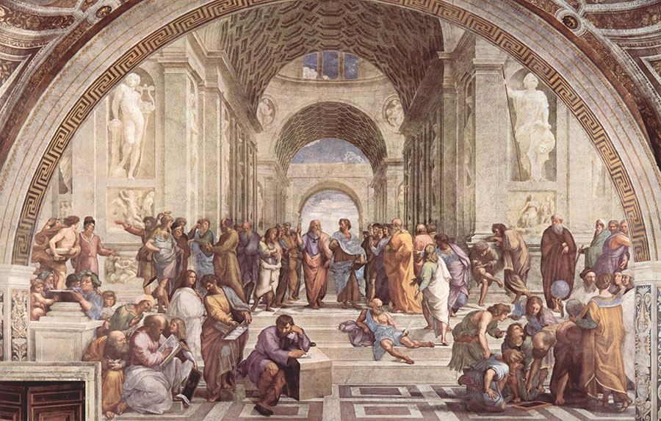

Looking at it from a modern perspective, Socrates was the first wellness coach. He felt that to live in well-being required the activity of the rational soul in accordance with virtue, but that each person has a different path to this ultimate truth and goodness.  For Plato, Socrates, and Aristotle, well-being was not simply a question of being happy, but it was the result of good functioning, virtue, and action. To be in a state of well-being, is not only about “feeling good,” but also about “doing good.” For them, living well is synonymous with well-being. At the same time, Socrates never claimed to have all the answers, but he did have a lot of good pointed questions, and he was a patient and tireless listener.

“Then, if one of you disputes this and says he does care [about well-being], I shall not let him go at once or leave him, but I shall question him, examine him and test him, and if I do not think he has attained the goodness that he says he has, I shall reproach him because he attaches little importance to the most important things and greater importance to inferior things […] wealth does not bring about excellence, but excellence makes wealth and everything else good for people, both individually and collectively.”

--Socrates (In Plato's Apology)

Socrates was so firm in his own conviction about the importance of his role that he chose to die rather than contradict his own principles.  His death left an indelible mark on Plato, who made it his life’s mission to help create a truly just society that would never put someone as pure as Socrates to death, something he never achieved, but his dream and vision is still very much with us today. Historical and modern exponents of the social justice movement, like MLK, Gandhi, and Cornel West still reference Socrates and Plato’s foundational work.

**The Role of Well-Being in Mental Health and Trauma-informed Care**

In work we’ve done at the Center for Well-Being at Washington University in St. Louis, my father, Dr. C. Robert Cloninger, and I have written extensively about the promotion of well-being in person-centered mental health care.  In many articles, workshops, and books we have made the case that one of the major problems that limits the effectiveness of mental health care is the failure to promote well-being due to an excessive contemporary focus on deficits symptomatic of mental ill-being. Our treatments too often focus on symptoms rather than on causes of dysfunction and fail to promote healthy functioning. In contrast, randomized controlled trials of treatments designed to promote well-being have been shown to reduce dropout, relapse, and recurrence rates compared with treatments for symptoms of disorder (CR Cloninger, 2006; Fava & Ruini, 2003; Fava & Tomba, 2009). In addition, mental health care that promotes well-being reduces the stigma of mental illness and increases recovery of mental health. In other words, mental health care appears to be more effective than mental illness care.

**Why Well-Being is Essential in a Time of Great Crisis**

Far from being a luxury or indulgence of the rich, the work on well-being is key to facing the crises of the 21stcentury. This is due in no small part to how important self-understanding is to healing. We simply can’t change if we don’t start by becoming more aware of what we are. Well-being is impossible without an understanding of the Being, which is well or unwell.  And yet, people differ markedly from one another in the depth of their understanding of themselves and their relationships. That said, whether people are being treated for major mental disorders or are successful in their work and personal life, everyone ultimately seeks three inseparable goals in their life—greater well-being, self-understanding, and unity or coherence (CR Cloninger, 2004). It is literally written into our DNA; our brains and bodies are built to function in well-being, which is why the work on well-being can help to jumpstart the traumatized organism by helping the being to reestablish its normal functioning.

There has never been a more important time to become a well-being coach. Anthropedia's Well-Being Coach Certification is unique in its emphasis on mental well-being. If you want to participate in addressing the mental health crisis become a Anthropedia well-being coach today, and we'll equip you with everything you'll need to start providing assistance.

‍

**TRAINING**

**SERVICES**

**ABOUT**

**[ARTICLES](https://anthropedia.org/articles)**

[**CONTACT US**](https://anthropedia.org/contact)

**Relevant Articles**

[[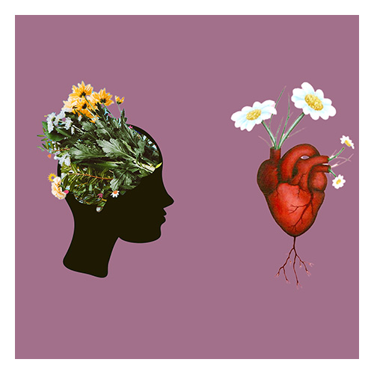](https://anthropedia.org/articles/temperament-and-the-emotional-brain)](https://anthropedia.org/articles/temperament-and-the-emotional-brain)

**[Temperament and the Emotional Brain: A Case Study](https://anthropedia.org/articles/temperament-and-the-emotional-brain)**

[Our temperament has a huge impact on our emotions and perceptions. This article explores this idea.](https://anthropedia.org/articles/temperament-and-the-emotional-brain)

[[](https://anthropedia.org/articles/temperament-and-the-emotional-brain)](https://anthropedia.org/articles/temperament-and-the-emotional-brain)

**[Christina Mengert](https://anthropedia.org/articles/temperament-and-the-emotional-brain)**

[PhD](https://anthropedia.org/articles/temperament-and-the-emotional-brain)

[September 18, 2022](https://anthropedia.org/articles/temperament-and-the-emotional-brain)

**Want to take action on your well-being?**

Become a part of the Anthropedia community and receive our newsletter and other updates on our work in the community, new articles, upcoming events, webinars, and more.

Top of Form

Full Name\*

Email\*

Join Us

Bottom of Form

**More than just   
a training to become  
a wellness coach**

[**info@anthropedia.org**](mailto:Contact%20from%20footer%20link?subject=info%40anthropedia.org)[**+1(314)721-3878**](tel:+13147213878)

[DONATE](https://anthropedia.org/donate)[Become a Coach](https://anthropedia.org/apply)

**Training**

[Coach Certification](https://anthropedia.org/well-being-coach-certification)[TCI Training Programs](https://anthropedia.org/tci-training-programs)[Workshops & Classes](https://anthropedia.org/articles/well-being-in-troubled-times?utm_source=ActiveCampaign&utm_medium=email&utm_content=Big+announcement+about+our+new+offerings%21&utm_campaign=First+blog+post+%28prune+master+list%29&vgo_ee=ZfqaTI2CwKgeyrhDvwMjPEzkASpiHornD%2Fz2wZTd1jg%3D)

**Services**

[Well-Being Coaching](https://anthropedia.org/well-being-coaching)[Take the TCI](https://anthropedia.org/articles/well-being-in-troubled-times?utm_source=ActiveCampaign&utm_medium=email&utm_content=Big+announcement+about+our+new+offerings%21&utm_campaign=First+blog+post+%28prune+master+list%29&vgo_ee=ZfqaTI2CwKgeyrhDvwMjPEzkASpiHornD%2Fz2wZTd1jg%3D)[Visit our Center](https://anthropedia.org/our-center)

**About Us**

[About Us](https://anthropedia.org/about-us)[Mission](https://anthropedia.org/mission)[Leadership Team](https://anthropedia.org/board-of-directors)[Our Impact](https://anthropedia.org/impact)[The Science of Well-Being](https://anthropedia.org/the-science-of-well-being)[Read Articles](https://anthropedia.org/articles)

Copyright © Anthropedia 2016-2022

[Privacy Policy](https://anthropedia.org/privacy-policy)