Disability
Business Start-up Commitment Objectives
Strategic UK Group |  | Business Start-up

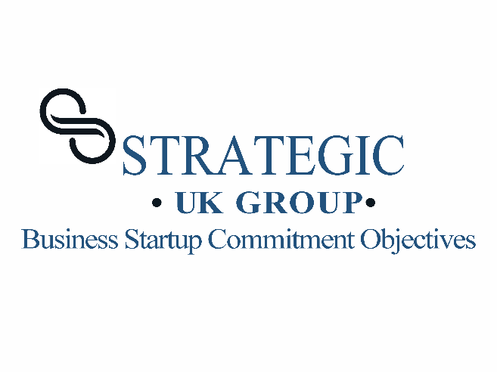

Our commitment to Disability is to support disabled people with their business start-up journey through a focused approached.
To help set our commitment objectives for Disabled our engagement encourages disabled people to take part in setting our business start-up commitment objectives.
Our Business Start-up Commitment Objectives for disabled comes from a publication on Disability and Entrepreneurship. The questions has been set based on the finding from this disability publication.
We would like disabled people to take part in our commitment objectives questionnaire.
Questions:
- What describes commitment objectives for disability start-up business? Describe in your own words.
- How can our New Business Start-up Programme support Disabled?
- How can accessibility to the New Business Start-up Programme be better-quality?
- How can our new business start-up programme support disabled people with their ambition?
- What support do disabled people need for starting up their own business?
- How can the New Business start-up programme support disabled people over a 24 month?

- How can the New Business Start-up Programme reduce the burden of starting a new business?
- How can the deliver of the New Business Start-up be accessible to disabled people?
- How can Strategic HUB improve accessibility for disabled people?
- . What flexibility do disabled people need from the New Business Start-up Programme?
- . How can forms and sign-up accessibility be improved by the New Business Start-up Programme?
- . What type of learning resource would support disabled people business start-up?
Strategic Group UK believes that diversity drives innovation, and we are dedicated to empowering individuals with disabilities to contribute to the vibrant landscape of business and entrepreneurship.
These commitments reflect our sincere dedication to creating an environment where everyone has an equal opportunity to succeed.

Questionnaire link

