**Exchange Vs. Gifting**

**with an Influencer**

1. **Is it a good idea to exchange product/services with an influencer? I don’t have money to hire an influencer.**

Often small businesses will approach influencers looking for an exchange of services. E.g. I’ll give you this t-shirt if you’ll do a post for me. Some influencers do accept this and it can work well especially if both parties are just starting out. However, there are disadvantages to this, both parties need to agree on the value proposition of the items/services being exchanged. Often one party can feel they got the short end of the stick. Sometimes these unofficial deals don’t pan out and one party won’t follow through.

If you do agree to an exchange, I’d suggest putting what each party is giving and will be receiving in writing, especially if high value items/services are being exchanged.

It is also important to note that it is usually only new influencers who accept exchanges rather than money for their services, this means a smaller audience, a less experienced influencer, and likely a lower quality promotion overall compared to a paid promotion.

Note that Canada Revenue Agency considers an exchange of services as payment. So technically influencers must report all exchanged items as income that they must then therefore pay taxes on. (Most new influencers don’t know this.)

1. **What if I offered the influencer my product/service as a gift?**

Gifting and an exchange are often confused, they are however very different. **To gift, is to offer something to an influencer “no strings attached.**” Influencers are more likely to accept gifts than exchanges. There is a risk to the business associated with gifting of course, as the influencer may not like your product/service and may never post about it. Thus, you will receive nothing in return for your gift. This is however the exception, not the norm. In most cases the influencer will offer ***some*** exposure as a thank-you for your gift.

**How much exposure you receive for a gift depends on:**

* the influencer,
* how much they like it personally,
* how much they think their audience will like it,
* how busy they are at that time,
* the dollar value of the gift, and
* your relationship with the influencer.

It is also important to note that not all influencers accept gifts. This isn’t uncommon so **don’t be offended if an influencer doesn’t want your free gift**. This is usually because they must prioritize paid work ahead of yours and recognize that promoting your gift may not get done and that isn’t fair to you.

*Two Separate Examples of Gifting*

I once received a gifted no-strings-attached service for an eyelash lift and curl, unfortunately, the service was performed by a new lash tech and it was quite poorly done. **As much as I would have loved to promote the service, I couldn’t do it with any conscience**, so sadly she did not receive any promotion for the service she gifted me. Note this business never asked me to post, she simply gifted me the service and let me decide the rest.

I once received a no-strings-attached gifted shirt. I did an unboxing on my stories, but I also ended up wearing that shirt a bunch of times, so it reappeared on myself in multiple stories and in a video that received tens of thousands of views. There were multiple comments on the video asking where I got the shirt from. Furthermore, **I liked the shirt so much, I became a customer of this business** and since have ordered from them multiple times. Note this business never asked me to post, they simply gifted me the item and let me decide the rest.

___________________

If this document was helpful feel free to pass it along to your friends. Unfortunately, because the influencer business is so new there is little practical information out there so let’s spread the info around! 😊

If you’re interested in working with me specifically, [please reach out](mailto:sarahsociables@gmail.com)! I have an all-local audience (Calgarians) who follow for information about local events and restaurant news.

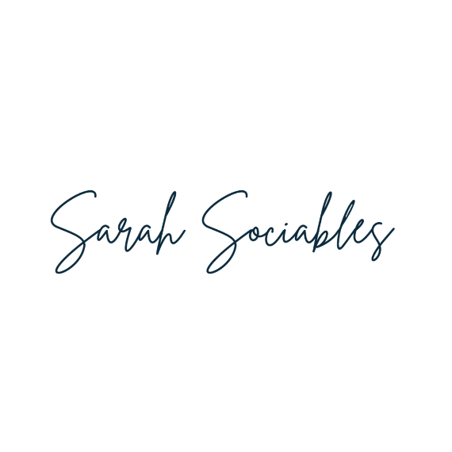

**Instagram:** [**@sarah.sociables**](https://www.instagram.com/sarah.sociables/)

**TikTok:** [**@sarahsociables**](https://www.tiktok.com/@sarahsociables)

**Website:** [**sarahsociables.com**](https://sarahsociables.com/)