**Tips for Small Businesses on**

**Working with an Influencer**

1. **I’m curious about working with an influencer. Is my business ready?**

Before you engage an influencer, you’ll want to be best set up to take maximum advantage of your money spent. The influencer will be sending traffic to your Instagram profile so you’ll want to make sure your bio is clear on what you do, professional, and the images represent your brand well. This will increase the likelihood that people will follow or click on your website. Make sure there are no typos in your bio and your link is active.

1. **Which influencers should I approach?**

The most common mistake small businesses make is to approach the influencers with the largest audiences they come across. **However, a big audience doesn’t mean they are made up of your target customers.** The classic example is a young woman who posts attractive scantily clad photos of herself and has a million followers. She is hired for a campaign to sell bikinis but because her audience is made up of mostly males the campaign flops and sales are poor despite her having a large audience.

Whatever it is you’re selling should roughly match the type of content that influencer already posts. If you’re selling diapers approach a mom blogger, if you’re selling a new seltzer, try an influencer who already posts about alcohol. **It’s more important that your product/service be in front of the right audience than it is to be in front of a bigger wrong audience.**

1. **How do I get information on the influencer’s audience?**

Ask them! This is a common request. Ask for screenshots of Instagram demographics.

1. **I don’t have money to hire an influencer, what if I offered to exchange product/services?**

Often small businesses will approach influencers looking for an exchange of services. i.e. I’ll give you this t-shirt if you’ll do a post. Some influencers do accept this and it can work well but usually only if both parties are just starting out. However, there are disadvantages to this, both parties need to agree on the value proposition of the items/services being exchanged. Often one party can feel they got the short end of the stick. Sometimes these unofficial deals don’t pan out and one party won’t follow through.

If you do agree to an exchange, I’d suggest putting what each party is giving and will be receiving in writing, especially if higher value products/service are being exchanged.

It is also important to note that **usually only new influencers will accept an exchange as payment rather than money for their services**, this means a smaller audience, a less experienced influencer, and likely a lower quality promotion overall compared to a paid promotion.

1. **What if I offered the influencer my product/service as a gift? Will they post about it?**

Gifting and an exchange are often confused, they are however very different. **To gift, is to offer something to an influencer “no strings attached.**” Influencers are more likely to accept gifts than exchanges. There is a risk to the business associated with gifting of course, as the influencer may not like your product/service and may never post about it. Thus, you will receive nothing in return for your gift. This is however the exception, not the norm. In most cases the influencer will offer ***some*** exposure as a thank-you for your gift.

**How much exposure you receive for a gift depends on:**

* the influencer,
* how much they like it personally,
* how much they think their audience will like it,
* how busy they are at that time,
* the dollar value of the gift, and
* your relationship with the influencer.

It is also important to note that not all influencers accept gifts. This isn’t uncommon so **don’t be offended if an influencer doesn’t want your free gift**. This is usually because they must prioritize paid work ahead of yours and recognize that promoting your gift may not get done and that isn’t fair to you.

*Two Separate Examples of Gifting*

I once received a gifted no-strings-attached service for an eyelash lift and curl, unfortunately, the service was performed by a new lash tech and it was quite poorly done. **As much as I would have loved to promote the service, I couldn’t do it with any conscience**, so sadly she did not receive any promotion for the service she gifted me. Note this business never asked me to post, she simply gifted me the service and let me decide the rest.

I once received a no-strings-attached gifted shirt. I did an unboxing on my stories, but I also ended up wearing that shirt a bunch of times, so it reappeared on myself in multiple stories and in a video that received tens of thousands of views. There were multiple comments on the video asking where I got the shirt from. Furthermore, **I liked the shirt so much, I became a customer of this business** and since have ordered from them multiple times. Note this business never asked me to post, they simply gifted me the item and let me decide the rest.

1. **If I gift something to an influencer and they put it in their stories (or post it) can I ask for analytics?**

No. This is a faux pas. Only paid collaborations should request analytics.

1. **If I gift something to an influencer can I give them instructions on when or how to post about it?**

No. This is a faux pas. Only paid collaborations get that priority. A gift is no-strings attached and should not come with instructions. You can give information (e.g. tags or hashtags) but as for **anything that serves as directions - you should be hiring the person.**

1. **But aren’t I helping the influencer out by giving them content to post about? I’m doing them a favour.**

Yes, influencers need content, but they’re not short on it and they don’t need yours specifically. The world is endlessly full of content so it’s not a good idea to approach an influencer with this mentality.

1. **What’s the best way to approach an influencer?**

I think there is a bit of a myth out there that you must have a relationship with an influencer prior to approaching them about working together. Yes, that helps (following, liking posts, offering supportive comments) but this is not at all necessary. **Approach an influencer like you would any other business-to-business transaction**. Send an email with a clear ask (or if it’s a gift, be clear on that). **If you have a budget (aren’t gifting or exchanging) mention that very early on**. **This will prioritize you** over the many other exchange and gift offers the influencer receives.

1. **How do I know how much to pay an influencer?**

Similar to most lines of work, influencers can choose to charge a lot or a little for their services. Either ask for a price for a particular service, or if you are limited in budget, choose a price point you are comfortable with starting with and offer it to the influencer. Some influencers are open to negotiate and will work with low budgets (particularly if it’s a slow period.)

1. **I’m scared the influencer will rip me off. How do I know I can trust them?**

There are urban myths of influencers who essentially take the money (or product) and run. However, this doesn’t happen any more frequently than other industries, perhaps it’s just more widely publicized. I suggest having a signed contract to protect your investment.

I’ve had some people be hesitant to work with me and come into the conversation from a defensive position. Maybe they’ve had poor experiences in the past, but most influencers truly want what’s best for your business. After all, influencers want to get hired again, want to have a good reputation, want to have successful collaborations they can be proud of. So, while it’s good to have some level of skepticism with every new business you work with, please don’t think that all influencers are sketchy people who want to take advantage of you.

1. **What kind of results can I expect?**

That depends on your objective. Think this through and have this conversation with the influencer. Are you looking for followers? A certain number of video views? An increase of people to your physical storefront? More website visits? More awareness of your brand in a particular market? **Knowing this ahead of time will affect what strategy the influencer recommends to you.**

Keep in mind that influencer marketing isn’t a magic bullet form of marketing, yes, perhaps when Kim Kardashian posts about a pair of shoes those will sell out the next day, most won’t have that level of impact on people’s buying behavior and they do not have that large of an audience.

Keep your expectations realistic regarding what results you would expect especially with regards to sales. **It is possible you’ll make back your investment with a single post from the influencer, but that would not be typical**. In advertising, a general rule of thumb is that someone needs to see a product/service 7 times before they are sufficiently encouraged to buy. They need to move through the stages of awareness, liking, and then motivation to purchase. This usually doesn’t happen with a single post.

Example of a great ROI

I once did a paid video post for a local art store, for whatever reason it had a viral component to it and received over 30,000 views on TikTok. Not only that, it inspired copycat TikTokers to go to the store and replicate their own version of the video. This provided the store with a ripple advertising effect and a number of new customers and sales. This store made back their original ad dollars plus much more all within a single post. (It is important to note these results are NOT typical and cannot be predicted.) While I do my best to make every video go viral, I certainly don’t have that ability, (and if anyone else tells you they do, they’re trying to steal your cash).

___________________

If you’re interested in working with me specifically, please reach out to [info@yycsociables.com](mailto:info@yycsociables.com) I have an all-local audience (Calgarians) who follow for information about local events and restaurant news.

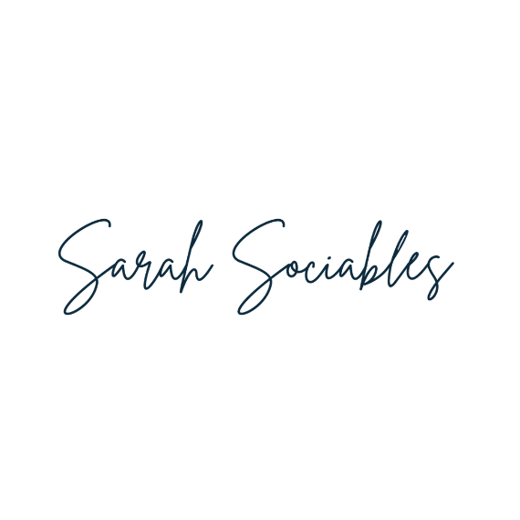

**Instagram:** [**@sarah.sociables**](https://www.instagram.com/sarah.sociables/)

**TikTok:** [**@sarahsociables**](https://www.tiktok.com/@sarahsociables)

**Website:** [**sarahsociables.com**](https://sarahsociables.com/)