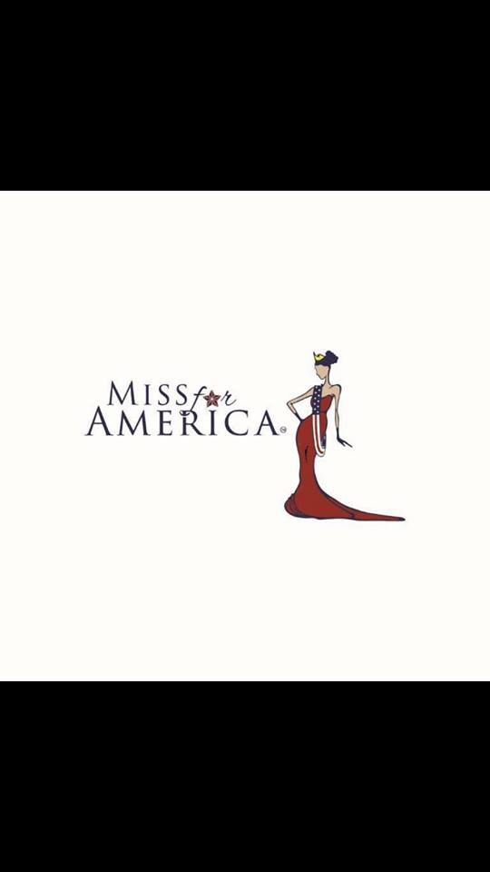

**2026 MISS WEST VIRGINIA FOR AMERICA**

**HOW TO BEGIN:**

Complete and submit the attached application, meet requirements below, and pay fee by deadline. No current title, no problem!! Together we will select the perfect title for you for the competition.

**REQUIREMENTS TO ENTER STATE PAGEANT:**

*Must be 18 years of age and a resident/attend college in the state of West Virginia.

*Must be single at the date of entry. (Divorced, widow, with or without children). Must remain single throughout your reign, if crowned.

*Complete and submit all required paperwork/documents and pay fee by deadline.

*Submit a headshot for publication, website and social media announcements

**REQUIRED FINANCIAL OBLIGATIONS TO ENTER STATE PAGEANT**

*Entry fee: $495.

*Bring a silent auction basket day of pageant.

**WARDROBE REQUIREMENTS FOR STATE PAGEANT**

*Opening number – Pretty in Pink will be the theme this year. Your choice of attire (cocktail, jumpsuit, etc.)

*One-piece swimsuit (waist coverup may be worn but cannot be removed during competition)

*Full length gown

*Interview attire.

**PROGRAM ADS**

*Program Ads are not required to enter but encouraged.

* Program ads allow businesses, family, friends, and communities to show their support for you. Each full-page color ad is $125. Design must be created prior to submission; we do not design your ad pages. Judges will have a copy of the program book to reference prior to and during the competition. Ad pages are 8.5 x 11 with a bleed and need to be in pdf format.

*Selling Two or more ad pages will allow you to select your place in the line-up prior to the competition. The first to submit and pay for ads will select their place in the line-up first and so on. The contestant to sell the most ads will receive the publication award during the competition.

**LOCATION, DATES & DEADLINES:**

*Pageant date is Feb. 21-22. Deadline to enter and submit ALL ADS AND FEES is FEBRUARY 4, 2026.

*Pageant will be held at WV Culture Center, Charleston WV.

**Additional Competition Information**

**Interview:**

Each contestant will have a four (4) minute interview with the judges. Our judges will be looking for your ability to articulate and communicate while observing your overall presence. Judges will have your Biography form and application to use as a reference but may ask other questions. Interview is 50% of your total score.

Attire: Select an outfit or dress that is stylish and sophisticated. The color and fit should be flattering to your skin tone and shape. Remember first impressions are everything and you are interviewing for the job of a lifetime!

**Swimsuit:**

Each contestant will model a swimsuit on stage. Swimsuit is a one-piece and color/style of your choice. Judges will be looking for confidence, poise and physical fitness. Swimsuit is 25% of your score.

**Evening Gown:**

Each contestant will model an evening gown of their choice on stage. The evening gown should complement your complexion and figure. The gown should reflect your own style and make you feel amazing! Confidence, elegance and how you present yourself will be key! Evening gown is 25% of your score.

**Final Question:**

Finalist will have a random question on stage. Each question is light-hearted and fun. The final question isn’t judged, but our judges will be considering the final ranking during this event.

**Scoring:**

Our scoring system is the “circle” system. During each phase of competition judges will select their top choices (this number is determined by the number of total contestants). Each time a contestant is selected (circled) they receive a “point”. After finalists are announced, the judges will rank each finalist i.e., Queen, 1st Runner – up and so on. Totals will be calculated, and winners announced.

Hair & Make-up artists will not be allowed backstage this year. You will come ready for competition the day of the pageant.

All questions may be directed to the email below.

We hope you will join us!

Stephanie Duffield & Lisa Dawson – Executive Directors

Michael Rader – Assistant Director

wvamericapageants@gmail.com